Team Toyota Design Notebook

Team Toyota Design Notebook

Group members: Owen Cutler, cutler.o@northeastern.edu; Nolan Leonhardt, leonhardt.n@northeastern.edu

Maintaining a Design Notebook is a critical aspect of any engineering project. Each group is expected to keep one Design Notebook per project to document the design process, track progress, and ensure accountability. This template has been created to guide you in effectively using your Design Notebook.

Purpose
Design Notebooks serve multiple key purposes:
- Document the Design Process: It helps you capture the evolution of your engineering design, from brainstorming to final implementation, including challenges and solutions.
- Track and Assess Progress: It provides a record of your progress that can be reviewed to assess how well you’re developing your design process and overcoming obstacles.
- Develop Industry-Standard Practices: The habit of maintaining a well-organized Design Notebook mirrors industry practices, where documentation is critical for tracking project development and ensuring legal accountability.
- Resource for Future Use: Your notebook serves as a valuable reference when preparing reports, memos, or portfolios, allowing you to revisit the design journey and communicate key insights.
- Communicate and Collaborate: In professional settings, Design Notebooks are often used to demonstrate diligence, communicate progress, and assist others in understanding the project, either when they join the team or if they’re working on a related task.

Instructions for Using this Template
- Keep it Consistent: Ensure that your group consistently updates the Design Notebook after each session.
- Be Detailed: Capture all aspects of the design process, including initial sketches, meeting minutes, brainstorming sessions, failed attempts, flowcharts, images, and final designs.
- Highlight Challenges and Solutions: Make sure to document not only your successes but also any setbacks and how they were resolved.
- Organize Chronologically: Entries should be arranged in reverse chronological order, with the most recent work at the top, so that it reads like a blog.

Design Notebook Template: Design Notebook Template

Team Toyota Chater: Team Toyota Charter

12/03/2024 | Concluding Reflection | Owen Cutler, Nolan Leonhardt

The goal of this short entry is to reflect on the peer feedback on Team Toyota’s engineering notebook given by a fellow classmate. Additionally, there should be an explanation of how the team functions and divides work, maintaining clear communication and collaboration. This reflection should also include a detailed reflection on both team members contributions of Challenges Three and Four; explaining any discrepancies in the distribution of work among members.

Reviewing Peer Feedback:
The team received peer feedback in the form of comments in your notebook and/or on Canvas. Review and summarize them. Reflect on the key points mentioned and address the issues identified.
The majority of the peer feedback provided on Team Toyota’s engineering notebook was positive. The peer reviewer noted how they appreciated the level of detail and extensiveness in our task lists, resource lists, and meeting minutes. They also wrote positively of details like the labeling added to supporting images.
The only critique the reviewer mentioned was how some entries lacked detail in their reflection, with them only being a short paragraph in length. With this feedback being given not long after challenge one, Team Toyota was able to move forward with this in mind. Since this feedback, the length and detail of every aspect of the team's entries have greatly increased and are now reviewed after first writing to guarantee nothing of importance was left out. This feedback was incredibly helpful in improving the quality of the team’s engineering notebook.

Team Functions and Distribution of Work:
A brief explanation of how the team functions and splits the work.
Team Toyota has, for the entirety of this project, attempted to keep the distribution of time required for work equal among both team members. The only reason this would not be true is if the specific skills of one team member were especially useful to some aspect of work. The strong suits of both Nolan Leonhardt and Owen Cutler were considered each time work was being distributed. Not long after the beginning of this project, there were certain tasks that group members were consistently doing.
Firstly, much of the team's Solid Works and AutoCAD work was done by Nolan Leonhardt, with exceptions including the individual laser cutting project, due to his past experience with computer design software and 3D printing. Nolan Leonhardt’s skills in this area were incremental to the success of the team.
Second, the majority of assembly and wiring on the robot was done by Owen Cutler. Despite being a computer science major, his focus on order and thought through design was important when assembling the robot. It was this work that resulted in consistently organized wiring and an easily troubleshooted robot.
Next, programming for the robot was completed by Nolan Leonhardt. Nolan’s past experience in high school robotics gave him the knowledge to efficiently make changes to the code quickly when testing with the team. His work allowed for rapid testing on demonstration days and subsequently earned the team higher performance grades during each challenge.
Additionally, the majority of information collection, photo and video documentation, meeting minutes, and notebook entities were completed by Owen Cutler. Prior experience in leadership roles that entailed documenting meeting notes and an interest in informative writing give him the ability to effectively express the work done throughout the duration of this project. It was this work that resulted in the report this reflection resides within.
Design, problem solving, strategy revisions, and goals were all decided collectively with all members of Team Toyota participating.

Team Member Contributions:
A detailed reflection on each team member’s contributions to Challenges 3 and 4. If the team member’s contributions were not equal, include a clear and specific explanation of the reasons behind the discrepancy.
Contributions to both Challenge Three and Challenge Four stayed with trends that had been already established while working on earlier challenges. These trends were listed above in the Team Functions and Distribution of Work portion of the reflection.
Focusing on the penultimate and final challenges:
Nolan Leonhardt played a key role in much of the robot for these assignments. Creating several 3D printed parts from scratch including a battery pack holder/mount, maze wall stands, and connection pieces for maze walls; each serving an incremental role in the successes of Team Toyota. Additionally Nolan Leonhardt was responsible for the programming of the robot, adjusting wheel speeds and refining the turning behavior of the robot during team testing. His insight and troubleshooting were vital in improving the robot’s performance in the maze.
Owen Cutler primarily focused on the physical assembly and wiring of the robot and Maze. Taking charge of assembling the robot, wiring all components, and maining neat, organized, and functional wiring. Additionally, Owen Cutler was responsible for designing the layout of the challenge four modular maze. Following the issues surrounding battery power in lead to challenge three, Owen Cutler rewired the robot entirely in an attempt to troubleshoot the issues. Owen Cutler also led documenting the team’s work, providing detailed notes stored in this engineering notebook. Entries included outlining the team's approach, testing outcomes, and solutions to problems the team faced.
Both team members of Team Toyota contributed to every aspect of Challenge Three and Challenge Four. Any slight imbalance in work distribution stemmed from the personal strengths and expertise of members.

12/03/2024 | Challenge Four Demonstration Day | Owen Cutler, Nolan Leonhardt

The goal of today’s in class demonstrations were to show off the capabilities of our robots and the culmination of the work that went into this project as a team. Team Toyota would have to run the team robot through three mazes, only one of which we have seen in preparation (the team’s own maze). The robot must autonomously navigate through a maze assigned by Dr. Keyvani, a maze chosen by Team Toyota members, and Team Toyota’s own maze.

Planned tasks list:
- Setup Final Team Toyota Modular Maze
- Run Robot Through a Maze of The Team’s Choice
- Run Robot Through The Team’s Maze
- Run Robot Through Maze Assigned by Dr. Keyvani

Resources needed to complete the tasks
- Owen Cutler, Nolan Leonhardt
- Maker Space Classroom
- Charged Laptop
- USB Type C Cable
- Phone to take photos and videos
- 3D Printed Maze Stands
- Cardboard Maze Walls
- Pen

Useful reference links: List any link related to today’s work

- Videos:
- First Test of Team Toyota's Maze.
- Second Test of Team Toyota's Maze.
- Final Test of Team Toyota's Maze. (3/5 Points)

- First Test of Team Assigned to Team Toyota's Maze.
- An Additional Team Attempts Team Toyota's Maze.

- First Test of Assigned Maze.
- Second Test of Assigned Maze.
- Third Test of Assigned Maze.
- Fourth Test of Assigned Maze.
- Final Test of Assigned Maze. (3/5 Points)

- First Test of Team Choice Maze.
- Second Test of Team Choice Maze.
- Third Test of Team Choice Maze.
- Final Test of New Team Choice Maze. (3/5)

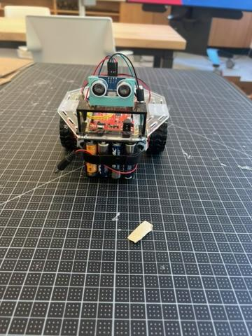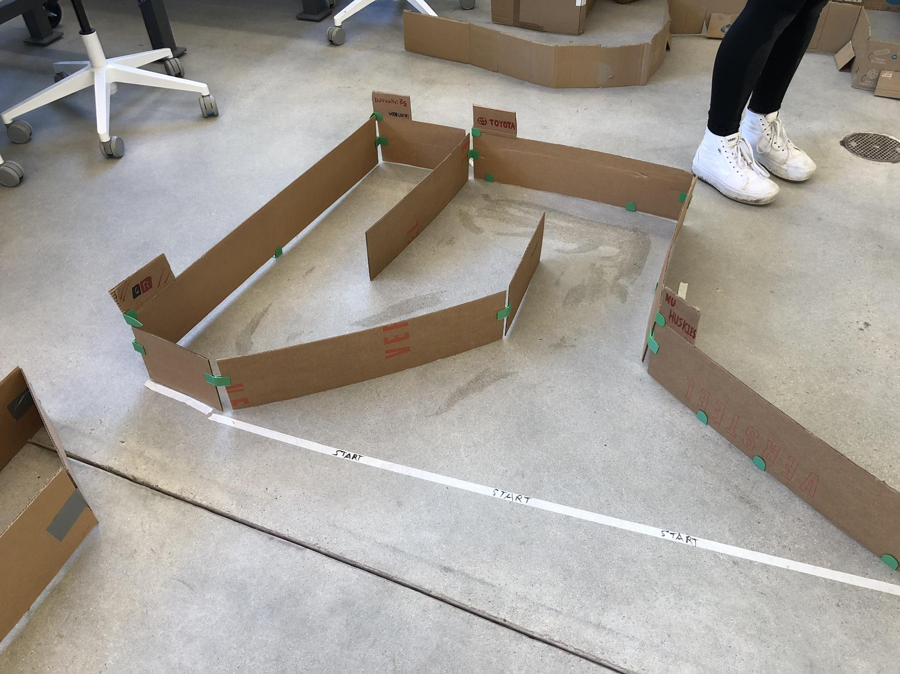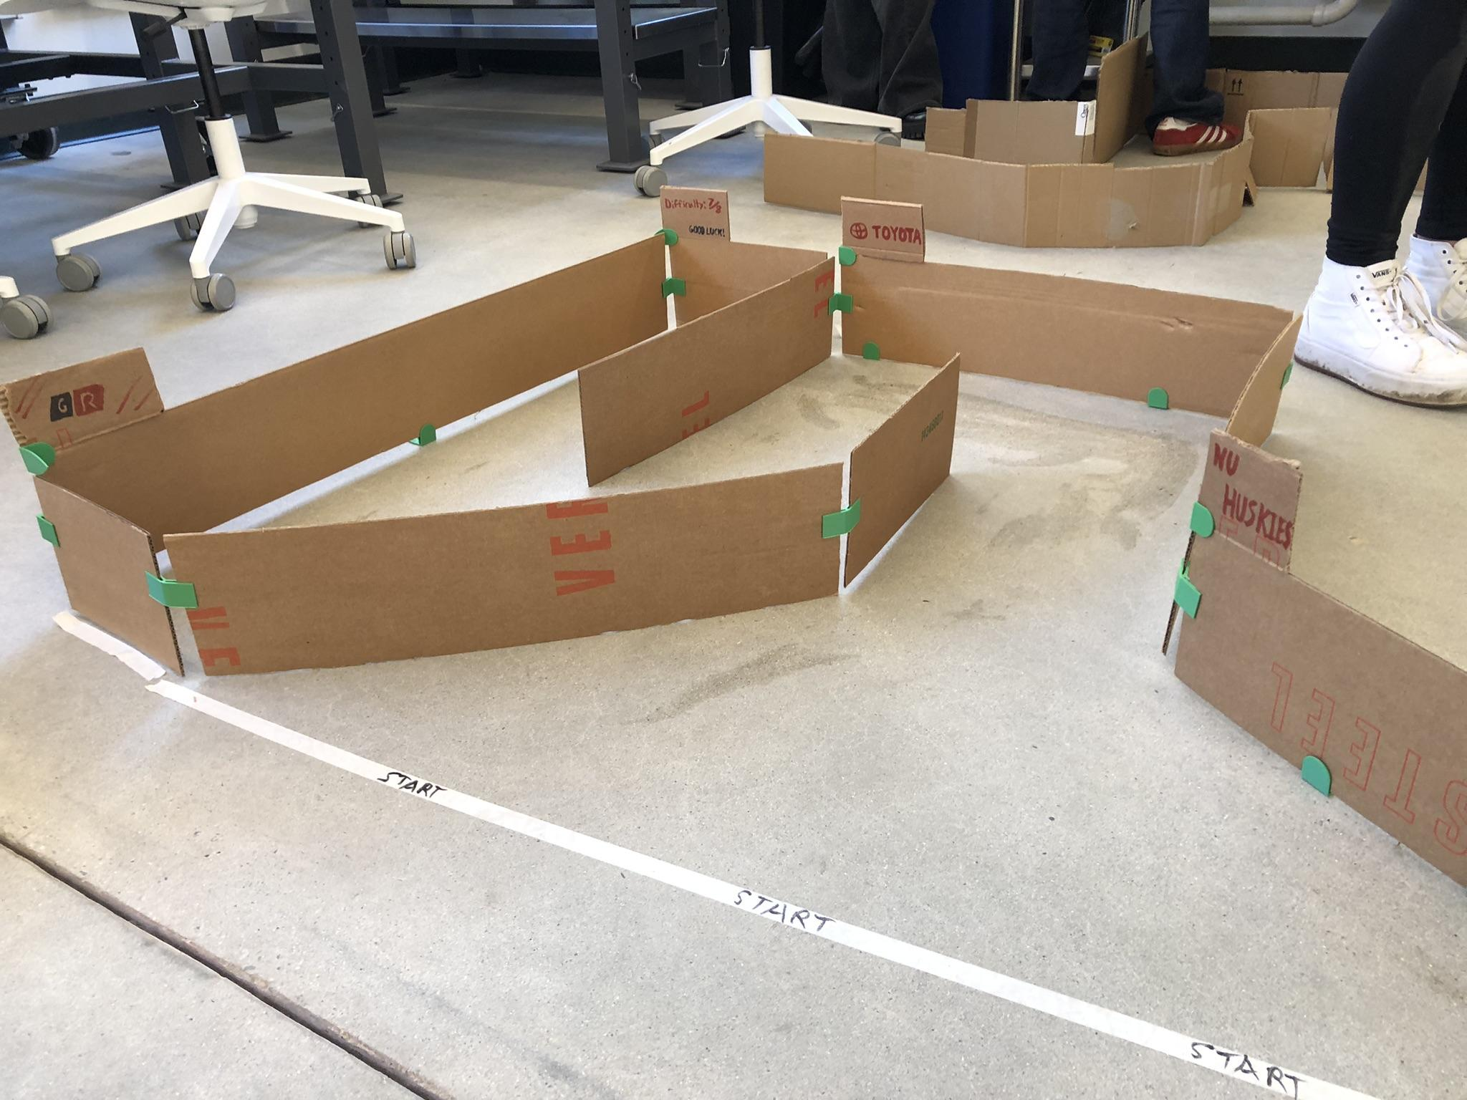
Final Version of Team Toyota’s Robot! Team Toyota’s Modular Maze (Above Front View) Team Toyota’s Modular Maze (Close Front View)

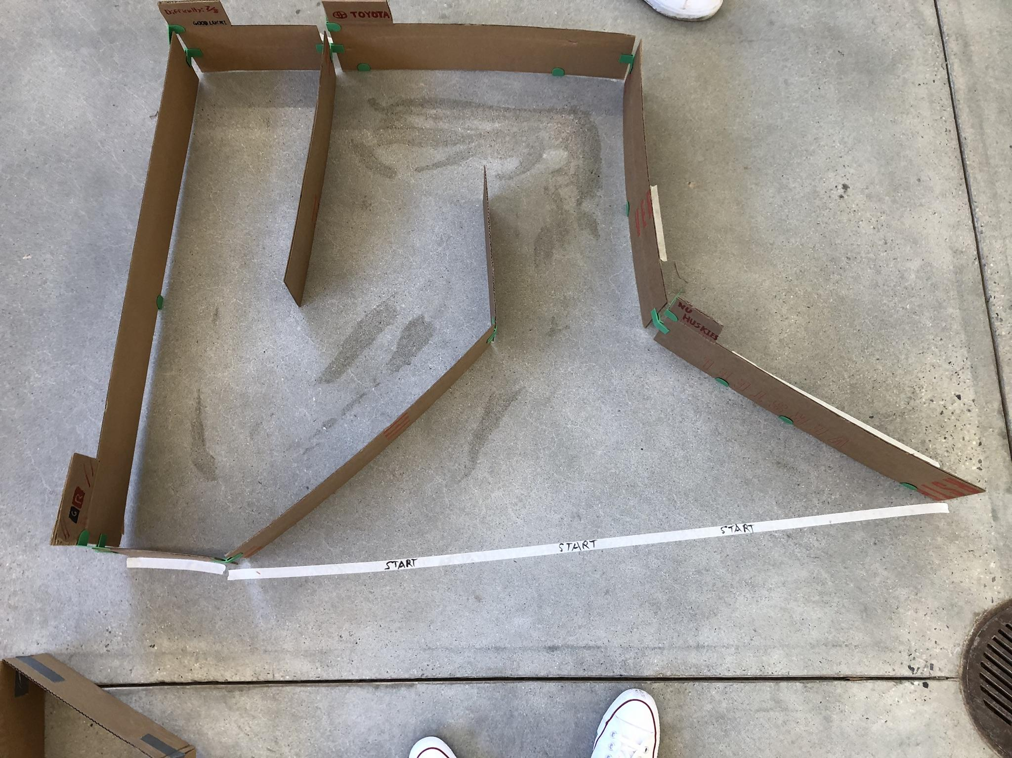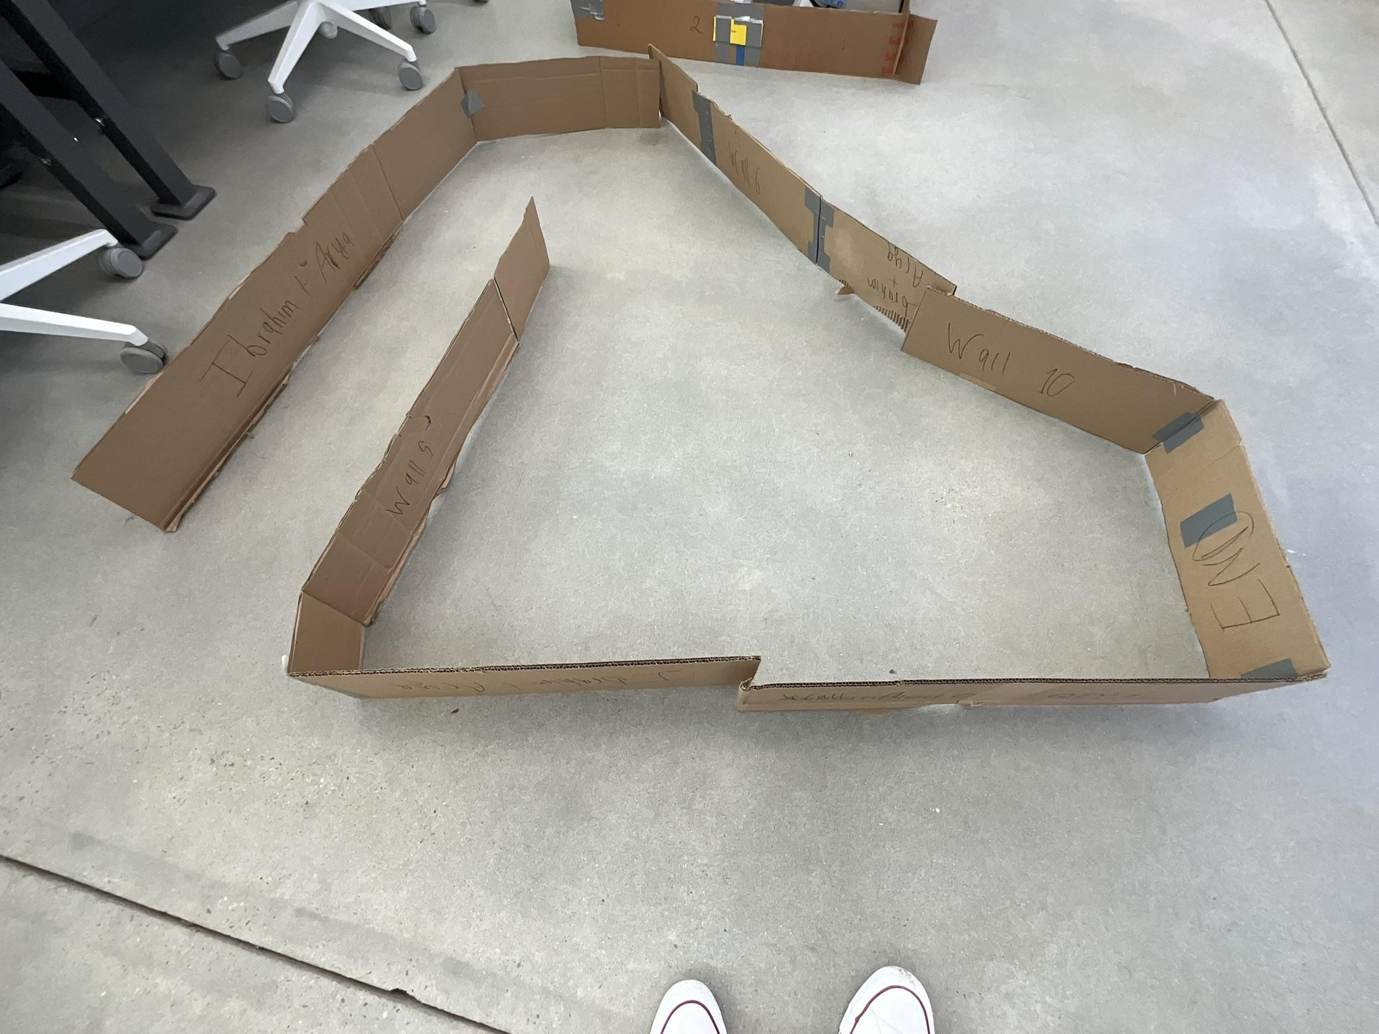
Team Toyota’s Modular Maze (Top View) Assigned Maze Before Fixes by Creators.

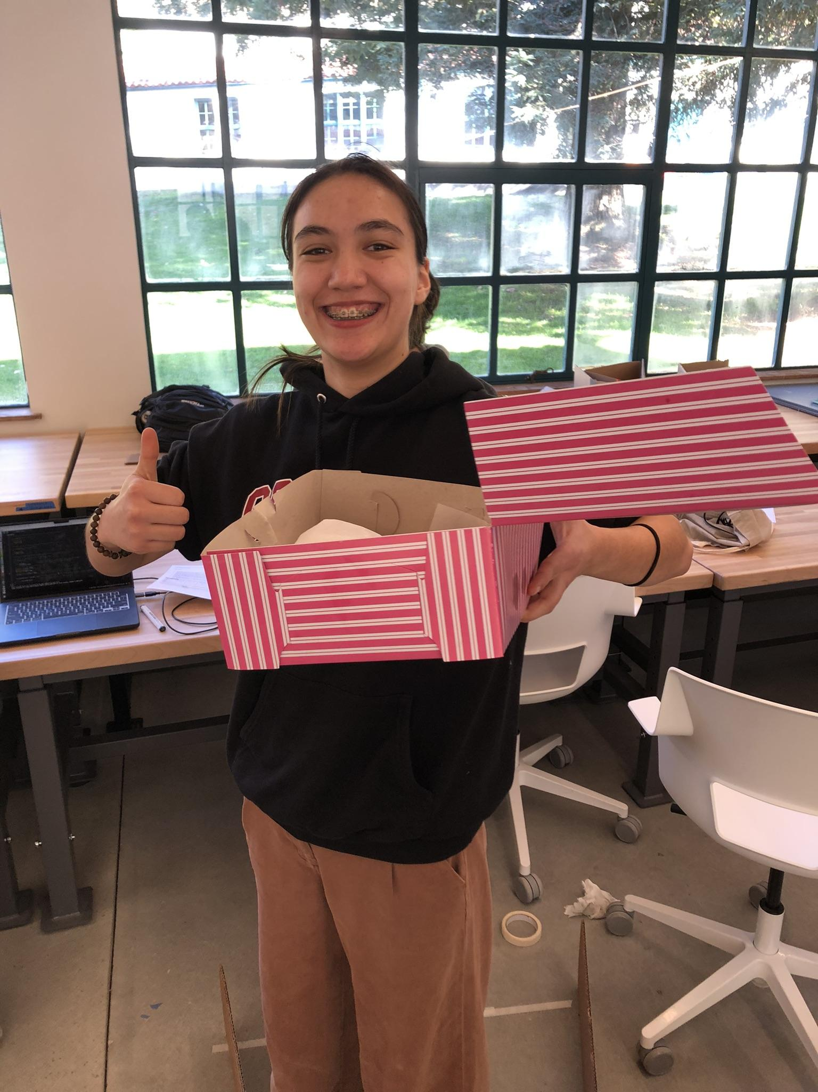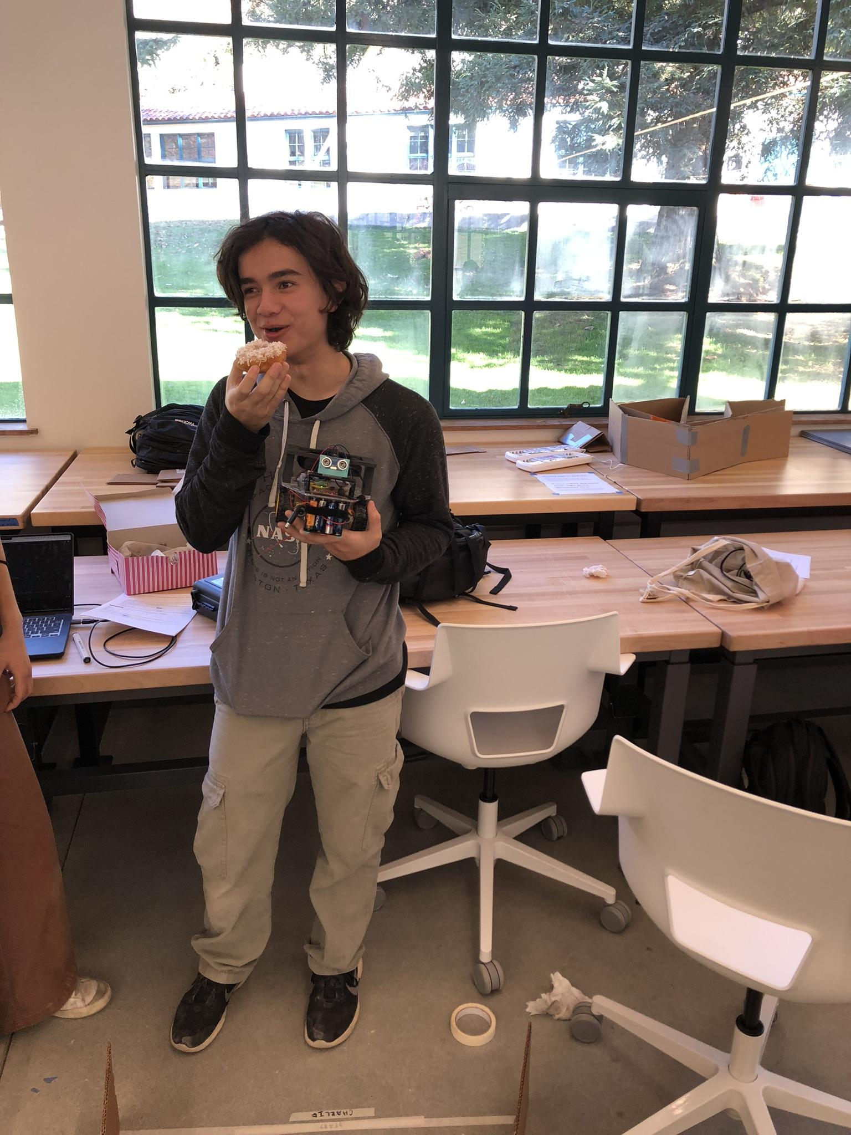
Doughnuts From English Class! Nolan Leonhardt Enjoying A Doughnut

What did I work on today?
Arriving on the final day of class in Cornerstone of Engineering One, Team Toyota was excited to see if the robot could face the difficult challenge at hand.
To begin, Nolan Leonhardt assembled the maze (using a few newly printed and improved connector pieces) as it had been designed and tested in previous work sessions. Following an announcement that there must be both the team name and maze difficulty written on the maze, Owen Cutler started the process of grading the maze. Due to factors like the number of turns, variety of turns, presence of no right angle walls, and varying width of the maze; Team Toyota’s maze received a difficulty score of seven out of eight. This meant that the maze would be among the most difficult of the mazes created in this semester. With the score determined, Owen Cutler created signs that included both the team name and the maze difficulty; some signs were designed to resemble those of Toyota motor sports ads that are typically placed around race tracks, referencing Toyota’s long history in motorsport.
Having assembled the team’s track, the next step was receiving our assigned maze and choosing a maze.
The set of mazes determined, Team Toyota set off on running the team robot through the mazes. Starting with the team’s own maze it required a number of runs to get a final submission worthy attempt. Frustratingly, due to a few factors, the highest score we were able to achieve was three out of five possible points. Due to the fact that the robot required a few minor redirections and had a small collision with the walls of the maze, some points were deducted, leaving us with three points. Second, the team attempted to run the robot through our assigned maze. While initial tests appeared to be more successful than our own maze runs had been, the team was informed that the maze was incorrectly set up. Frustrated but determined, Team Toyota was able to obtain a similar score to the first maze; three out of five points, due to the need for minor reductions by team members and a collision with a maze wall. Finally, the attempt of the team choice maze. Struggling with the first two mazes the goal was to find a simpler maze to complete. While simpler the team still struggled with completing this maze, having to make major redirections. It wasn't until Nolan Leonhardt chose a different maze that Team Toyota was able to complete Robot Challenge Four; receiving three out of five points on each of the attempted mazes.
In closing of the last Team Toyota meeting, team members stepped back from the chaos of the demonstration day and recognized the work that went into the robot. Although unable to achieve a perfect score the class day was ended with doughnuts brought by fellow student, Claire Montegut.

Record Group Meetings (if any):
ChatGPT4 was utilized to assist in the creation of a portion of the following bullet point summarization.
- Owen Cutler, Nolan Leonhardt
- Minutes:
  - Assembled the maze using newly printed and improved connector pieces.
  - Graded the maze with a difficulty score of 7 out of 8 based on factors like the number of turns, variety of turns, presence of no right angle walls, and varying width.
  - Designed signs to display the team name and maze difficulty, with reference to Toyota motorsports.
  - Began running the team robot through the mazes.
  - Ran attempts through Team Toyota’s own maze to begin.
  - Achieved a final score of 3 out of 5 points on the team’s own maze, due to redirections and a small collision.
  - Attempted to run the robot through the assigned maze.
  - The assigned maze was set up incorrectly. Maze is fixed by the team that designed the maze.
  - Scored 3 out of 5 points despite some redirections and a collision.
  - Attempted a maze chosen by Team Toyota.
  - Struggled on the first maze, despite a low difficulty score. Received 3 of 5 points.
  - Choose to submit the second team choice maze run.
  - Attempted to run the robot through a new maze. Higher difficulty, but received the same score.
  - Ended the meeting reflecting on the effort put into the robot, despite not achieving a perfect score.
  - The meeting concluded with doughnuts brought by Claire Montegut.

- Action Items:
  - Task: Assemble the maze using printed connector pieces.
    - Assigned to: Nolan Leonhardt
    - Status: Completed
- Task: Grade the maze and determine difficulty score.
  - Assigned to: Owen Cutler
  - Status: Completed
- Task: Create signs with team name and maze difficulty.
  - Assigned to: Owen Cutler
  - Status: Completed
- Task: Run the robot through the team’s own maze to achieve a final submission.
  - Assigned to: Team Toyota
  - Status: Completed
- Task: Run the robot through the assigned maze.
  - Assigned to: Team Toyota
  - Status: Completed
- Task: Choose and attempt a simpler maze to complete Robot Challenge Four.
  - Assigned to: Team Toyota
  - Status: Completed
- Task: Reflect on the work done and conclude the final meeting.
  - Assigned to: Team Toyota
  - Status: Completed

What will I work on next time?

- Task: Celebrate and Reflect, Cornerstone One Robot Project has Nearly Concluded
  - Assigned to: Owen Cutler, Nolan Leonhardt
  - Status: Not Started

12/02/24 | New Code | Nolan Leonhardt

Today's main project goal is to write a new code in order to complete our own maze and any maze that contains 45 degree turns in addition to 90 degree turns. The other goal is to test it. This is due to our previous code only being able to solve mazes that only contain 90 degree turns.

Planned tasks list:
- Write the new code
- Run a simple test of the code

Resources needed to complete the tasks
- Nolan Leonhardt
- Room
- Laptop
- Robot
- Cable

Useful reference links: List any link related to today’s work
- Team Toyota's Final Code
- 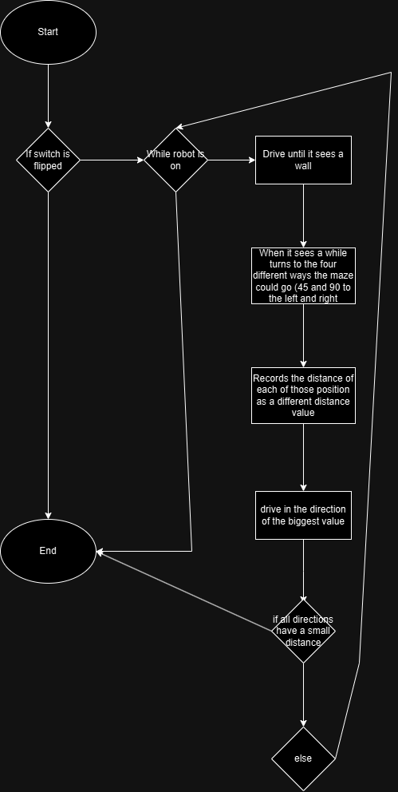

What did I work on today?
Today I worked on writing the new code for the robot in order to complete challenge four in addition to running a simple test to ensure the code would run during the demo day. I started by first figuring out what I needed the code to do which was to be able to detect 45 degree turns. This made me have to rethink how I did the previous code. I decided that the simplest way to do this was to have the robot look at all four possible turn locations after hitting a wall. After turning to the position, the code records the distance that the ultrasonic sensor reads. After it stores the value for all four possible directions, it then compares the values to find out which distance is the farthest away whilst also being over 8 inches away, if it happens to be the end of the course. It then tells the robot to go forward in that direction and the whole code repeats until it comes to a dead end. After writing it, I ended up testing it a bit in the makerspace until it closed to figure out the turn values for each turn. This concludes today’s work.
Record Group Meetings (if any):
- Attendees: Nolan Leonhardt
- Minutes:
  - Planned out how the robot should solve the maze so I could translate it into code
  - wrote out the base code and checked to see if it compiled and worked.
  - tested the code on the robot within my hands to make sure it worked as intended
  - tested it on the floor of the classroom to figure out the specific time values for the turns.
- Action Items:
  - Task: plan out a new code that can solve our maze
    - Assigned to: Nolan Leonhardt
    - Status: Completed
  - Task: Write the new code
    - Assigned to: Nolan Leonhardt
    - Status: Completed
  - Task: Do initial tests of the code
    - Assigned to: Nolan Leonhardt
    - Status: Completed
What will I work on next time?
- Task: Test the robot within our maze and the other mazes in the class
  - Assigned to: Owen Cutler, Nolan Leonhardt
  - Status: completed

11/25/2024 | Designing, Revising, and Building Modular Maze | Owen Cutler

The goal of this session was to attach the newly created riser for an ultrasonic sensor to the Team Toyota Robot and test the sensor to ensure that no new issues arise with the riser’s use.

Planned tasks list:
- Design Modular Maze.
- Build Modular Maze.
- Test Team Toyota Robot in Modular Maze.

Resources needed to complete the tasks
- Owen Cutler
- Maker Space Classroom
- Maker Space
- IPad
- Apple Pencil
- Charged Laptop
- Phone to take photos and videos
- 3D Printed Maze Stands
- CardBoard
- Precision Knife
- Cutting Mat
- Pen
- Ruler

Useful reference links: List any link related to today’s work

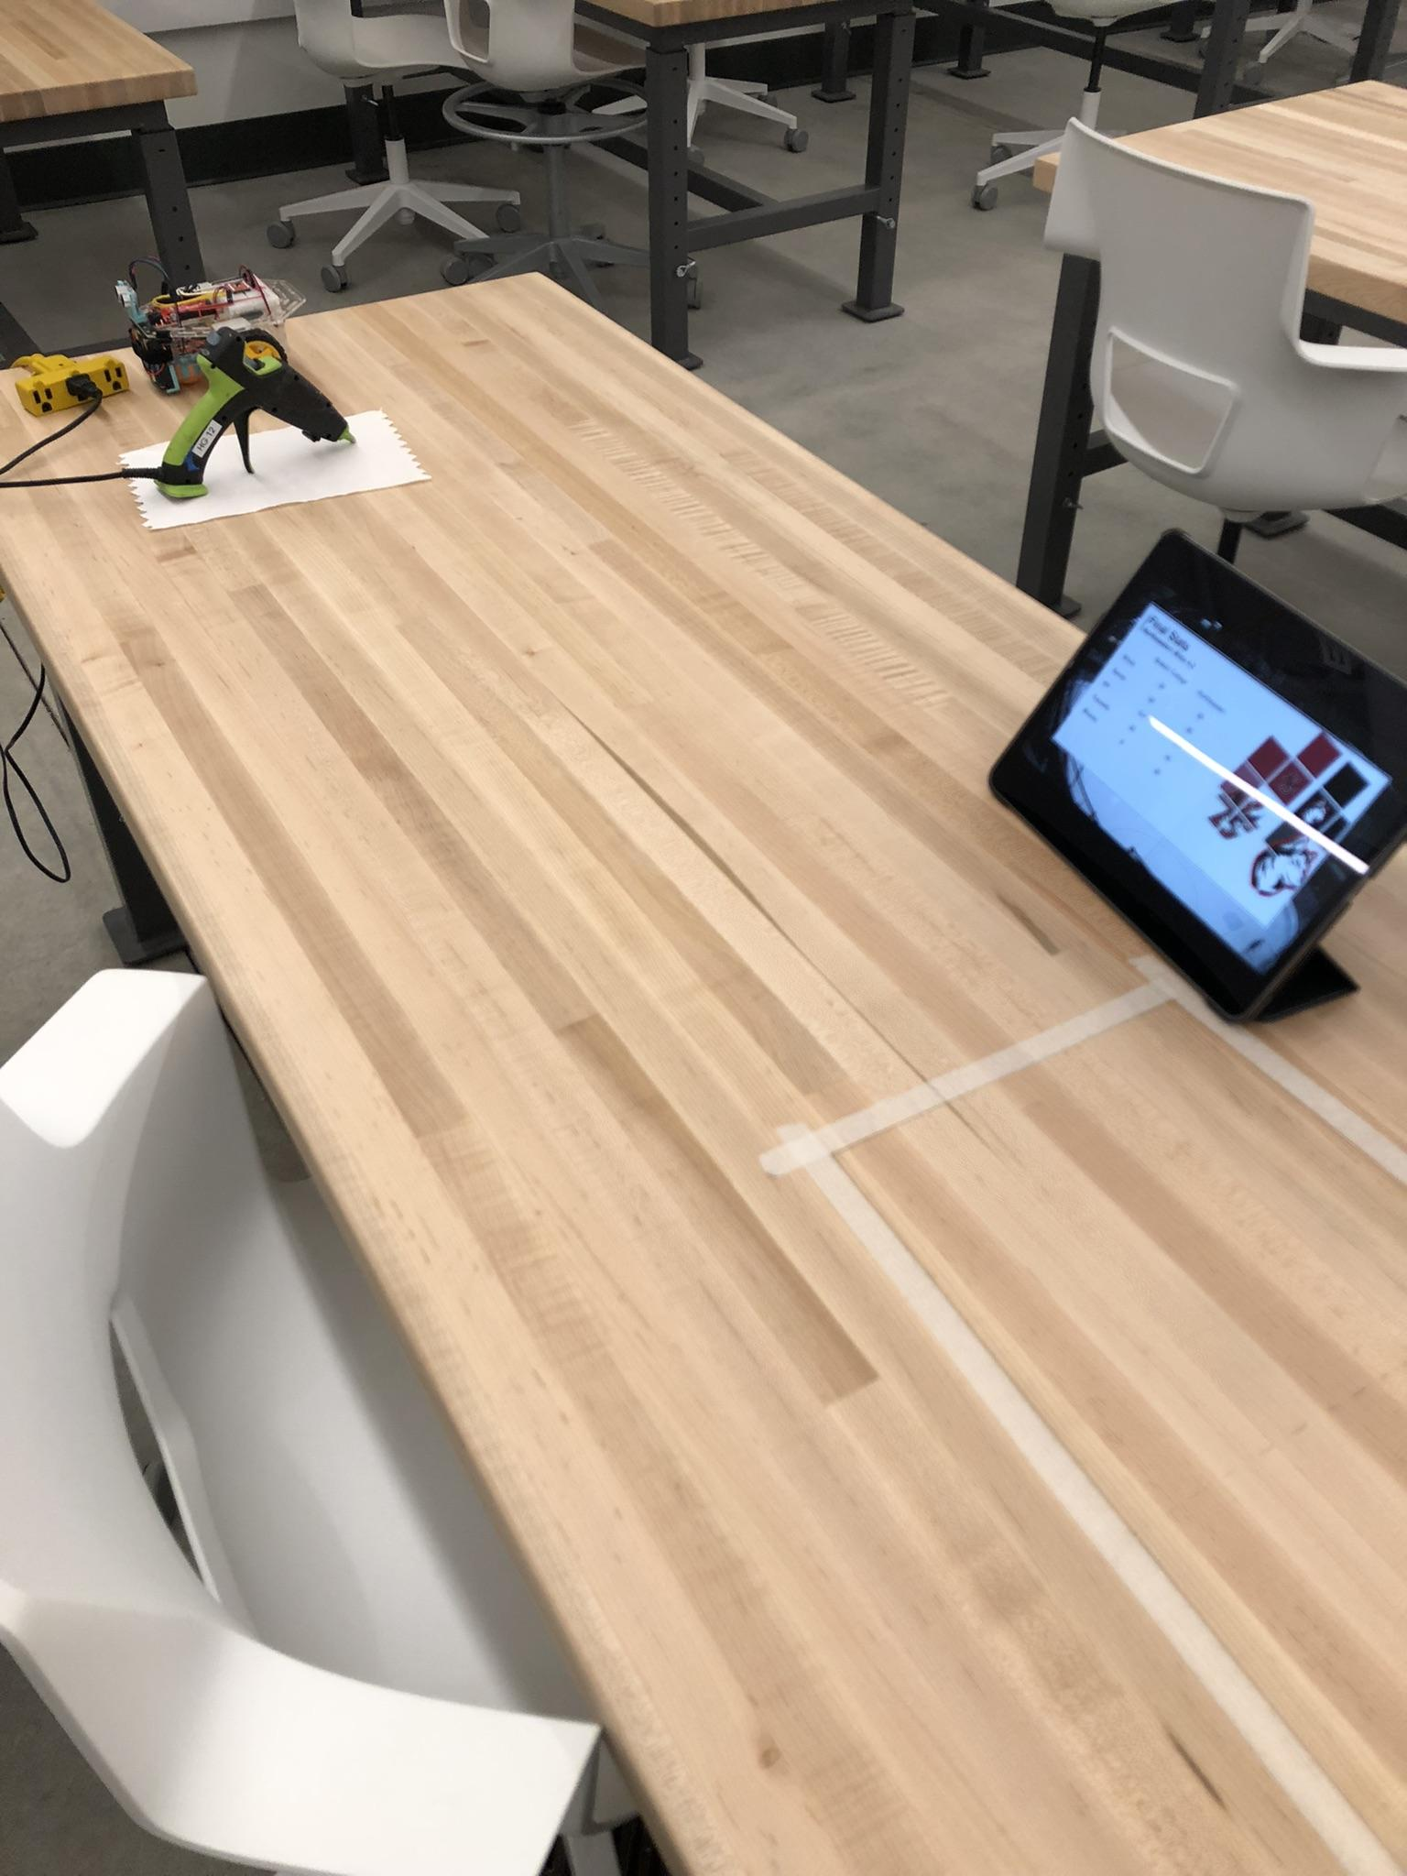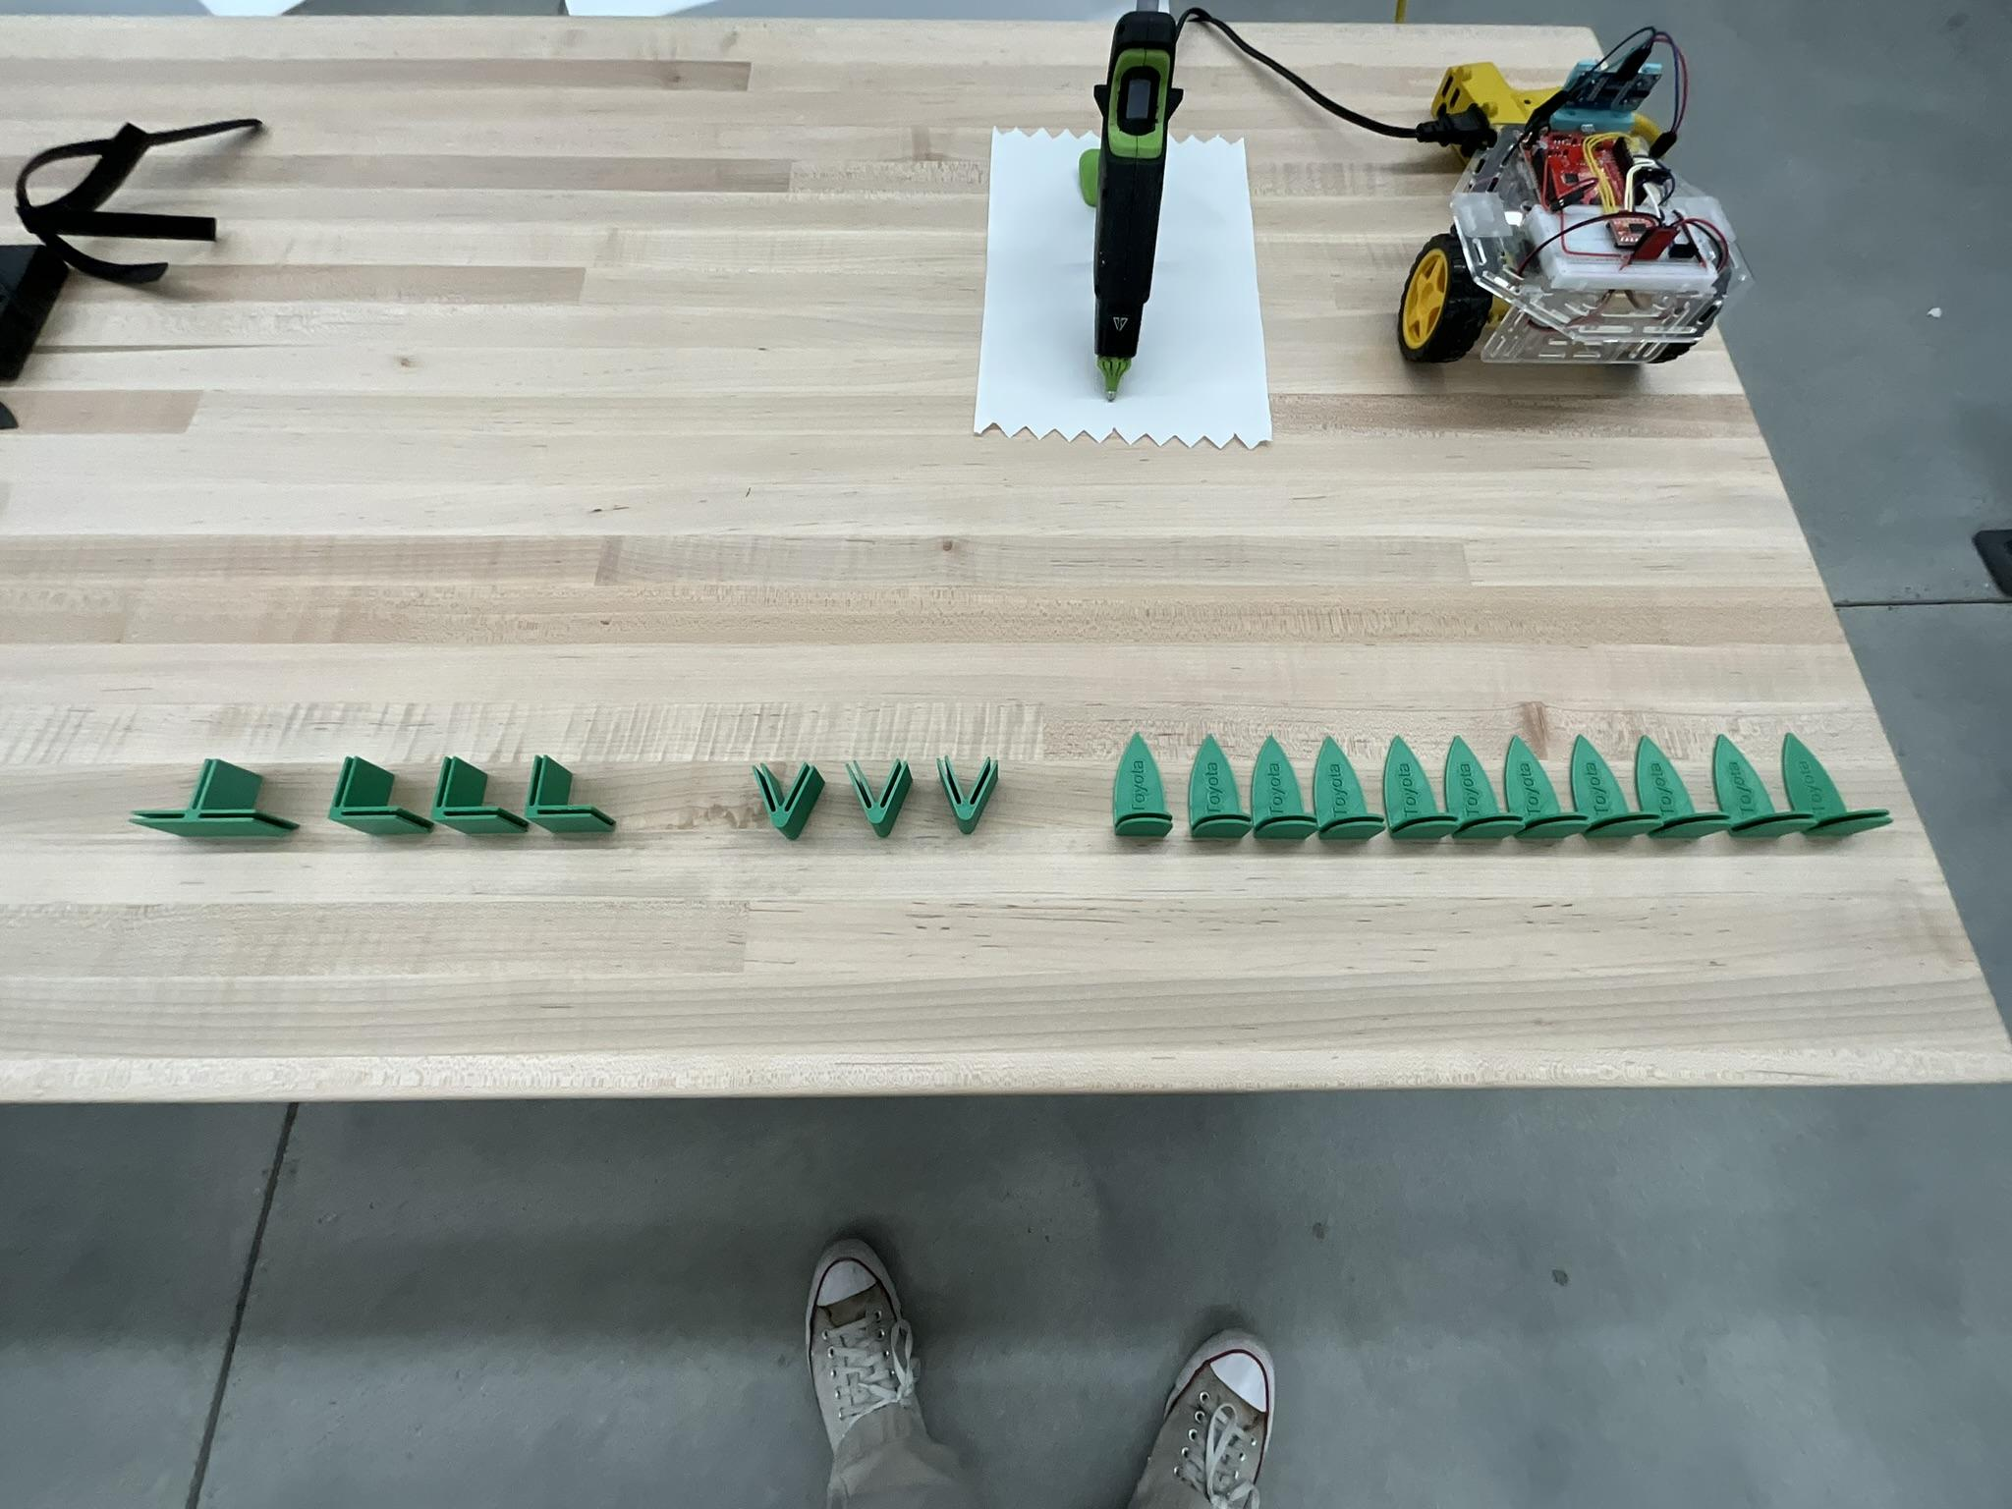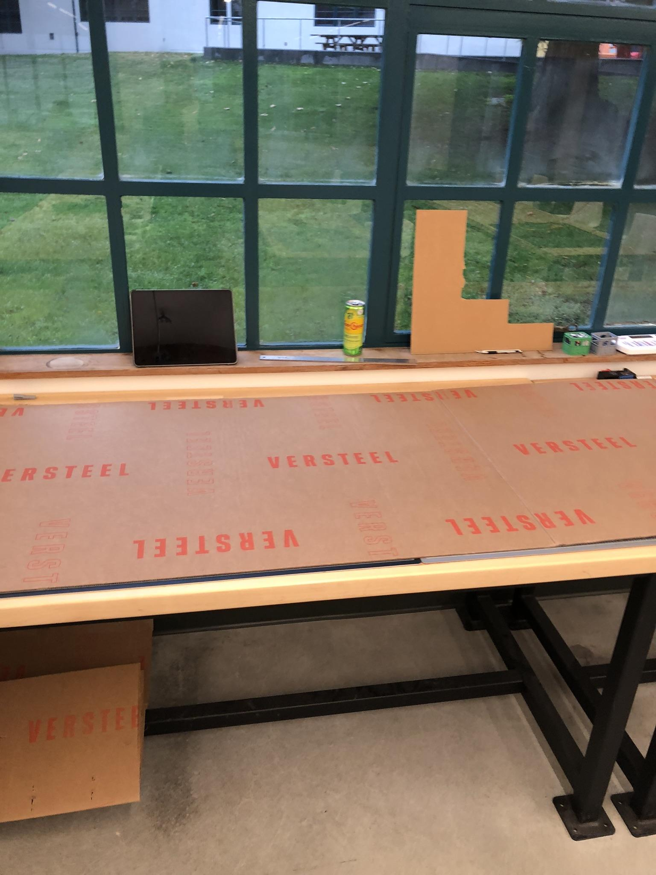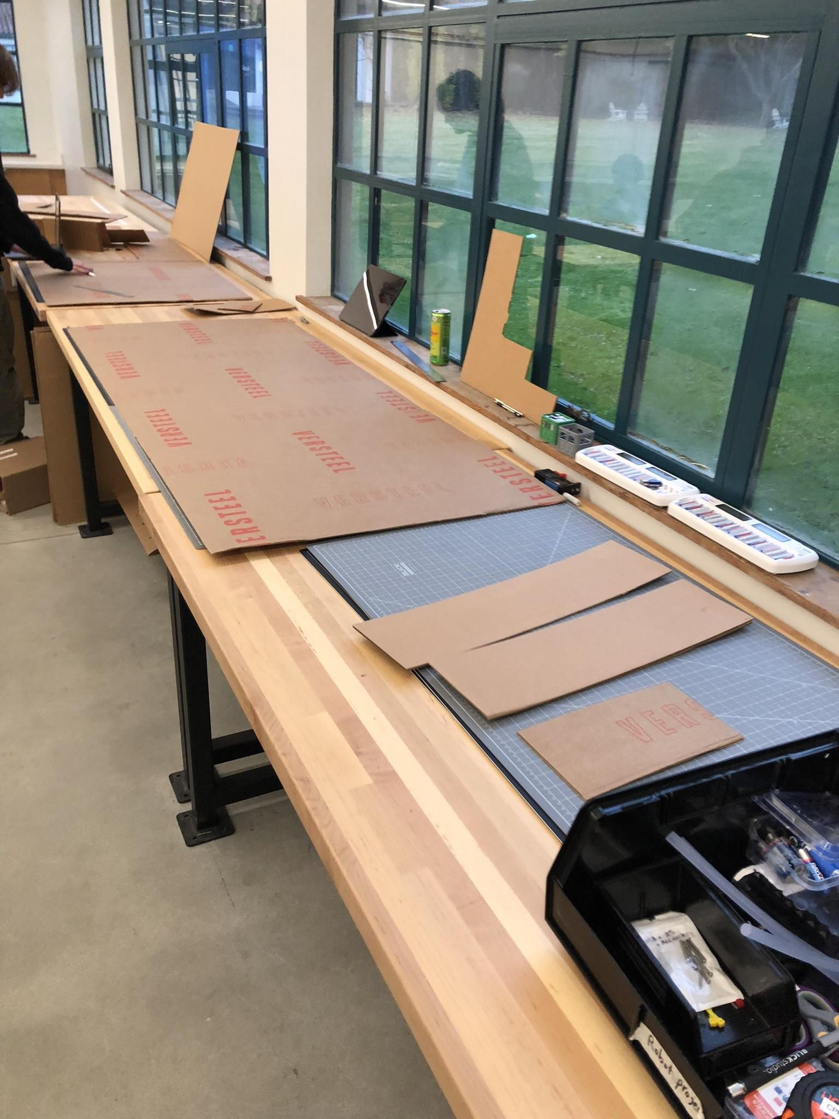
Watching Northeastern Hockey 3D Printed Stand / Connecting Pieces For Maze Cardboard Before Cutting Cutting Cardboard For Maze

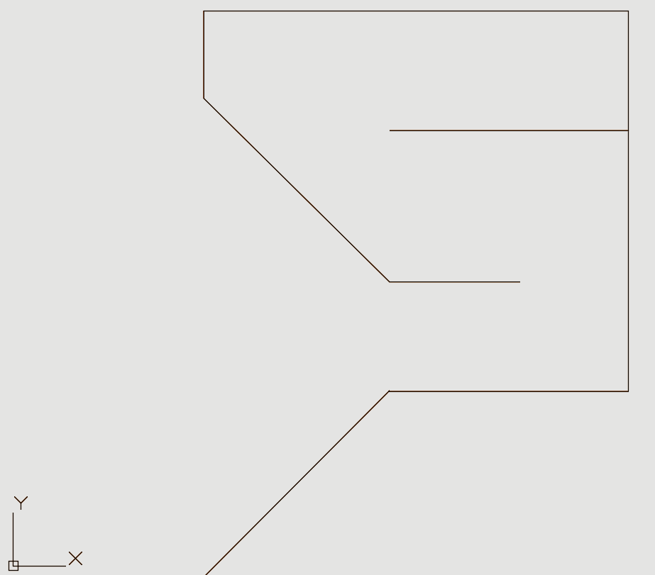
Modular Maze Line Design

What did I work on today?
Working quickly the day before our Thanksgiving break began, this session was held in the maker space classroom.
First came designing Team Toyota’s modular maze for the upcoming Robot Challenge Four in class demonstration day. Both team members agreed that we wanted to create a difficult maze, even if it was challenging for our own team’s robot to complete. The idea that was reached as a team was to use walls at a 45 degree angle. This would add an obstacle that no teams had had to face before this upcoming challenge. There were some ideas of a very long straight part of the maze also brought up when brainstorming; however, being conscientious of the size of the maze we opted for a more compact design.
This brainstorming session led to the final design. It begins with a wide opening, flanked by two walls set at a 45-degree angle that converge into a narrower passage. This leads to a left 90-degree turn, followed by a shorter straight section, then another left 90-degree turn. Next, a straight path leads to a 45-degree angled wall directing the way to the right, followed by a short straight stretch that ends at a flat wall, prompting a right 90-degree turn. Finally, a longer straight path leads to a dead-end finish. All portions of the design were checked to ensure there was at least ten inches of maze width for the robot.
To build this, Owen Cutler had to cut cardboard pieces that were all six inches tall and a variety of lengths; the needed lengths were specified by the design created in AutoCAD. Using a ruler and fine tip pen, the pieces were drawn out on cardboard and then cut using a precision knife.
Using the cardboard maze walls and 3D printed connectors/stands, designed by Nolan Leonhardt, the maze was assembled for the first time. Following a planned cursory check that the maze resembled the design, testing began using the Team Toyota robot. While difficult for our robot, the team ended the session knowing that improvements were needed to the design and programming of the robot, but a difficult and unique maze had been created as desired.

Record Group Meetings (if any):
ChatGPT4 was utilized to assist in the creation of a portion of the following bullet point summarization.
- Owen Cutler
- Minutes:
  - Discussed and planned the design for the team's modular maze.
  - Decided on creating a difficult maze.
  - Settled on using walls at a 45-degree angle as a unique obstacle, not previously used in other assignments.
  - Brainstormed a long straight section but opted for a more compact design to save space.
  - Finalized the maze design.
  - Cut the maze walls from cardboard, following the lengths specified in AutoCAD and using a ruler and precision knife for accuracy.
  - Assembled the maze using the cardboard walls and 3D printed connectors/stands.
  - Conducted a cursory check to ensure the maze resembled the design.
  - Began testing with the Team Toyota robot, noting that the maze was difficult for the robot to navigate.
  - Ended the session with the understanding that improvements to both the maze design and robot programming were necessary, but the maze was successfully created as intended.

- Action Items:
  - Task: Design Team Toyota’s modular maze for Robot Challenge Four.
    - Assigned to: Owen Cutler, Nolan Leonhardt
    - Status: Completed
- Task: Create maze walls at a 45-degree angle to increase difficulty.
  - Assigned to: Owen Cutler
  - Status: Completed
- Task: Assemble the maze using cardboard walls and 3D printed connectors.
  - Assigned to: Owen Cutler
  - Status: Completed
- Task: Ensure the maze resembles design.
  - Assigned to: Owen Cutler
  - Status: Completed
- Task: Conduct a cursory check to ensure the maze resembles design.
  - Assigned to: Owen Cutler
  - Status: Completed
- Task: Test the robot in the maze.
  - Assigned to: Owen Cutler
  - Status: Completed
- Task: Assess the robot’s performance and identify improvements needed in design and programming.
  - Assigned to: Owen Cutler
  - Status: Completed

What will I work on next time?

- Task: Complete Additional Testing of Team Robot in Modular Maze
  - Assigned to: Owen Cutler, Nolan Leonhardt
  - Status: Not Started
- Task: Program Robot For Challenge 4.
  - Assigned to: Nolan Leonhardt
  - Status: Not Started

11/23/2024 | Implementing and Testing Sensor Riser | Owen Cutler

The goal of this session was to attach the newly created riser for an ultrasonic sensor to the Team Toyota Robot and test the sensor to ensure that no new issues arise with the riser’s use.

Planned tasks list:
- Check riser for any problems in assembly.
- Attach riser to team robot.
- Attach ultrasonic sensor to riser.
- Test that no new problems have arisen due to use of the riser.
- Test that there is sufficient clearance above the formerly blocked ports.

Resources needed to complete the tasks
- Owen Cutler
- Maker Space Classroom
- Team Toyota Robot
- Charged Laptop
- Ruler
- Phone to take photos and videos

Useful reference links: List any link related to today’s work

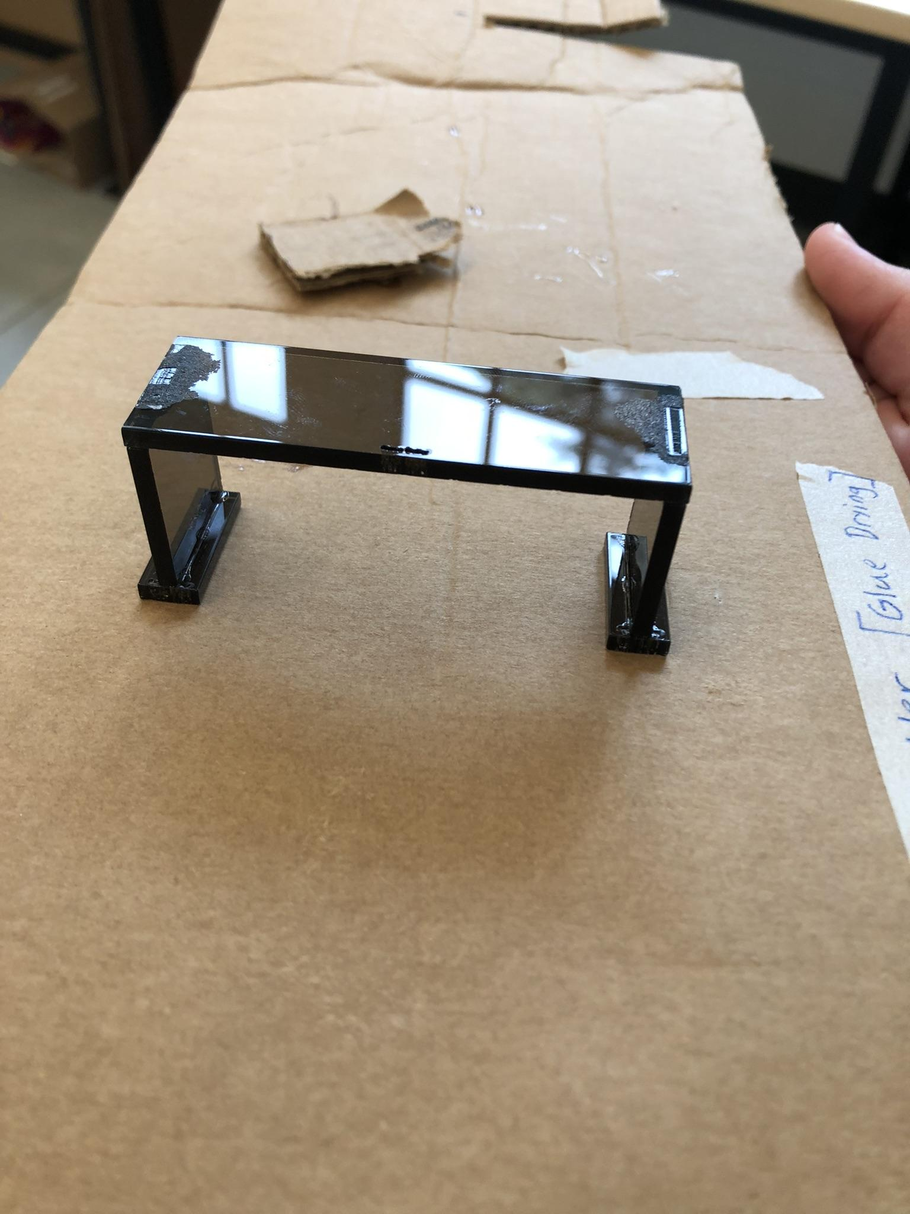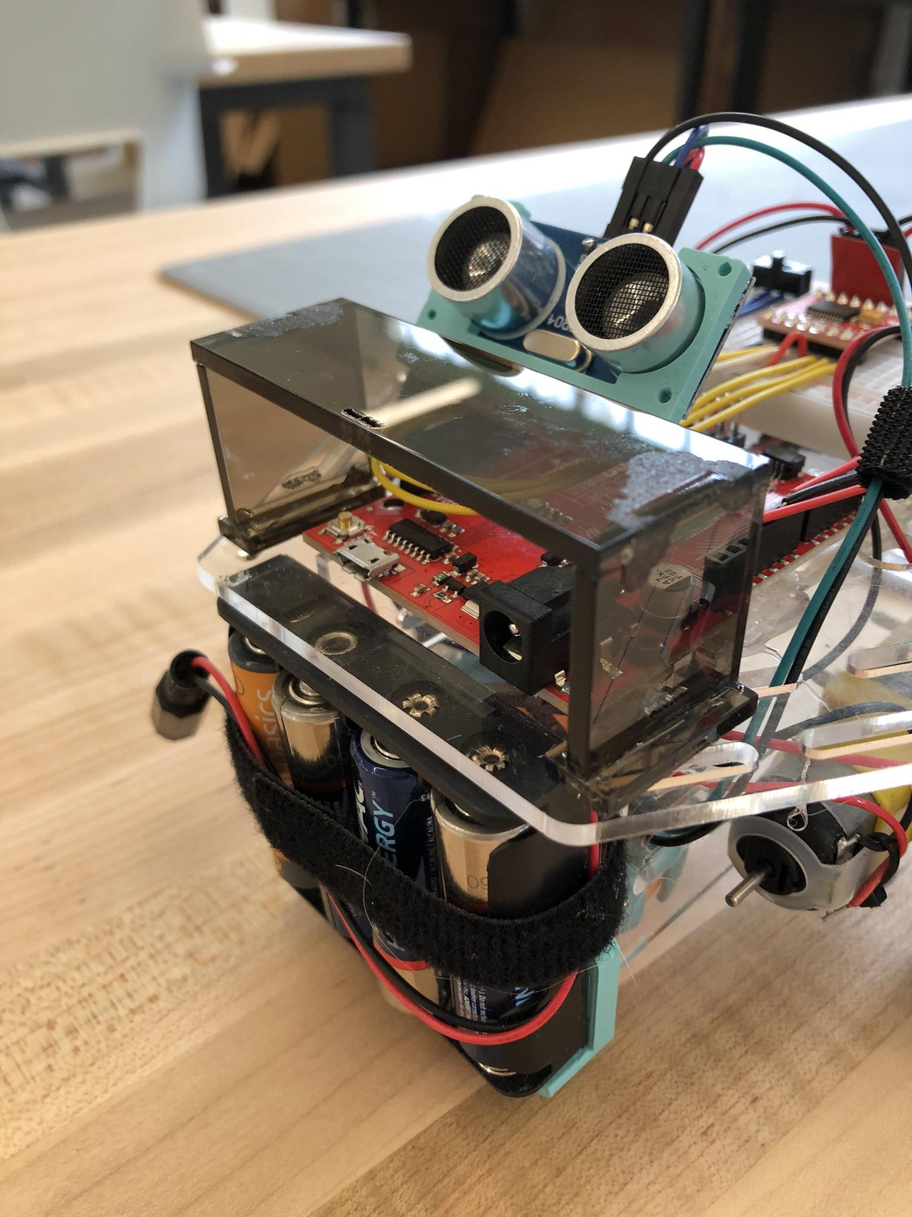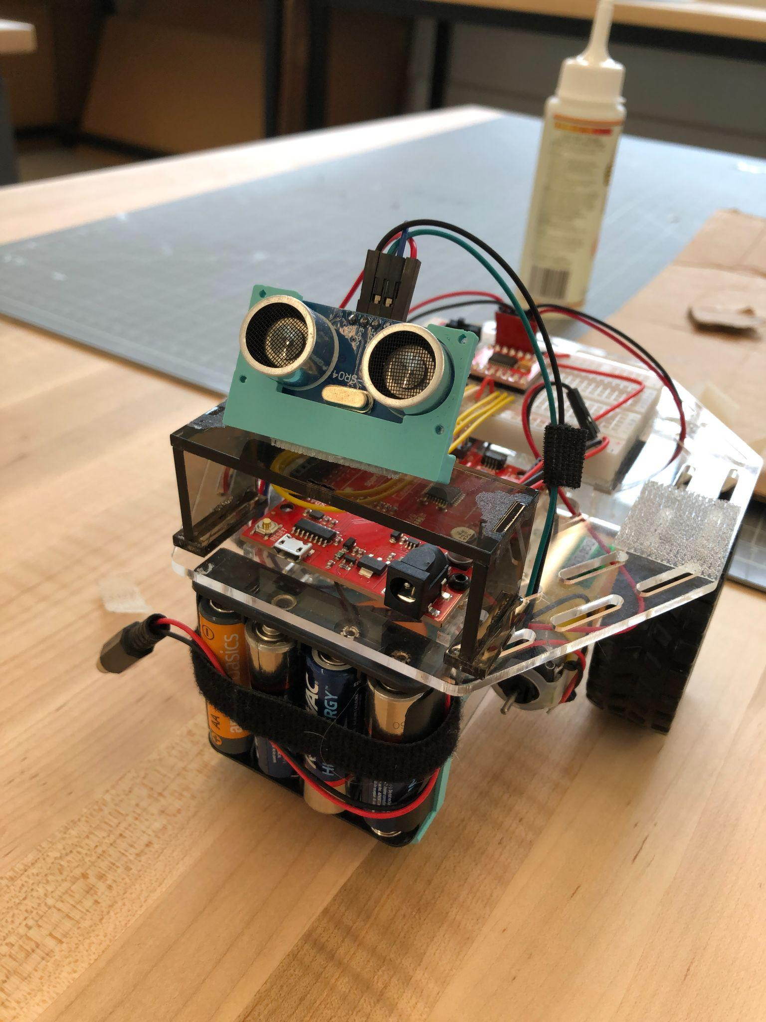
Assembled Riser Riser Attached to Robot Riser and Sensor Implemented

What did I work on today?
The session began by checking that the riser had correctly cured and didn't have any flaws in its assembly. Once this check had been completed, then the riser was attached to the top plate of the Team Toyota Robot in place of the ultrasonic sensor’s former mounting location. Dual sided tape was used to attach the riser to the top plate and the sensor to the riser.
With the riser and sensor attached to the robot, clearance below the riser was checked by attempting to plug both power and USB Type C into the RedBoard. The test was successful so the session moved on to ensuring that the robot still functioned as it did before the use of the riser. After running the robot through the Robot Challenge Three maze a handful of times, it was concluded that the riser had no noticeable impact on the functionality of the robot in use.

Record Group Meetings (if any):
ChatGPT4 was utilized to assist in the creation of a portion of the following bullet point summarization.
- Owen Cutler
- Minutes:
  - Checked riser for any flaws in its assembly.
  - No flaws in structure found.
  - Attach the riser to the robot's top plate.
  - Used double sided tape.
  - Attach the ultrasonic sensor to the riser.
  - Test access to RedBoard ports.
  - Test for impact on robot’s effectiveness in challenge maze.

- Action Items:
  - Task: Check that the riser had correctly cured and had no flaws in its assembly.
    - Assigned to: Owen Cutler
    - Status: Completed
- Task: Attach riser to the top plate of Robot, in place of the ultrasonic sensor’s former mounting location.
  - Assigned to: Owen Cutler
  - Status: Completed
- Task: Use dual-sided tape to attach the sensor to the riser.
  - Assigned to: Owen Cutler
  - Status: Completed
- Task: Test that the robot still functions as it did before the use of the riser.
  - Assigned to: Owen Cutler
  - Status: Completed

What will I work on next time?

- Task: Design Final Modular Maze for Challenge 4.
  - Assigned to: Owen Cutler
  - Status: Started
- Task: Build Modular Maze for Challenge 4
  - Assigned to: Owen Cutler
  - Status: Not Started
- Task: Program Robot For Challenge 4.
  - Assigned to: Nolan Leonhardt
  - Status: Not Started

11/22/2024 | Designing and Assembling The Sensor Mount | Owen Cutler

The goal of this session was to design a mount for the ultrasonic sensor that would move the sensor out from in front of the RedBoard’s power power and USB Type C ports. This meant coming up with a few possible solutions before then narrowing the options down to a single solution.

Planned tasks list:
- Define the problem with the way the ultrasonic sensor’s current mounting position.
- Draw possible solutions.
- Use Kepner-Tregoe Decision Analysis to find the best solution.
- Make any final changes to the design of the solution.
- Create the solution in AutoCAD with the provided template.
- Send CAD file to professor for Laser Cutting.
- Set glued pieces to dry for final implementation.

Resources needed to complete the tasks
- Owen Cutler
- Maker Space Classroom
- Team Toyota Robot
- Charged Laptop
- Ruler
- Phone to take photos and videos
- IPad to create drawings
- Laser Cutter
- Painters Tape
- Glue
- Cardboard

Useful reference links: List any link related to today’s work

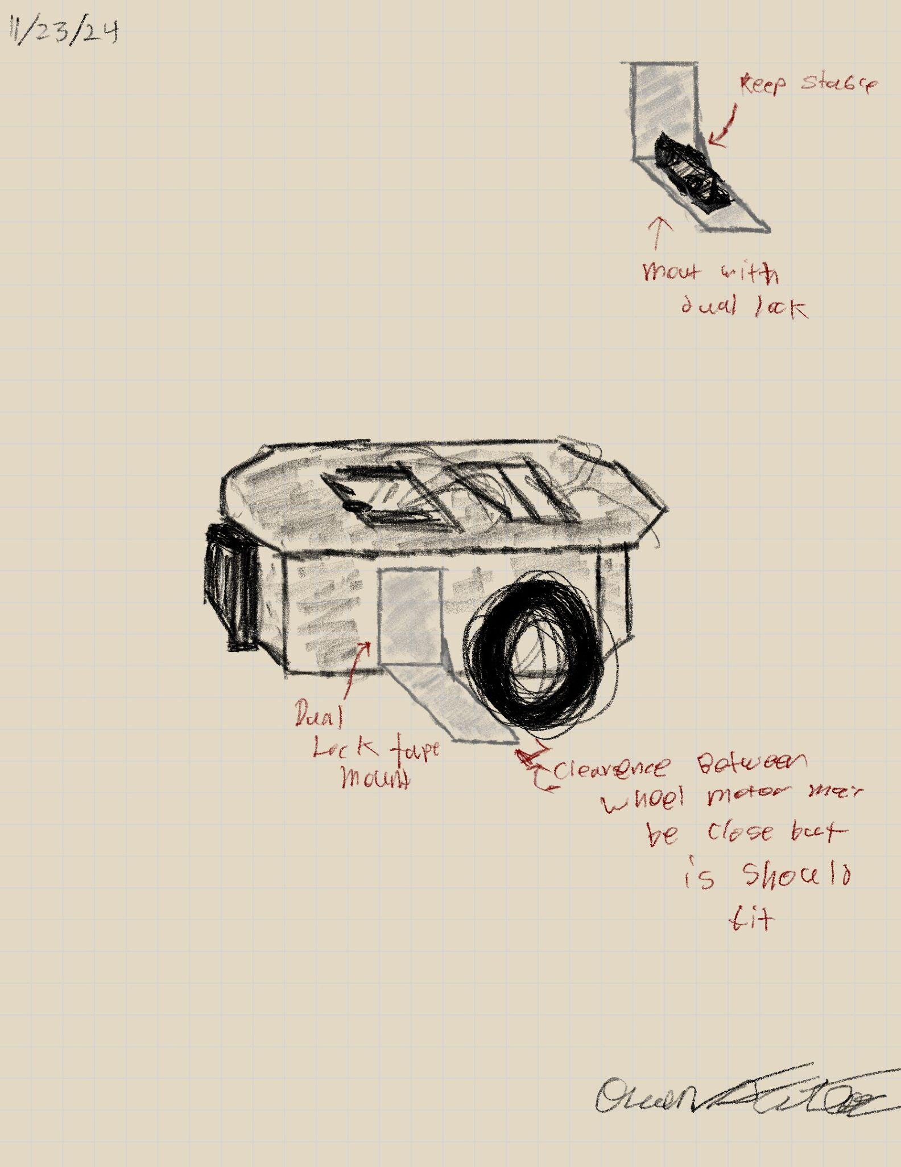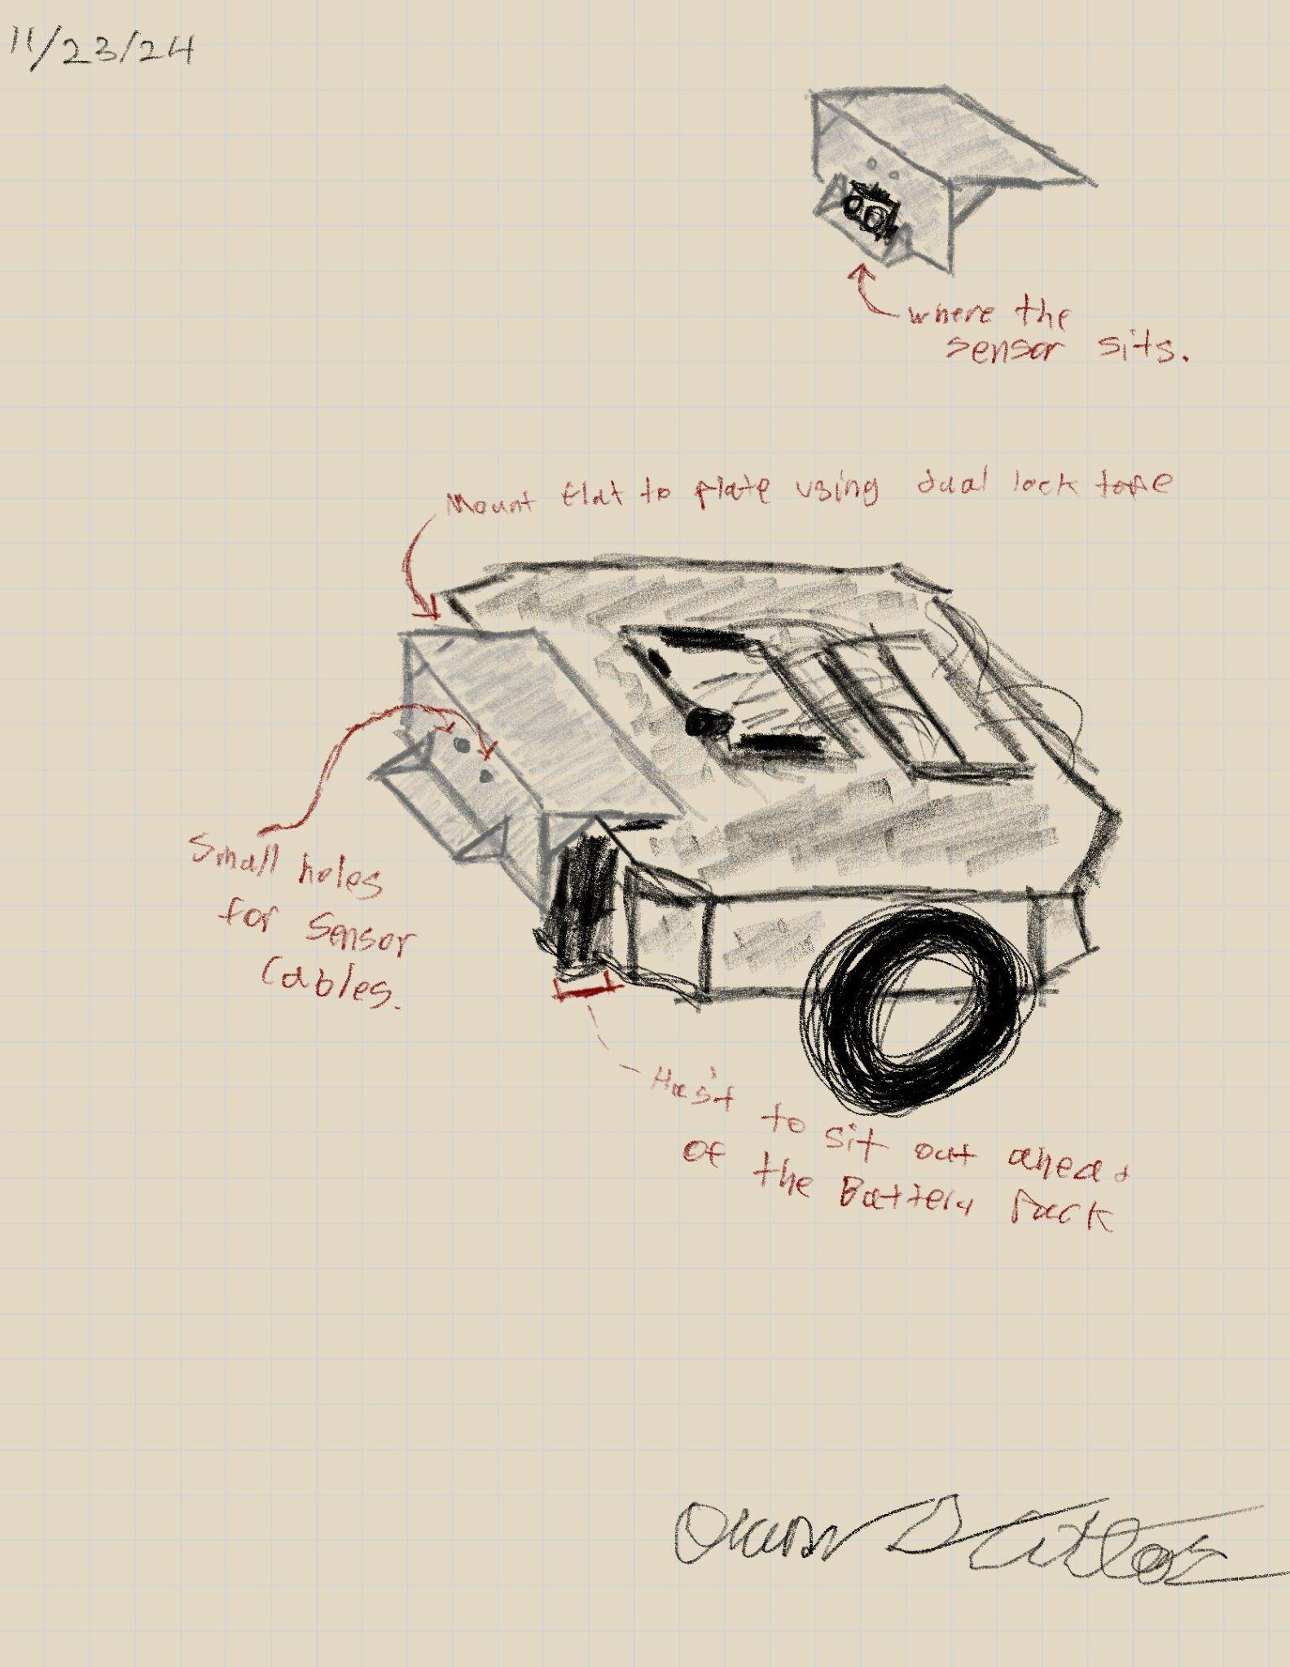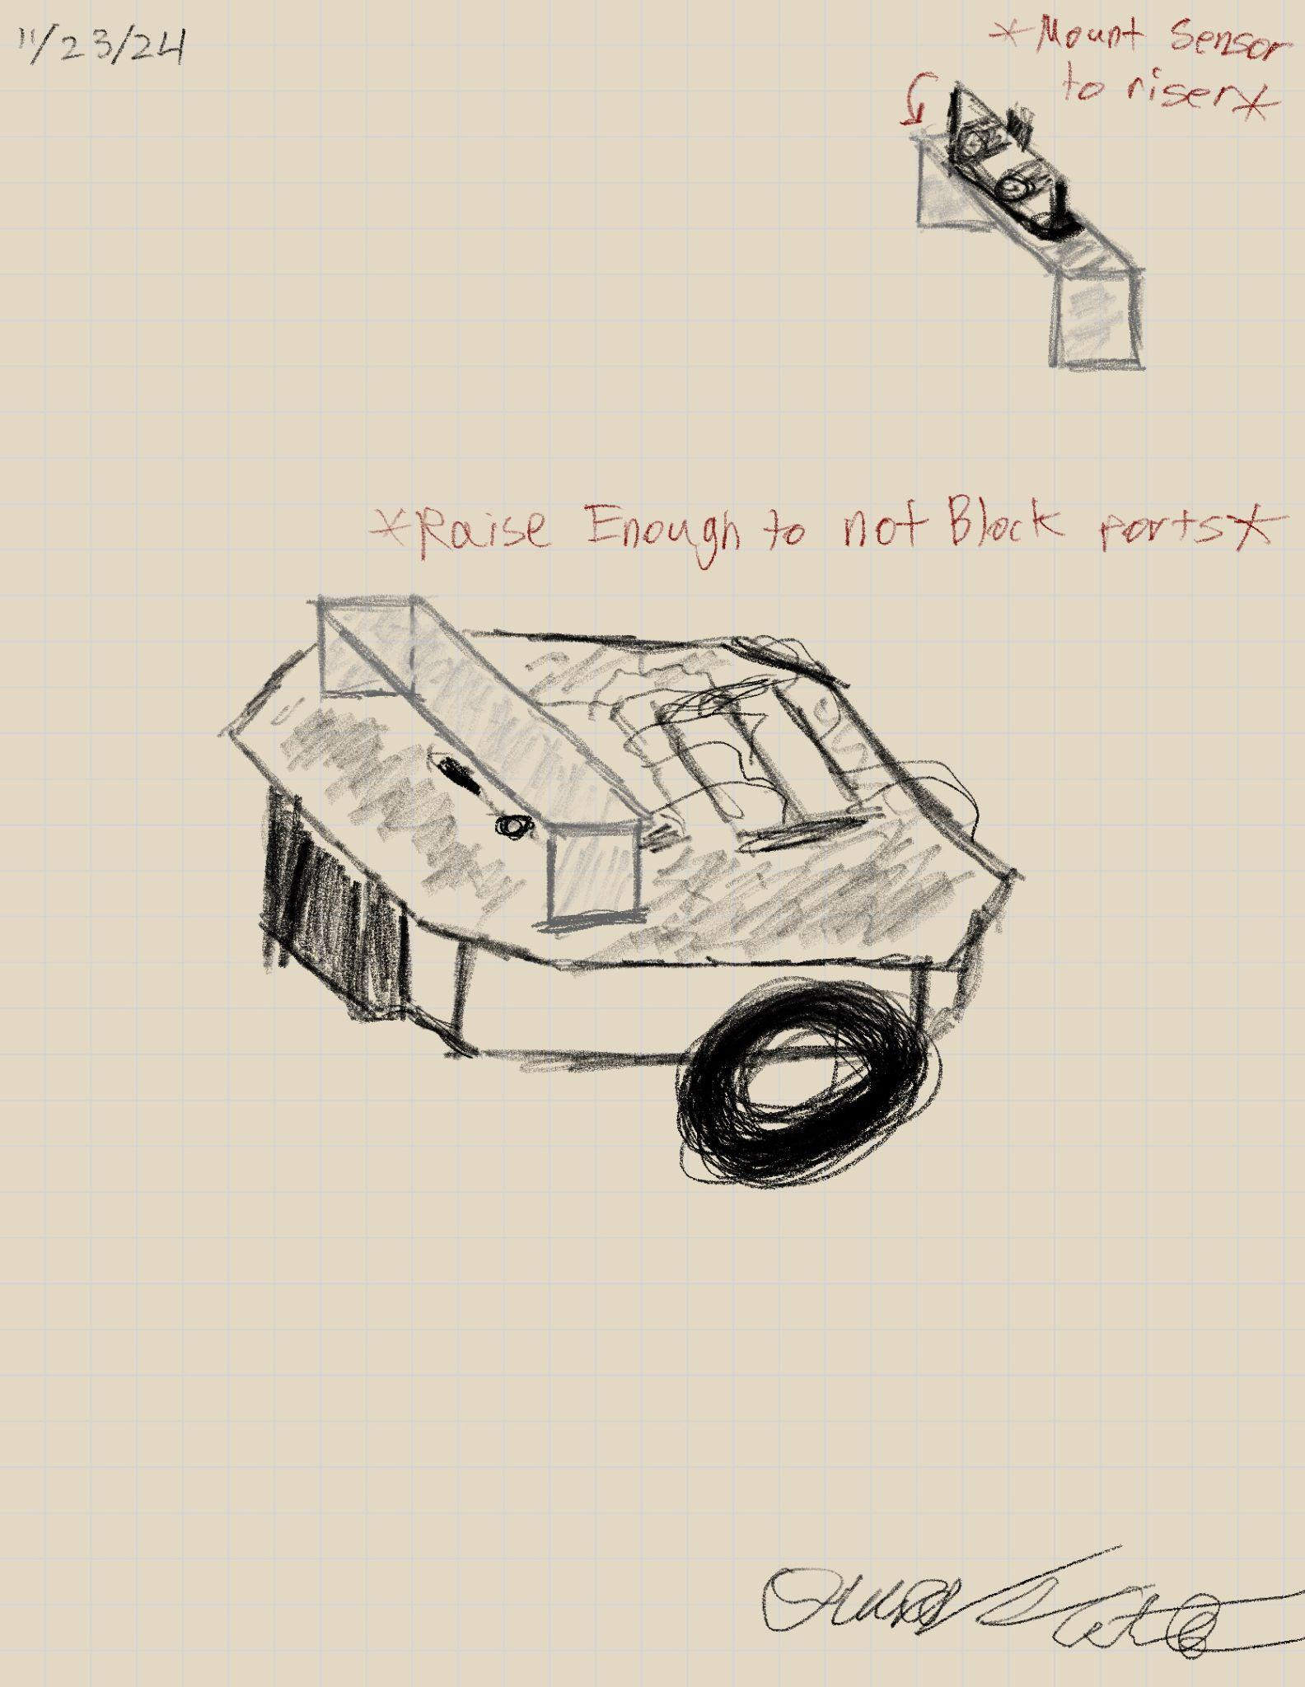
First Possible Solution Second Possible Solution Third Possible Solution (BEST)

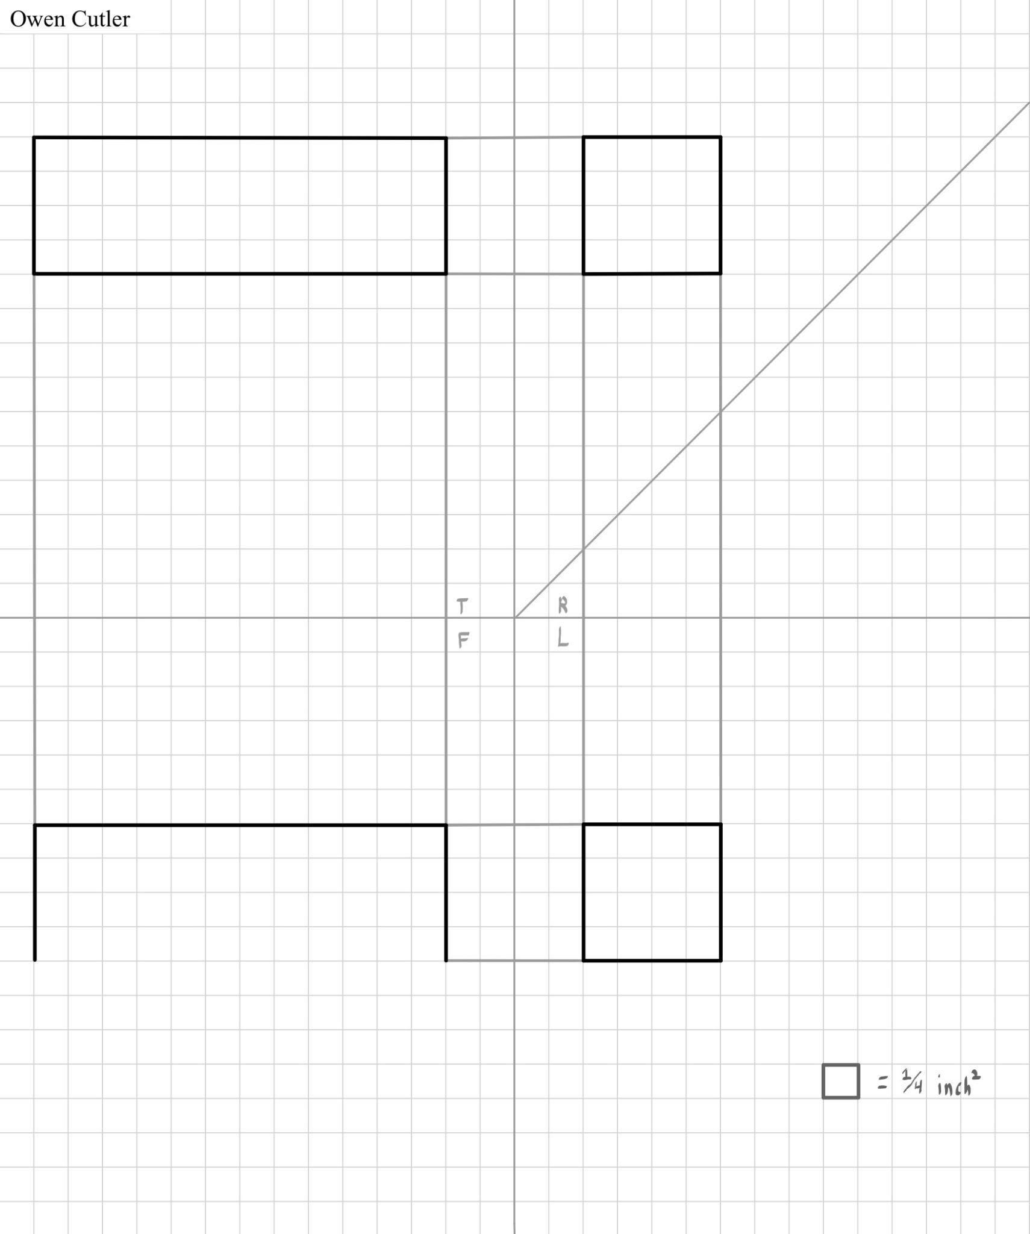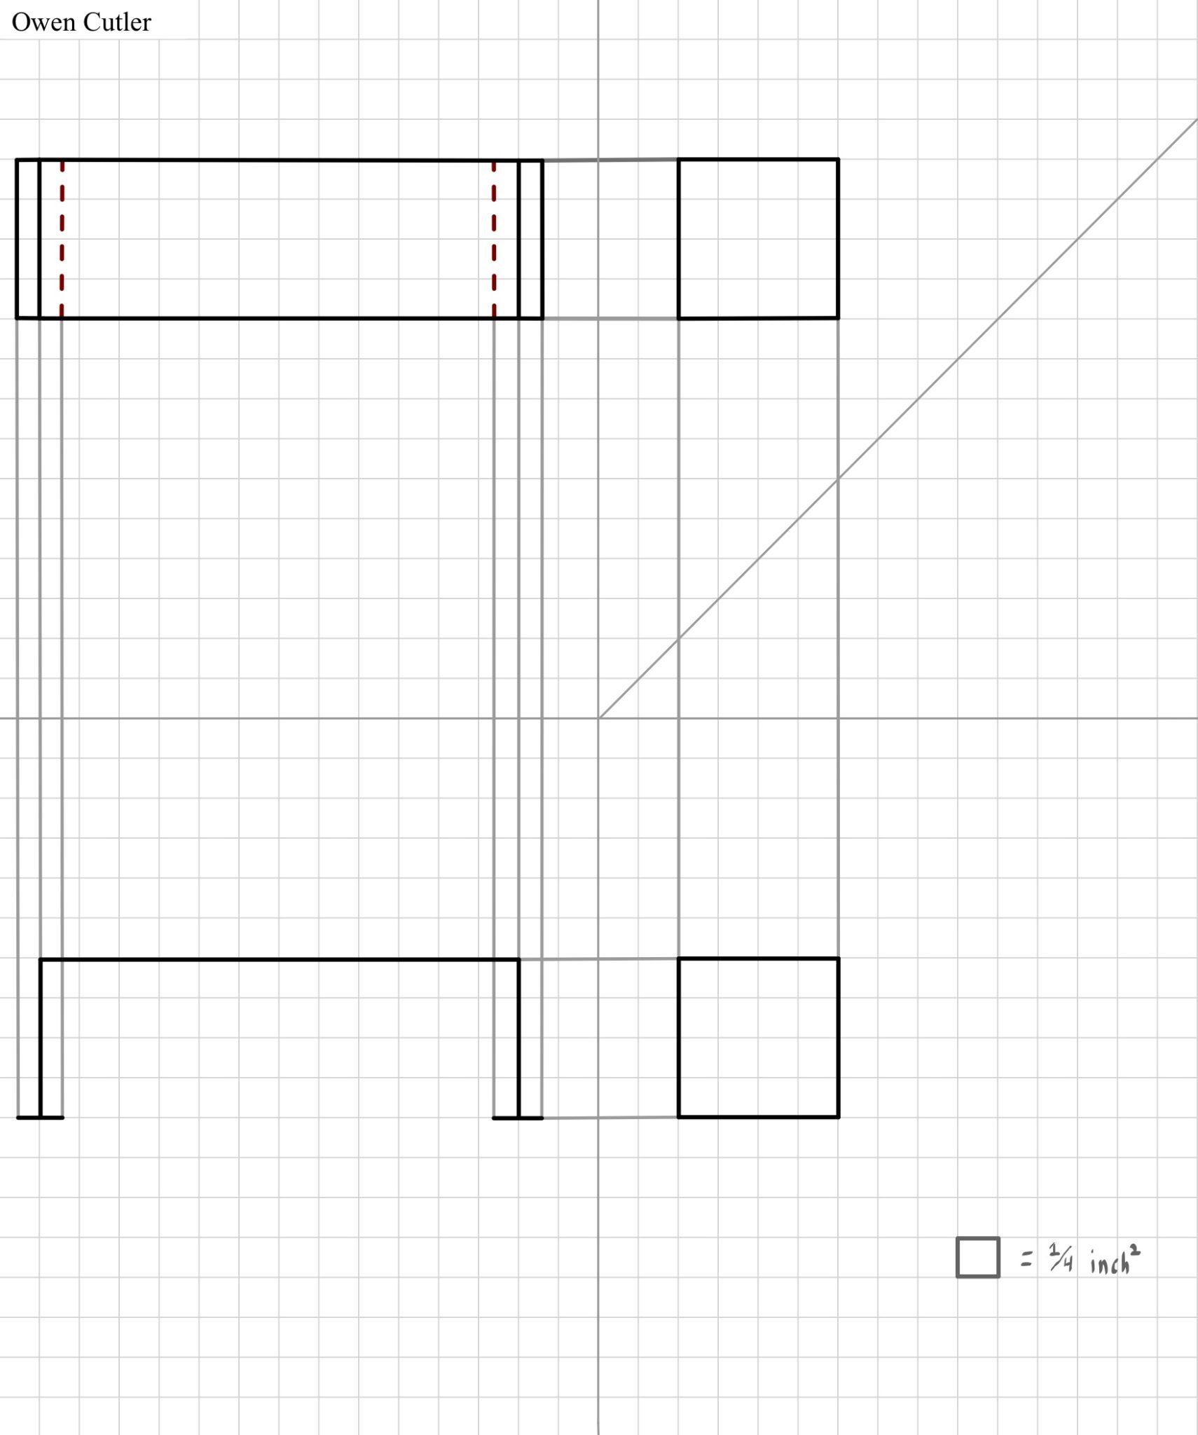
First Design of The Chosen Solution Second Revised Design of The Chosen Solution

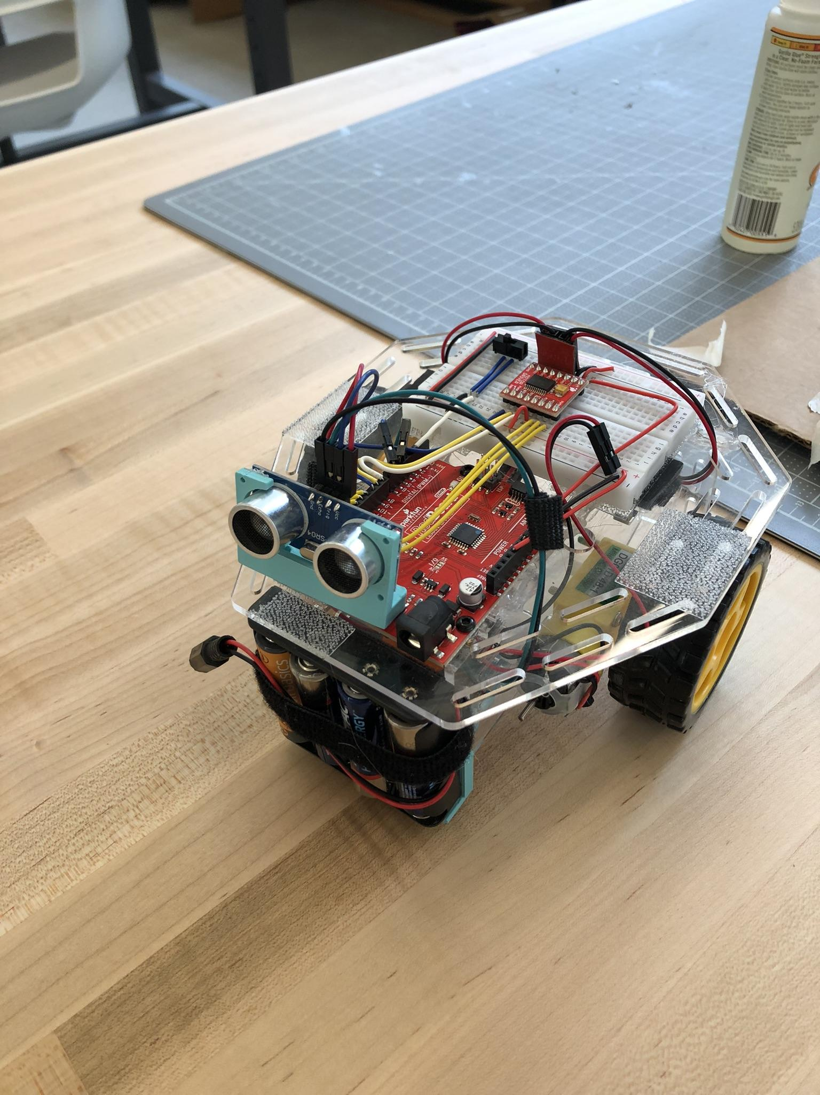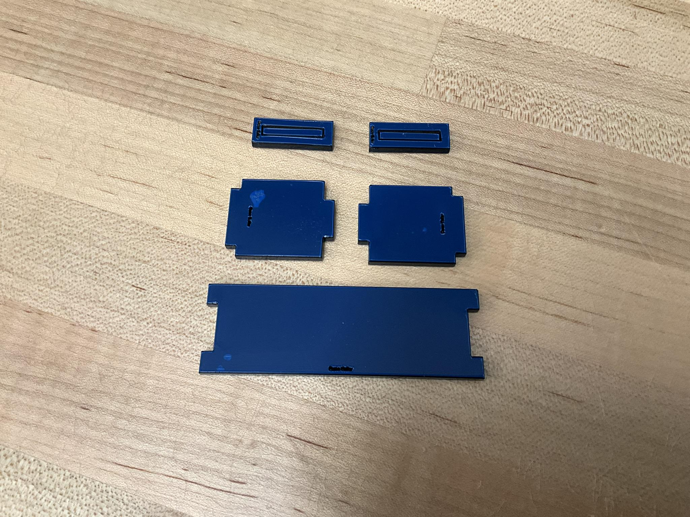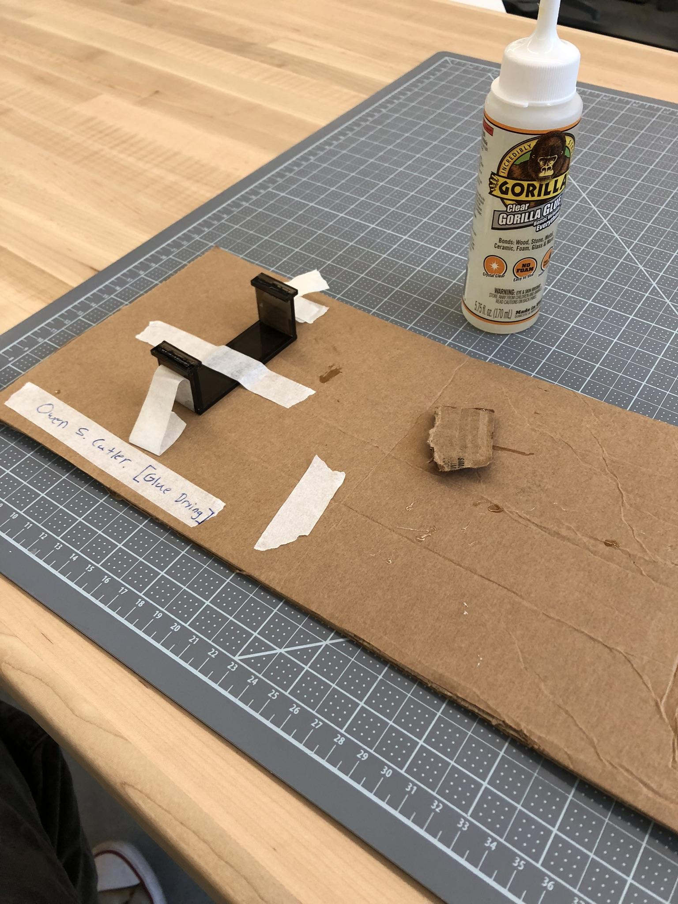
Team Robot Before Riser Parts Just After Being Cut Parts While Adhesive is Curing

Evaluating Solutions Using Kepner-Tregoe Decision Analysis:

Criteria | Weight | Riser Bracket | Side Mount | Front Mount
Feasibility | 30% | 4/5 | 1/5 | 2/5
Risk | 20% | 4/5 | 2/5 | 5/5
Impact | 50% | 5/5 | 4/5 | 5/5
Total Score |  | 4.5 | 1.1 | 4.1

What did I work on today?
This session started by defining the issue with the current mounting position of the ultrasonic sensor on the team robot. It was noted that when the team started Challenge Four of the robot project, Team Toyota realized the recommended mounting position for the ultrasonic sensor would not work with our design. The team chose to run our robot with the ping pong ball as the front wheel rather than having it in the rear of the robot. Because the recommended mounting position was given assuming the robot was driving with the ping pong ball in the rear, the sensor would be facing in the incorrect direction on our robot. To fix this the sensor was mounted on the opposite end of the robot's top plate. While being an acceptable place for the sensor to receive the information it needed, this position directly blocks both the barrel jack and USB Type B port on the redboard. The Temporary solution the team found was to mount the sensor and its mounting base using 3M Dual Lock Fastener Tape, allowing the sensor to be momentarily removed giving access to the blocked ports. This was an inelegant solution.
Once the issue was defined, Owen Cutler wrote down a handful of potential solutions. From there three solutions were drawn to better understand how each would be implemented and if they were realistic/useful. The solutions drawn included a side mount, a front mount, and a riser. All of the solutions could potentially solve the issue however it took using the Kepner-Tregoe Decision Analysis to find a single solution that would be used.
With a solution to focus on pursuing, it was again drawn in a different multi view style, where there was a small change made to the design. Then a final design was created in AutoCAD and subsequently sent to the maker space for cutting.
With all pieces cut, they were glued together and set to dry before the next session where the solution will be tested.

Record Group Meetings (if any):
ChatGPT4 was utilized to assist in the creation of a portion of the following bullet point summarization.
- Owen Cutler
- Minutes:
  - Identified the issue with the current mounting position of the ultrasonic sensor on the team robot.
  - The team recognized that during Challenge Four, the recommended sensor mounting position was incompatible with the current design, as the team was using the ping pong ball as the front wheel instead of the rear.
  - Owen Cutler outlined several potential solutions to address the mounting issue, and three primary options were selected for further exploration: side mount, front mount, and a riser.
  - Solutions were analyzed using the Kepner-Tregoe Decision Analysis method to determine the most feasible and effective approach.
  - After evaluating the options, the team decided on a single solution to move forward with; Riser Mount.
  - The selected solution was re-drawn in a different multi-view style with minor adjustments to the design.
  - Feet added to riser.
  - The final design was then created in AutoCAD and sent to the maker space for cutting.
  - Once the pieces were cut, they were glued together and set to dry, with plans to test the solution in the next session.

- Action Items:
  - Task: Define the issue with the current mounting position of the ultrasonic sensor.
    - Assigned to: Owen Cutler
    - Status: Completed
- Task: Identify and explore potential solutions to the mounting issue.
  - Assigned to: Owen Cutler
  - Status: Completed
- Task: Apply Kepner-Tregoe Decision Analysis to evaluate and select the best solution.
  - Assigned to: Owen Cutler
  - Status: Completed
- Task: Create and refine the final design in AutoCAD.
  - Assigned to: Owen Cutler
  - Status: Completed
- Task: Send the final design to the maker space for cutting.
  - Assigned to: Owen Cutler
  - Status: Completed
- Task: Assemble the cut pieces and set them to dry.
  - Assigned to: Owen Cutler
  - Status: Completed

What will I work on next time?

- Task: Allow the glued riser to fully cure.
  - Assigned to: Owen Cutler
  - Status: Started
- Task: Ensure the Assembled Riser has no issues.
  - Assigned to: Owen Cutler
  - Status: Not Started
- Task: Implement riser.
  - Assigned to: Owen Cutler
  - Status: Not Started
- Task: Test the solution.
  - Assigned to: Owen Cutler
  - Status: Not Started

11/19/2024 | Challenge Three Demo Day | Owen Cutler, Nolan Leonhardt

The goal of today’s in class meeting was to get the robot ready for the final submission of robot challenge three. The first thing the team had to do was implement both the new six cell battery pack and the 3D printed mounting plate, where the pack will sit, that Nolan Leonhardt designed and had printed overnight in preparation for today's meeting. Then the team will test the robot for any issues during practice runs through the challenge’s maze. If any issues were to arise they should be solved and fixed before the final in class demonstration.

Planned tasks list:
- Confirm the new battery pack fits on 3D printed mounting plate.
- Attach battery pack mount to the robot.
- Attach the battery pack to the mounting plate.
- Test robot in maze.
- Address any issues.
- Perform final demonstration in class.

Resources needed to complete the tasks
- Owen Cutler, Nolan Leonhardt
- Maker Space Classroom
- Team Toyota Robot
- Charged Laptop
- USB type A to USB type B cable
- Phone to take photos and videos
- New Battery Pack
- Challenge Three Maze

Useful reference links: List any link related to today’s work

- Final Code

- Videos:
- Demonstration Day Early Testing - Drifting Left
- Demonstration Day Early Testing - Drifting Right
- Demonstration Day Testing - Promising Test With Turning Issue
- Demonstration Day Testing - Back To The Start
- Demonstration Day Testing - Left Turn Issues
- Final In Class Demonstration

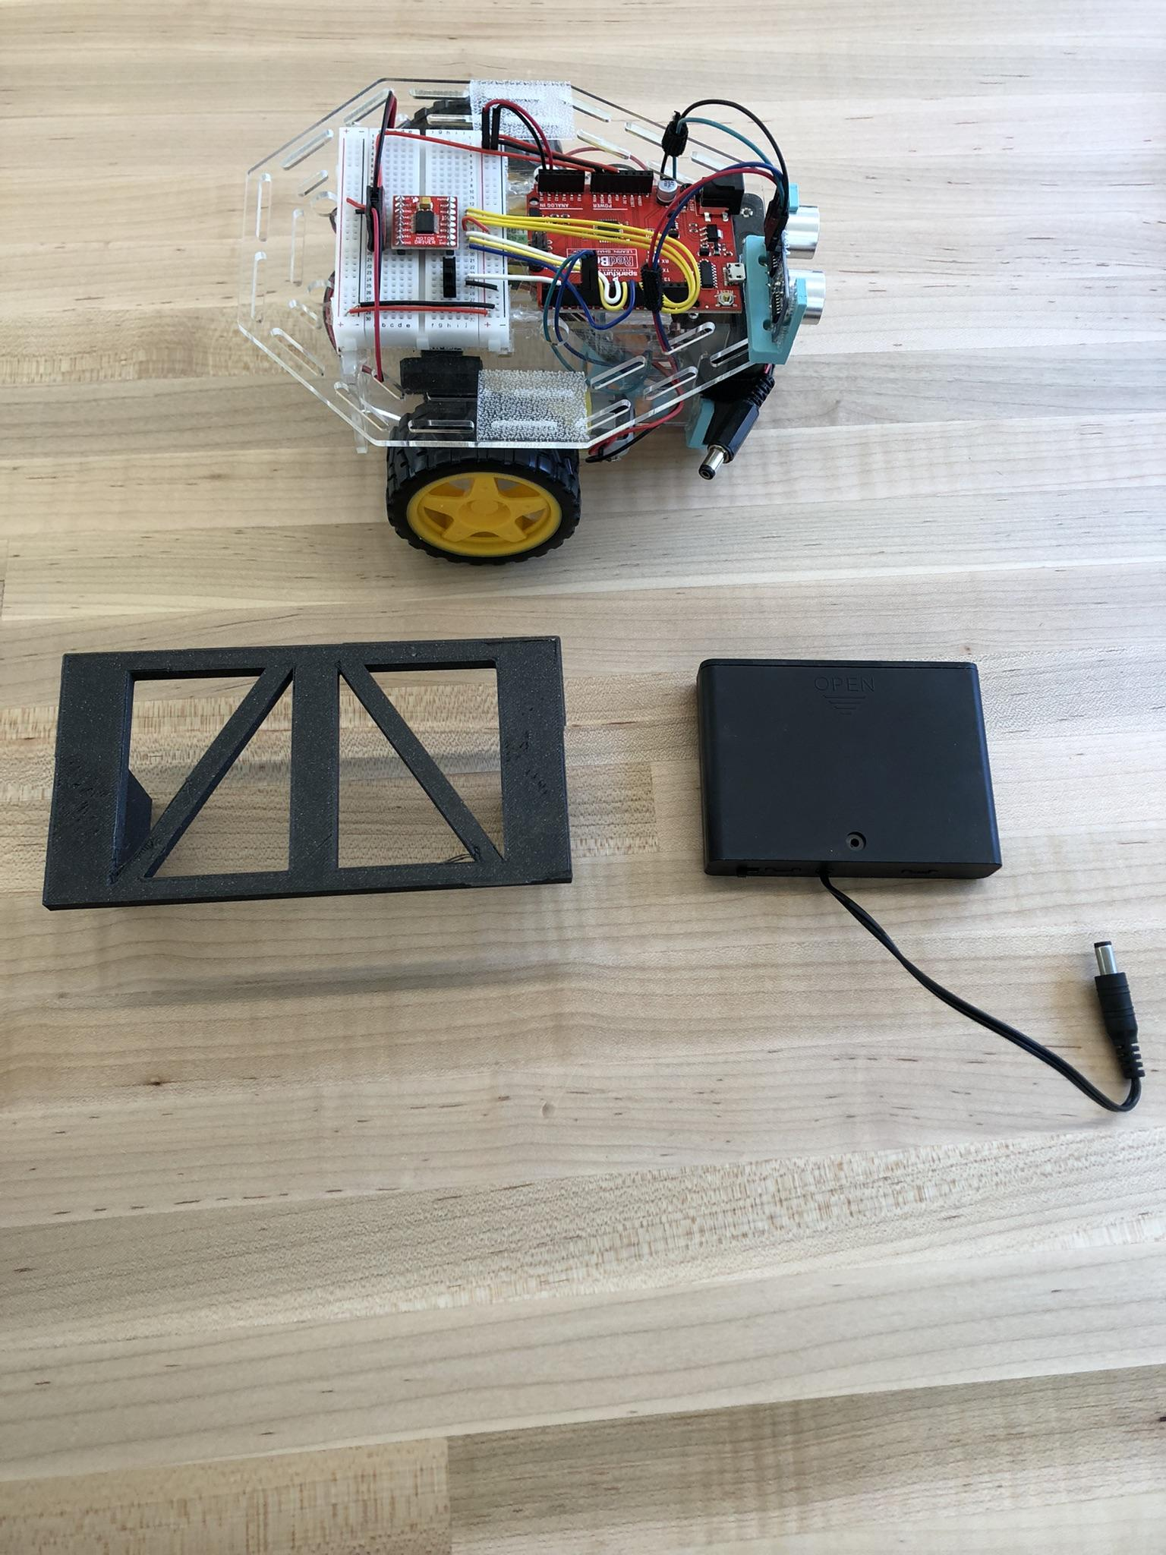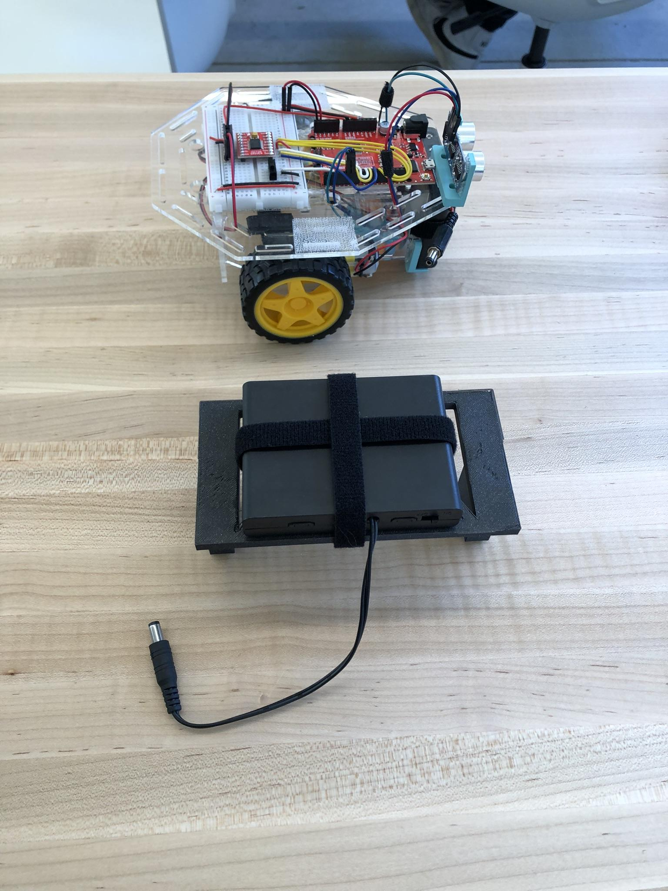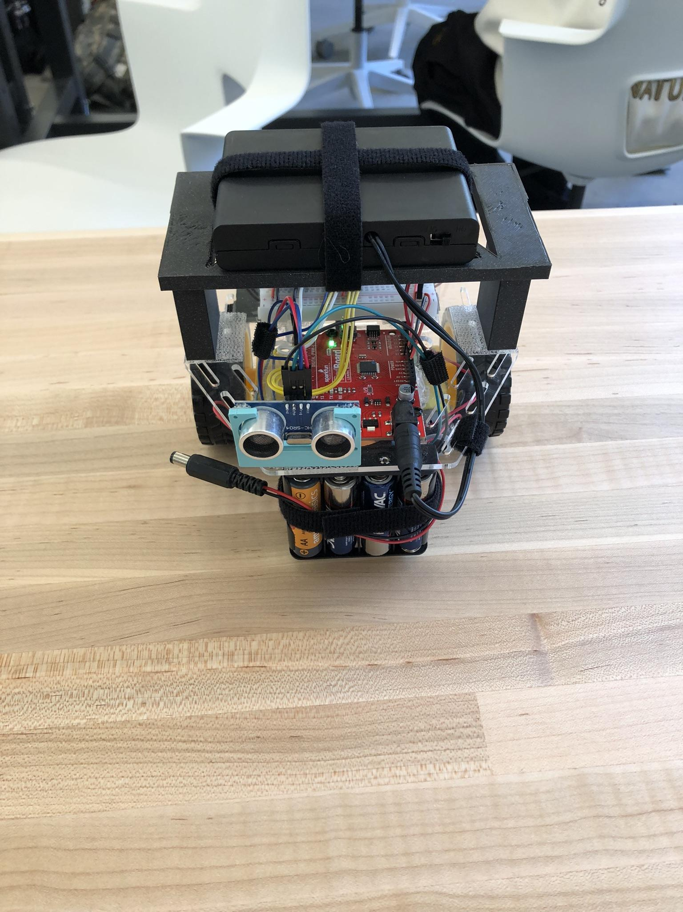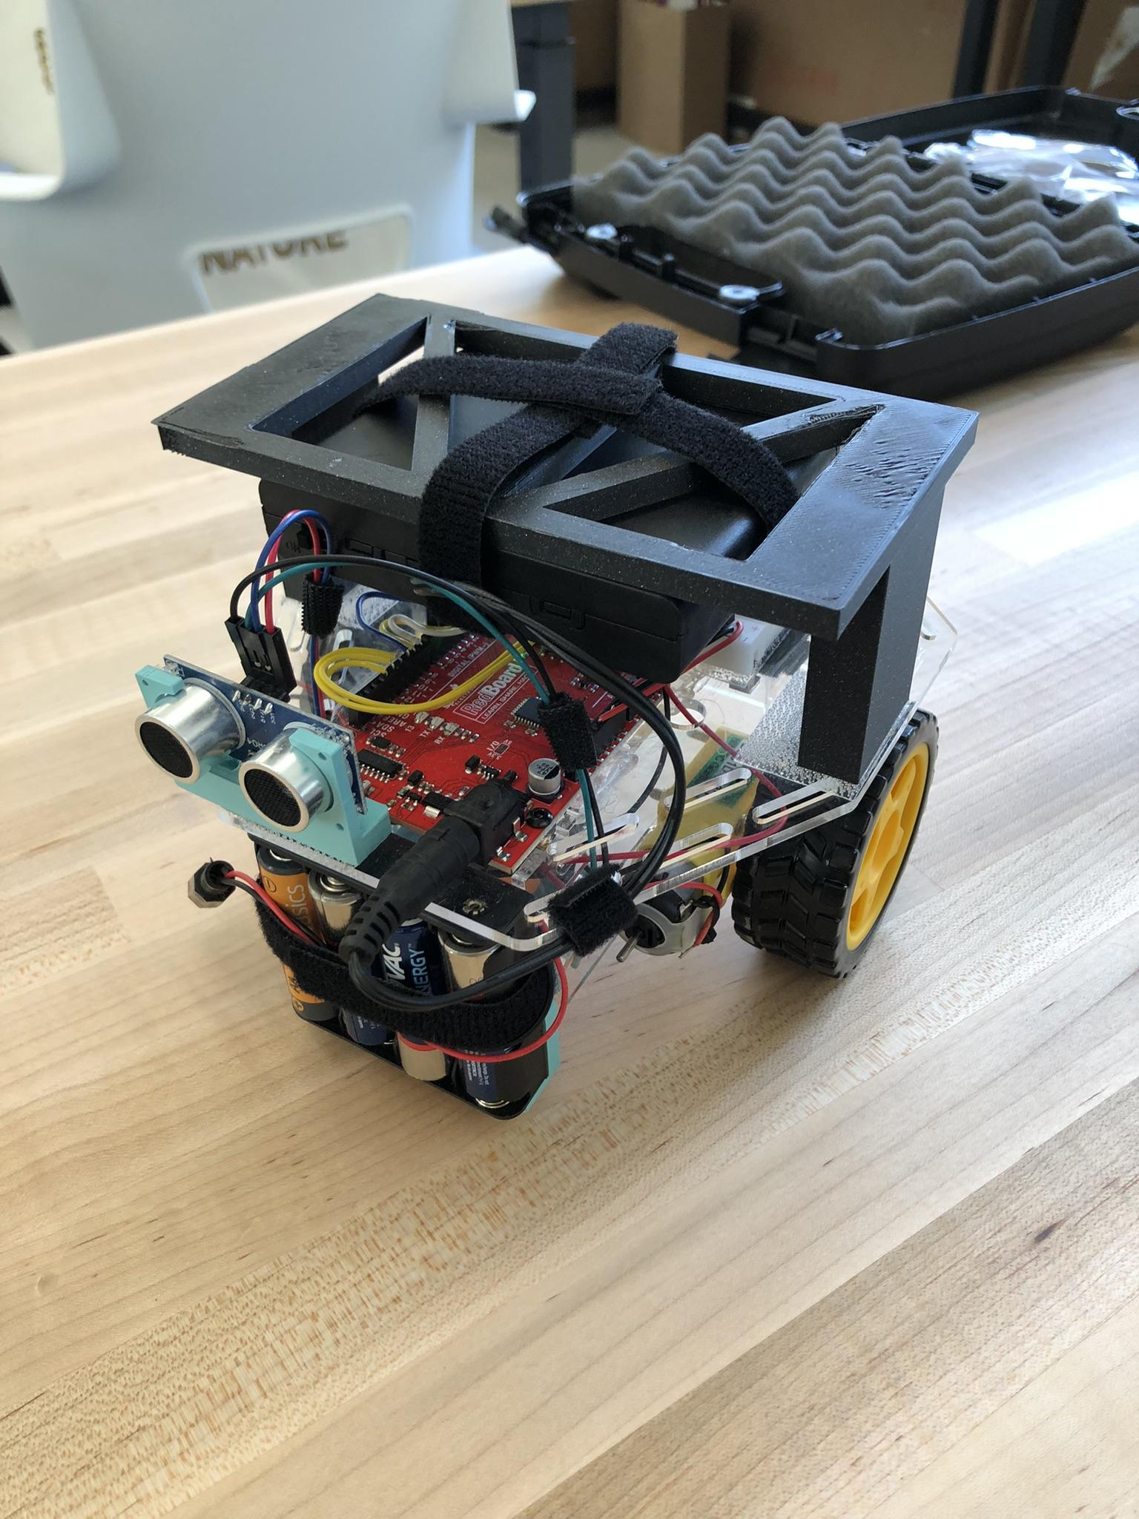
Battery Pack Mount Unassembled Assembled Battery Pack and Mount Battery Pack Attached to Robot Challenge Three Robot (Side View)
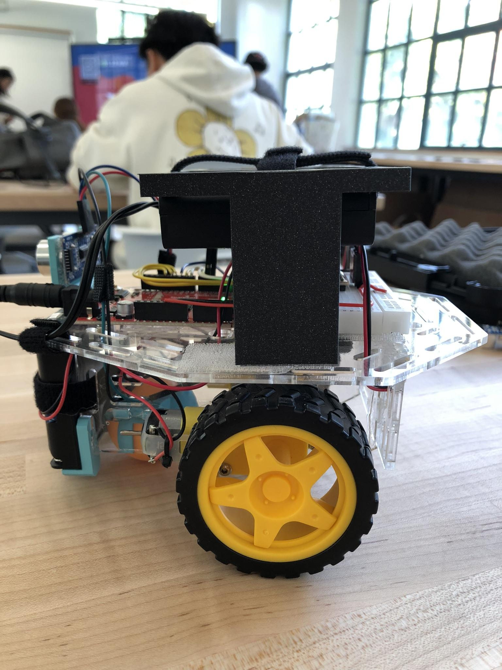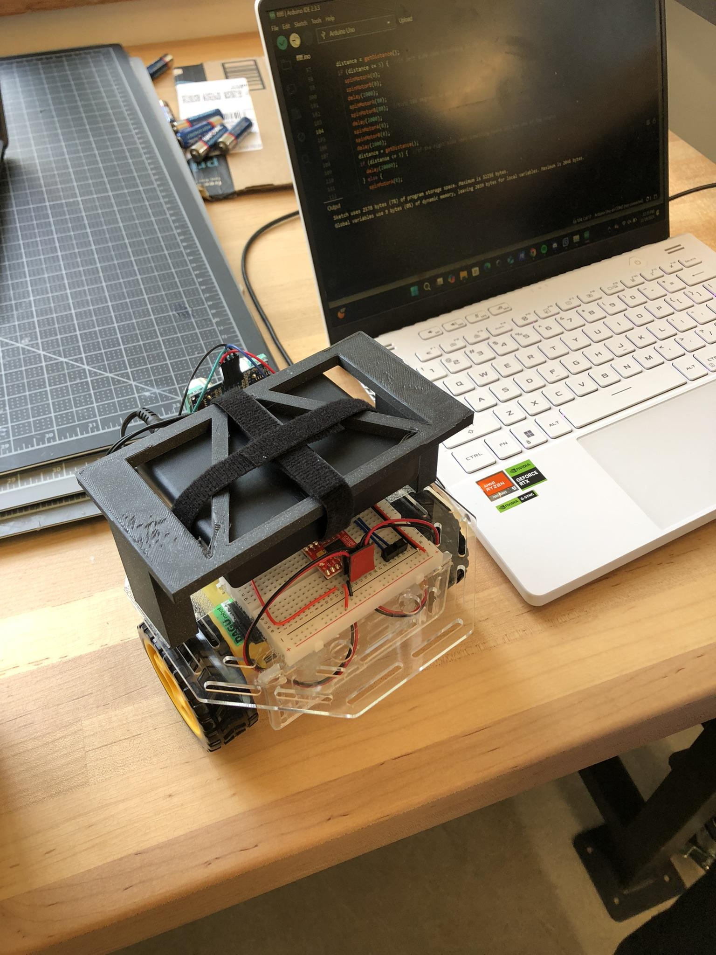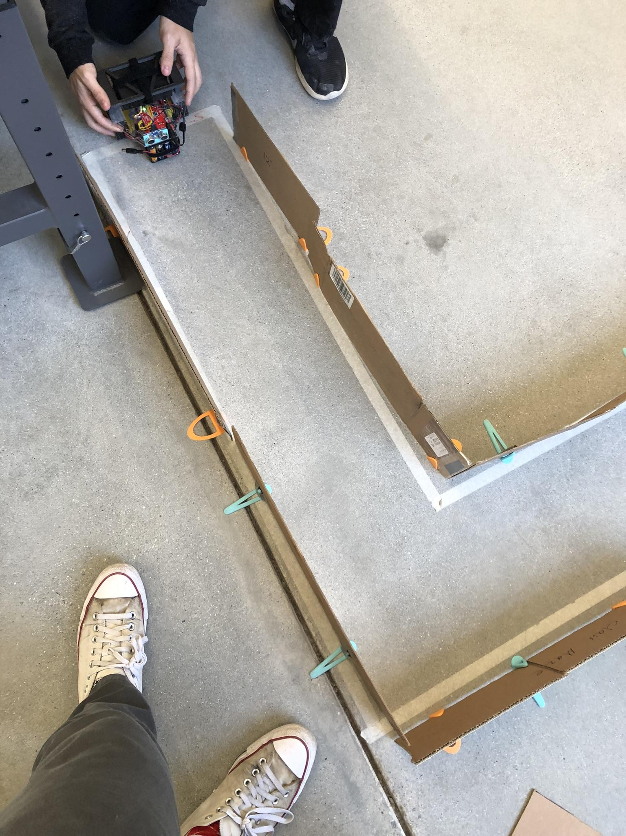
New Mounting Position Working on Robot Testing Robot in The Maze!

What did I work on today?
This meeting was held in class during our final day of challenge three.
The first thing that the team did at this meeting was checking that the part Nolan Leonhardt 3D printed overnight had successfully finished and was right for our robot. Removing the print from the printer bed and placing it on the robot, it fit correctly so we began finding the best way to attach the mount to the top plate of the robot. The solution we settled on was using pieces of 3M Dual Locking Fastener Tape adhered to both the bottom of the mount’s legs and the top plate of the robot. While this solution seemed acceptable we would run into some issues later on due to the way it altered the robot’s weight distribution.
Initial testing this meeting showed the robot drifting hard to the left and that our left turn was to an insufficient degree. In the process of attempting to solve both of these issues we ran into an additional problem; the robot now tilted backwards, lifting its front into the air, performing a wheelie due to the now extremely high center of weight. Before returning to address our more common issue of swerving, we had to find a method to lower or move the center of mass to a place where the robot would be less prone to performing two wheel stunts. While my initial thought would be to move the battery pack and mount forward toward the center of the robot, the team found that It was more effective to place them directly above the rear wheels. In combination with attaching the battery pack to the bottom of its mount, this issue appeared to be solved.
Moving back to the issues navigating the maze, Nolan Leonhard continued to change wheel speed values, as we have in the past, but there continued to be unpredictable and inconsistent issues. One test would result in the robot drifting right, the next two left, and then the next right again. The team seemed to get the turning values smoothed out to a correct place, yet diving in a straight line was still a challenge: one that affected a large portion of the class. By cleaning, the ping pong ball, ping pong ball socket, wheels, and the maze floor itself we were able to get more consistent tests.
This work resulted in a successful run through the maze.

Record Group Meetings (if any):
ChatGPT4 was utilized to assist in the creation of a portion of the following bullet point summarization.
- Owen Cutler, Nolan Leonhardt
- Minutes:
  - Checked the new 3D printed part to ensure it fit the robot.
  - 3D printed part was placed on the robot and the was attached to the top plate using 3M Dual Locking Fastener Tape.
  - Tested the robot in challenge three maze.
  - Testing showed the robot drifting left and making insufficient left turns.
  - Robot began tilting backward due to a high center of weight.
  - Battery pack was moved directly above the rear wheels to lower the center of mass, solving the tilting issue.
  - Robot continued to not run in a straight line.
  - Motor speed values changed.
  - Issues still present.
  - Cleaning the ping pong ball, socket, wheels, and maze floor; results are now more consistent.
  - Successful final demonstration runs through the maze.

- Action Items:
  - Task: Check the 3D printed part for proper fit on the robot.
    - Assigned to: Nolan Leonhardt
    - Status: Completed
- Task: Attach the mount to the top plate of the robot.
  - Assigned to: Owen Cutler, Nolan Leonhardt
  - Status: Completed
- Task: Prevent tilting issues from weight distribution.
  - Assigned to: Owen Cutler, Nolan Leonhardt
  - Status: Completed
- Task: Fix drifting, get the robot to run in a straight line.
  - Assigned to: Owen Cutler, Nolan Leonhardt
  - Status: Completed
- Task: Perform final demonstration through the maze.
  - Assigned to: Owen Cutler, Nolan Leonhardt
  - Status: Completed

What will I work on next time?

- Task: Design Challenge Four Maze.
  - Assigned to: Owen Cutler
  - Status: Not Started
- Task: Start Challenge Four.
  - Assigned to: Owen Cutler, Nolan Leonhardt
  - Status: In Progress

11/18/2024 | CADing a New Solution | Nolan

After still having the same issue with the robot code not working when plugged into batteries but working while plugged into the laptop, we decided to ask other classmates if they were experiencing any similar issues. After talking with Claire, a fellow classmate, we discovered that some students were able to fix their issues by changing their four battery packs for a six battery pack. After talking with her I realized that this made sense since the laptop was able to give the robot enough power to run everything while the 4 pack batteries only gave it enough to run the motors causing the ultrasonic sensor to not be read correctly. This lines up with what happened when we ran the code on batteries as it would only turn due to a wrong data point given by the ultrasonic sensor. With this realization, I decided to grab a 6 battery pack to test out this hypothesis and it ended up working. Now we have the issue of the battery pack not fitting where the old one is so the task is to CAD a solution.

Planned tasks list:
- Design a solution to mount the battery pack securely onto the robot
- CAD out the design
- Manufacture the design by tomorrow so we can test on Tuesday (11/19/24)

Resources needed to complete the tasks
- Nolan
- Desk and Makerspace
- 3d printer
- Laptop
- Robot
- Measuring tool
- PLA

Useful reference links: List any link related to today’s work

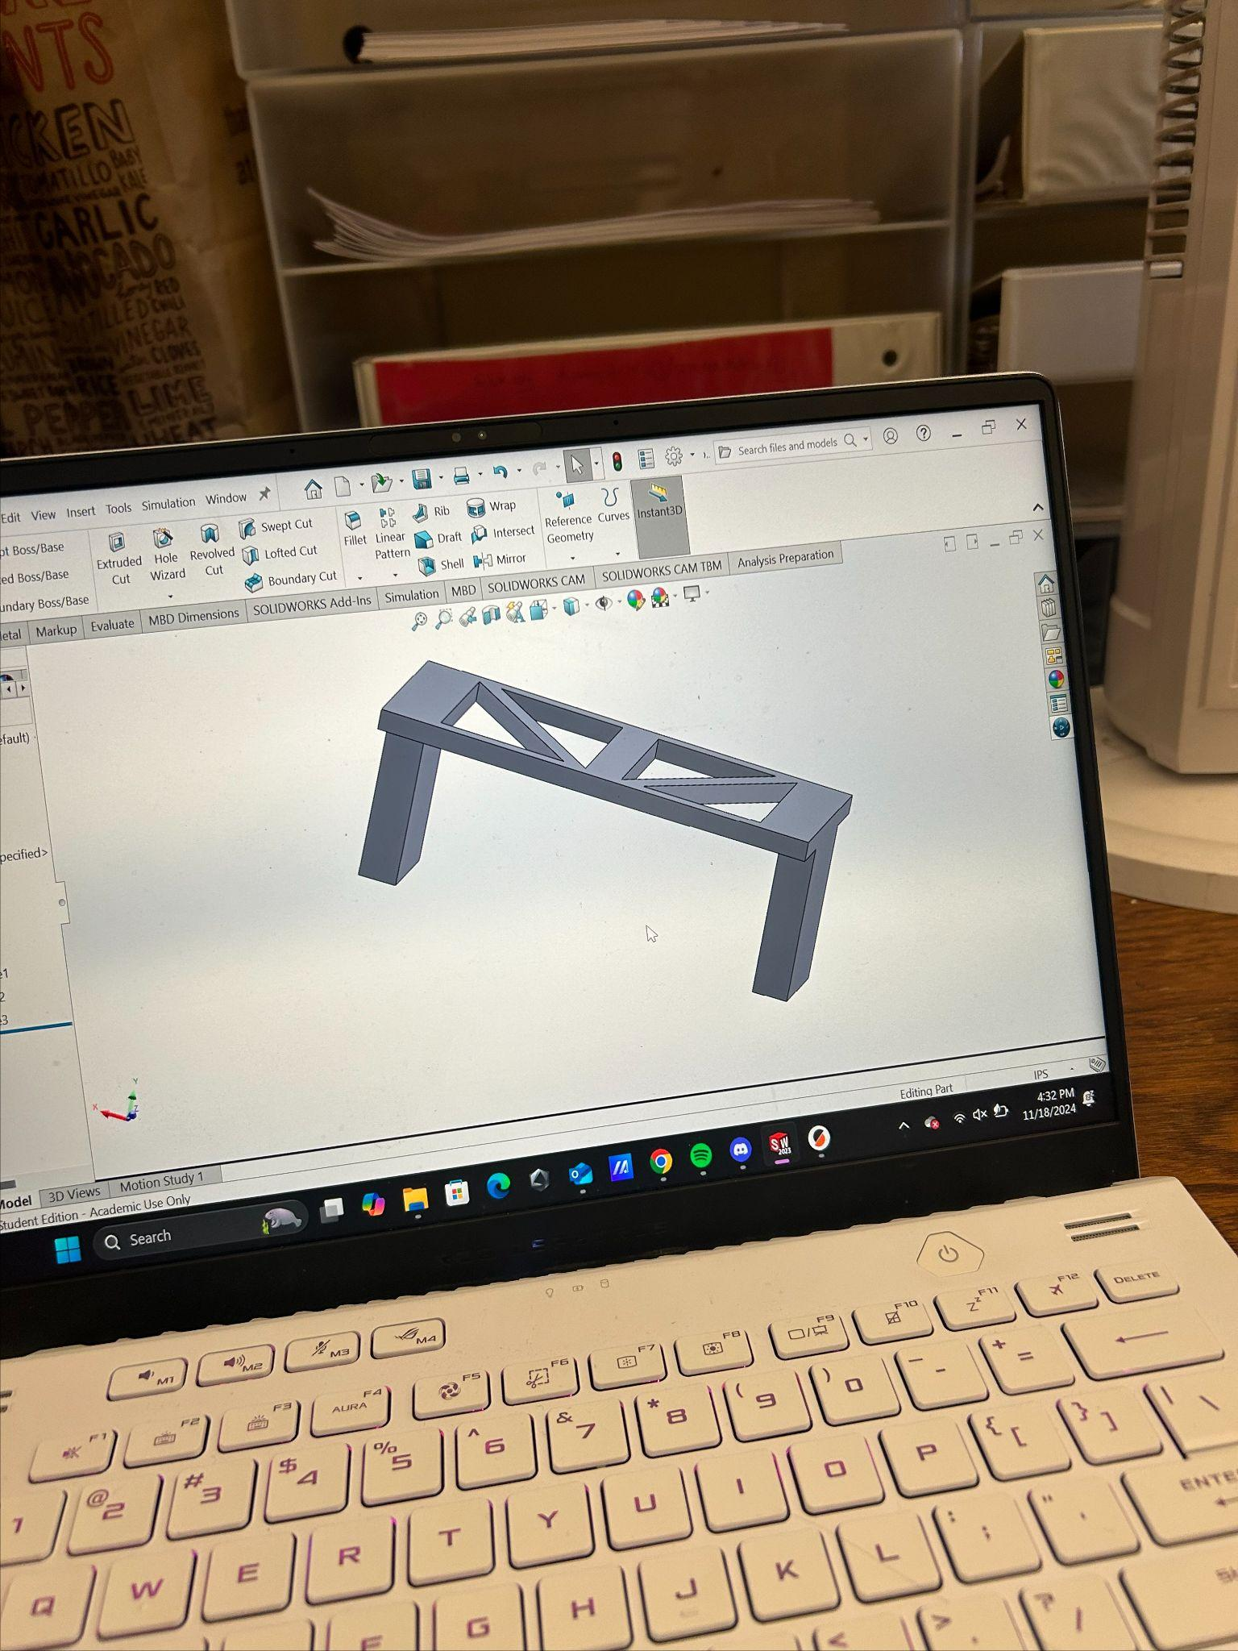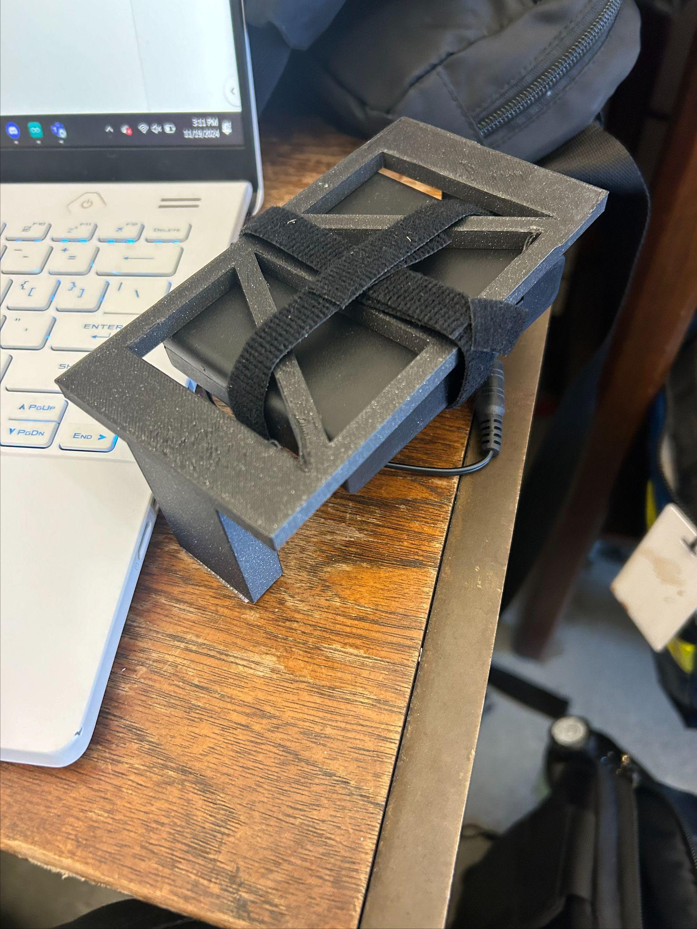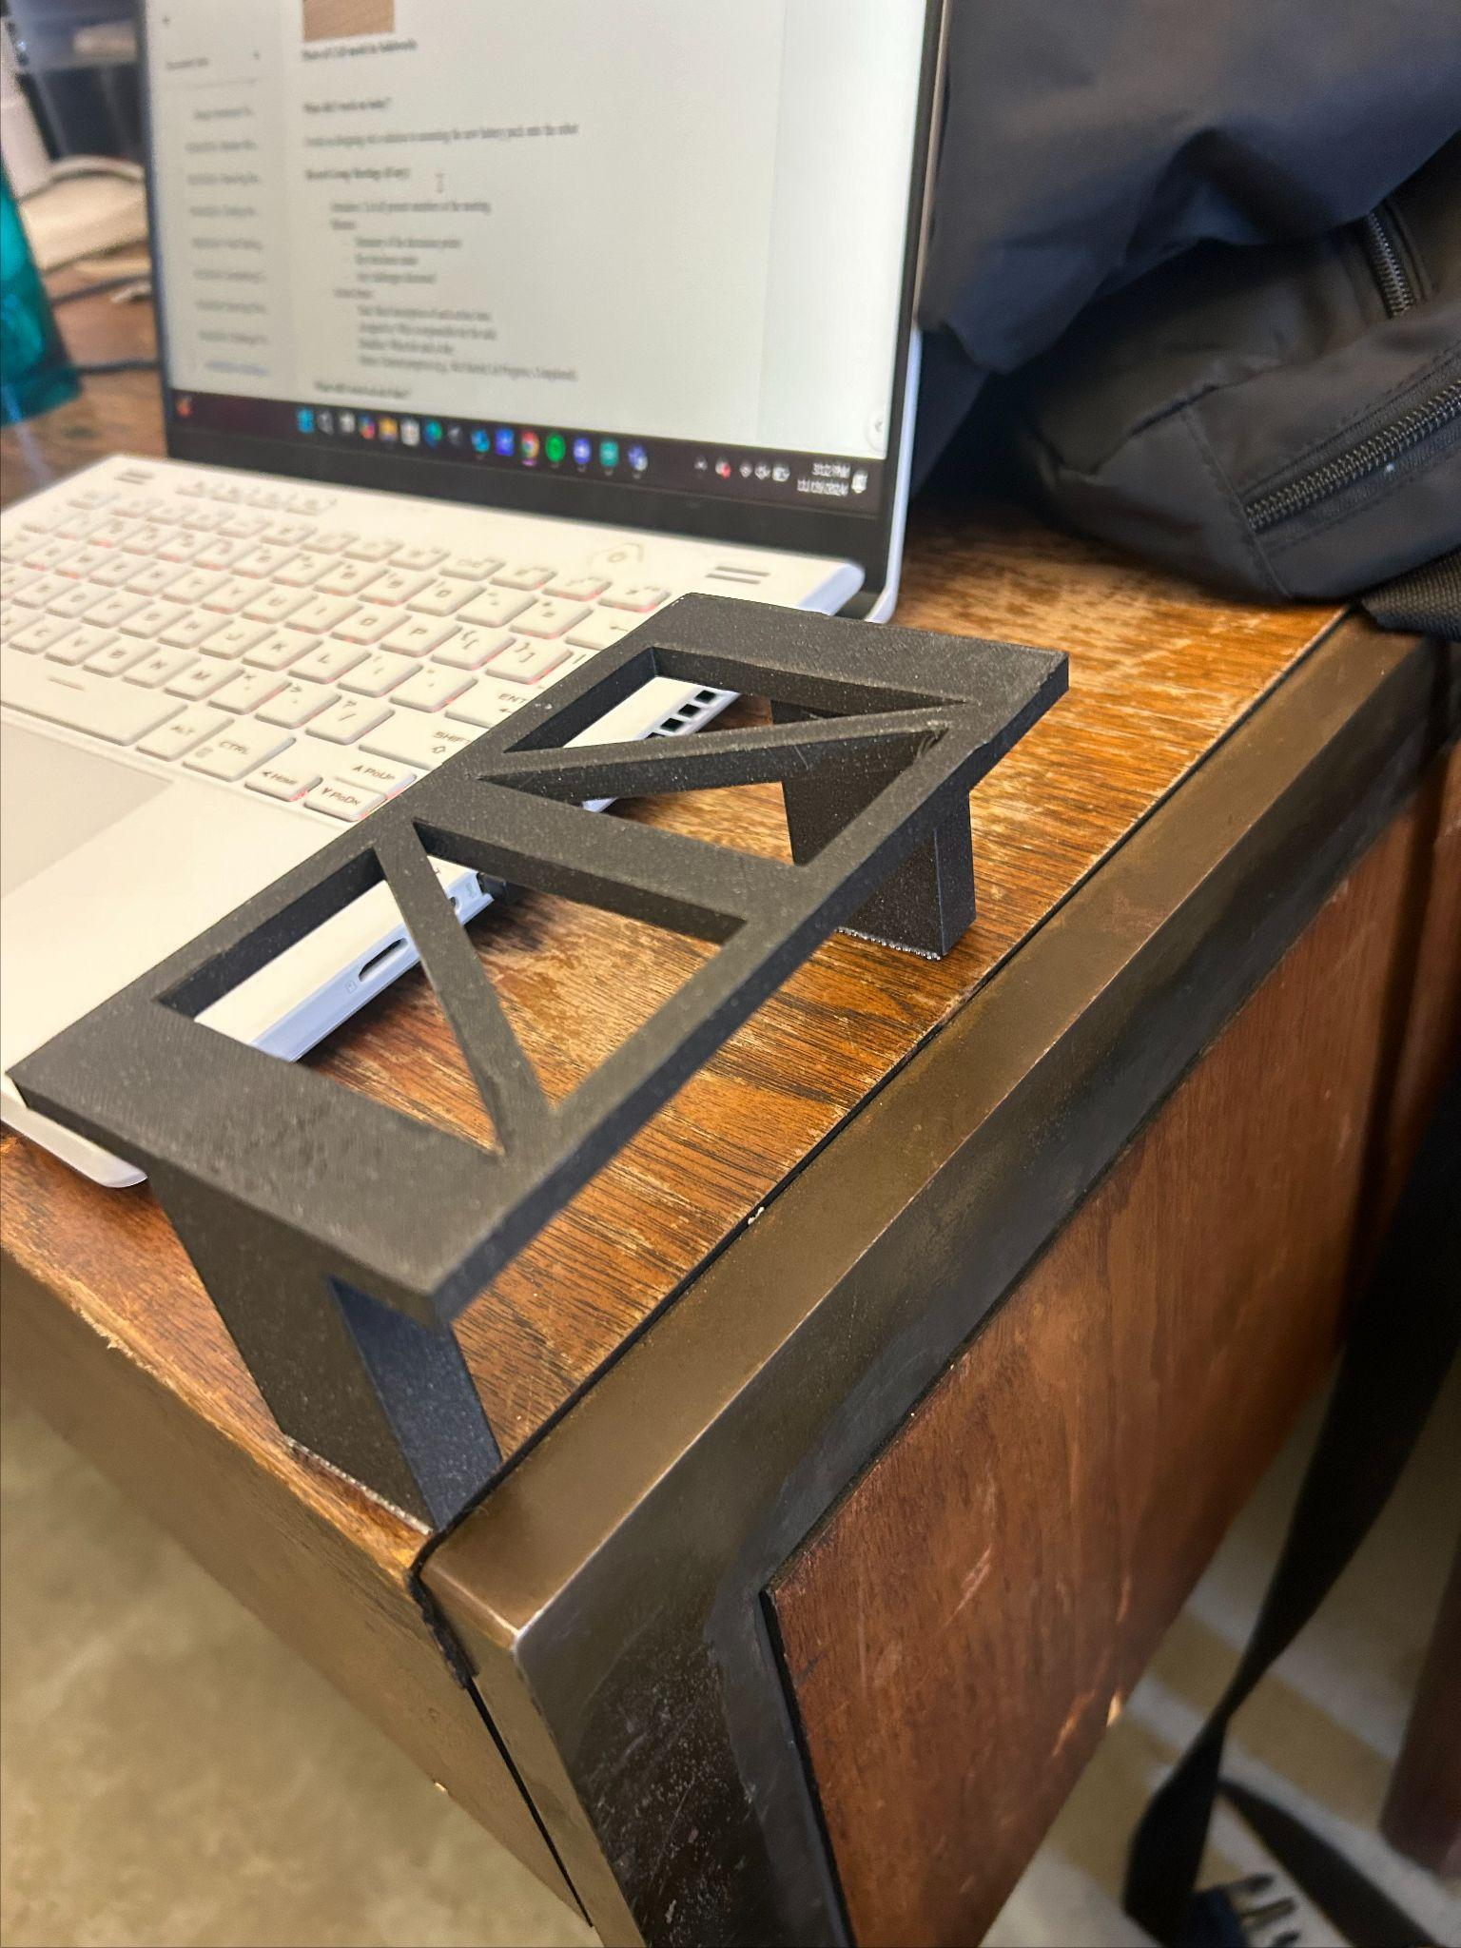
Photo of CAD model in Solidworks Printed Piece With Battery Pack Printed Piece Without Battery Pack

What did I work on today?
I worked on designing out a solution to mounting the new battery pack onto the robot. My initial thought was first where should I have the battery pack be placed since due to it being, it couldn’t fit under the robot anymore. So instead, I decided it would be better to have the battery pack be stored on top of the red and bread boards. This was due to there being plenty of space there for the battery pack. In addition, I also wanted it around the dead center of the robot so as to not throw off the entire weight of the robot. This gave me the idea to cad a little table for the battery pack to sit above the red and bread board. I was initially planning on making this my laser cutting project but very quickly released I couldn’t get it laser cut in time. This was due to me having work from 3-6 and not being able to get into the makerspace until 6:15 not giving me enough time to have them set up a laser cut. Instead, I decided it would be better for me to 3D print a table for it to stand on since even though it would take longer to print, I could have it print overnight and retrieve it during class the next day in order to finish challenge 3. So instead of CADing in autocad which is mainly 2d, I decided to CAD in Solidworks which I already knew how to do from highschool. As I began designing, I initially was going to secure it to the robot by having small notches that fit into the notches of the top panel and hot glue it in. But when I thought it through, I realized that this was a dumb idea because then we wouldn’t be able to easily access the wires on the red and bread board. So instead, I made the bottom of the table flat so I could add dual locking tape so it would be securely on while also being easy to take off if we have to fix the wiring of the robot. Finally, I also added triangle cut outs to the top of the table to initially reduce the time of the print and to help make it easier to secure the battery pack using velcro. I used this triangle pattern so it would still be strong to support the battery pack with the cut outs. After I finalized the CAD I headed over to the makerspace to get the print started. There I got certified on the 3D printer since I have used ones before and was able to start the print. That's when I decided to end the meeting as it would be hard to test the robot without a secure way to mount the battery pack onto the robot.

Record Group Meetings (if any):
- Attendees: Nolan
- Minutes:
  - Started planning out how I would mount the battery pack
  - Decided to have it mount above the red and bread boards
  - Began sketching out how I would have it mount on top
  - Decided on a table like structure due to it being sturdy enough and easy to make
  - Released that I would have to make it in Solidworks so I could 3D print it in order to have it by tomorrow morning
  - Measured out the dimensions of the robot in order to make my design.
  - Made my first draft of the CAD
  - After looking at it, I realized that using the notches to secure it would prevent us from accessing the wires.
  - Decided to leave the legs flat so I could use dual locking tape in order to be able to remove it easily.
  - Added cut out triangles on top in order to make it easier to mount the battery with velcro and to reduce the printing time
  - Made them triangles so as to not lose strength in the table.
  - Finalized the CAD
  - Went over to the makerspace
  - Got helped by the staff there so I could get certified on the 3D printer and start the print for the battery mount.
  - Ended the meeting since I couldn’t test the robot without the battery mount.
- Action Items:
  - Task: Design a mount for the battery pack.
    - Assigned to: Nolan Leonhardt
    - Status: Completed
  - Task: CAD the mount for the battery pack.
    - Assigned to: Nolan Leonhardt
    - Status: Completed
  - Task: Start the print for the battery pack mount.
    - Assigned to: Nolan Leonhardt
    - Status: Completed

What will I work on next time?

- Task: Attach on the new battery pack mount to the robot.
  - Assigned to: Owen Cutler, Nolan Leonhardt
  - Status: Complete
- Task: Test the code in class
  - Assigned to: Owen Cutler, Nolan Leonhardt
  - Status: Complete
- Task: Test robot on the maze to see if it can solve it.
  - Assigned to: Owen Cutler, Nolan Leonhardt
  - Status: In Progress
- Task: Design out a maze for Challenge 3
  - Assigned to: Owen Cutler
  - Status: Not Started

11/16/2024 | Challenge Three Wiring and Testing | Owen Cutler

With the end of the last meeting leaving the team’s robot inoperable and not functional, the goal of this session was to rewire the robot to the tested layout found in the previous meeting. After this the goal is to test a few possible culprits for the issue.

Planned tasks list:
- Unwire the robot. Remove all temporary jumper wires.
- Rewire the robot using hookup wires in a clear and understandable way.
- Test robot with new wiring.
- Test robot with new motors.

Resources needed to complete the tasks
- Owen Cutler
- Dorm Room
- Team Toyota Robot
- Charged Laptop
- USB type A to USB type B cable
- Hookup Wire
- Wire Cutter
- Wire Stripper
- Ruler
- Phone to take photos and videos
- Spare Motors
- New Batteries
- Flat surface to test robot
Useful reference links: List any link related to today’s work

- SparkFun circuit 5B reference page
- Testing New Wiring On Battery Power - Issues Persist
- Testing New Wiring On USB Power - No Issues
- Testing New Motors On Battery Power - Issues Persist
- Testing A Single Motor On Battery Power - No Issues

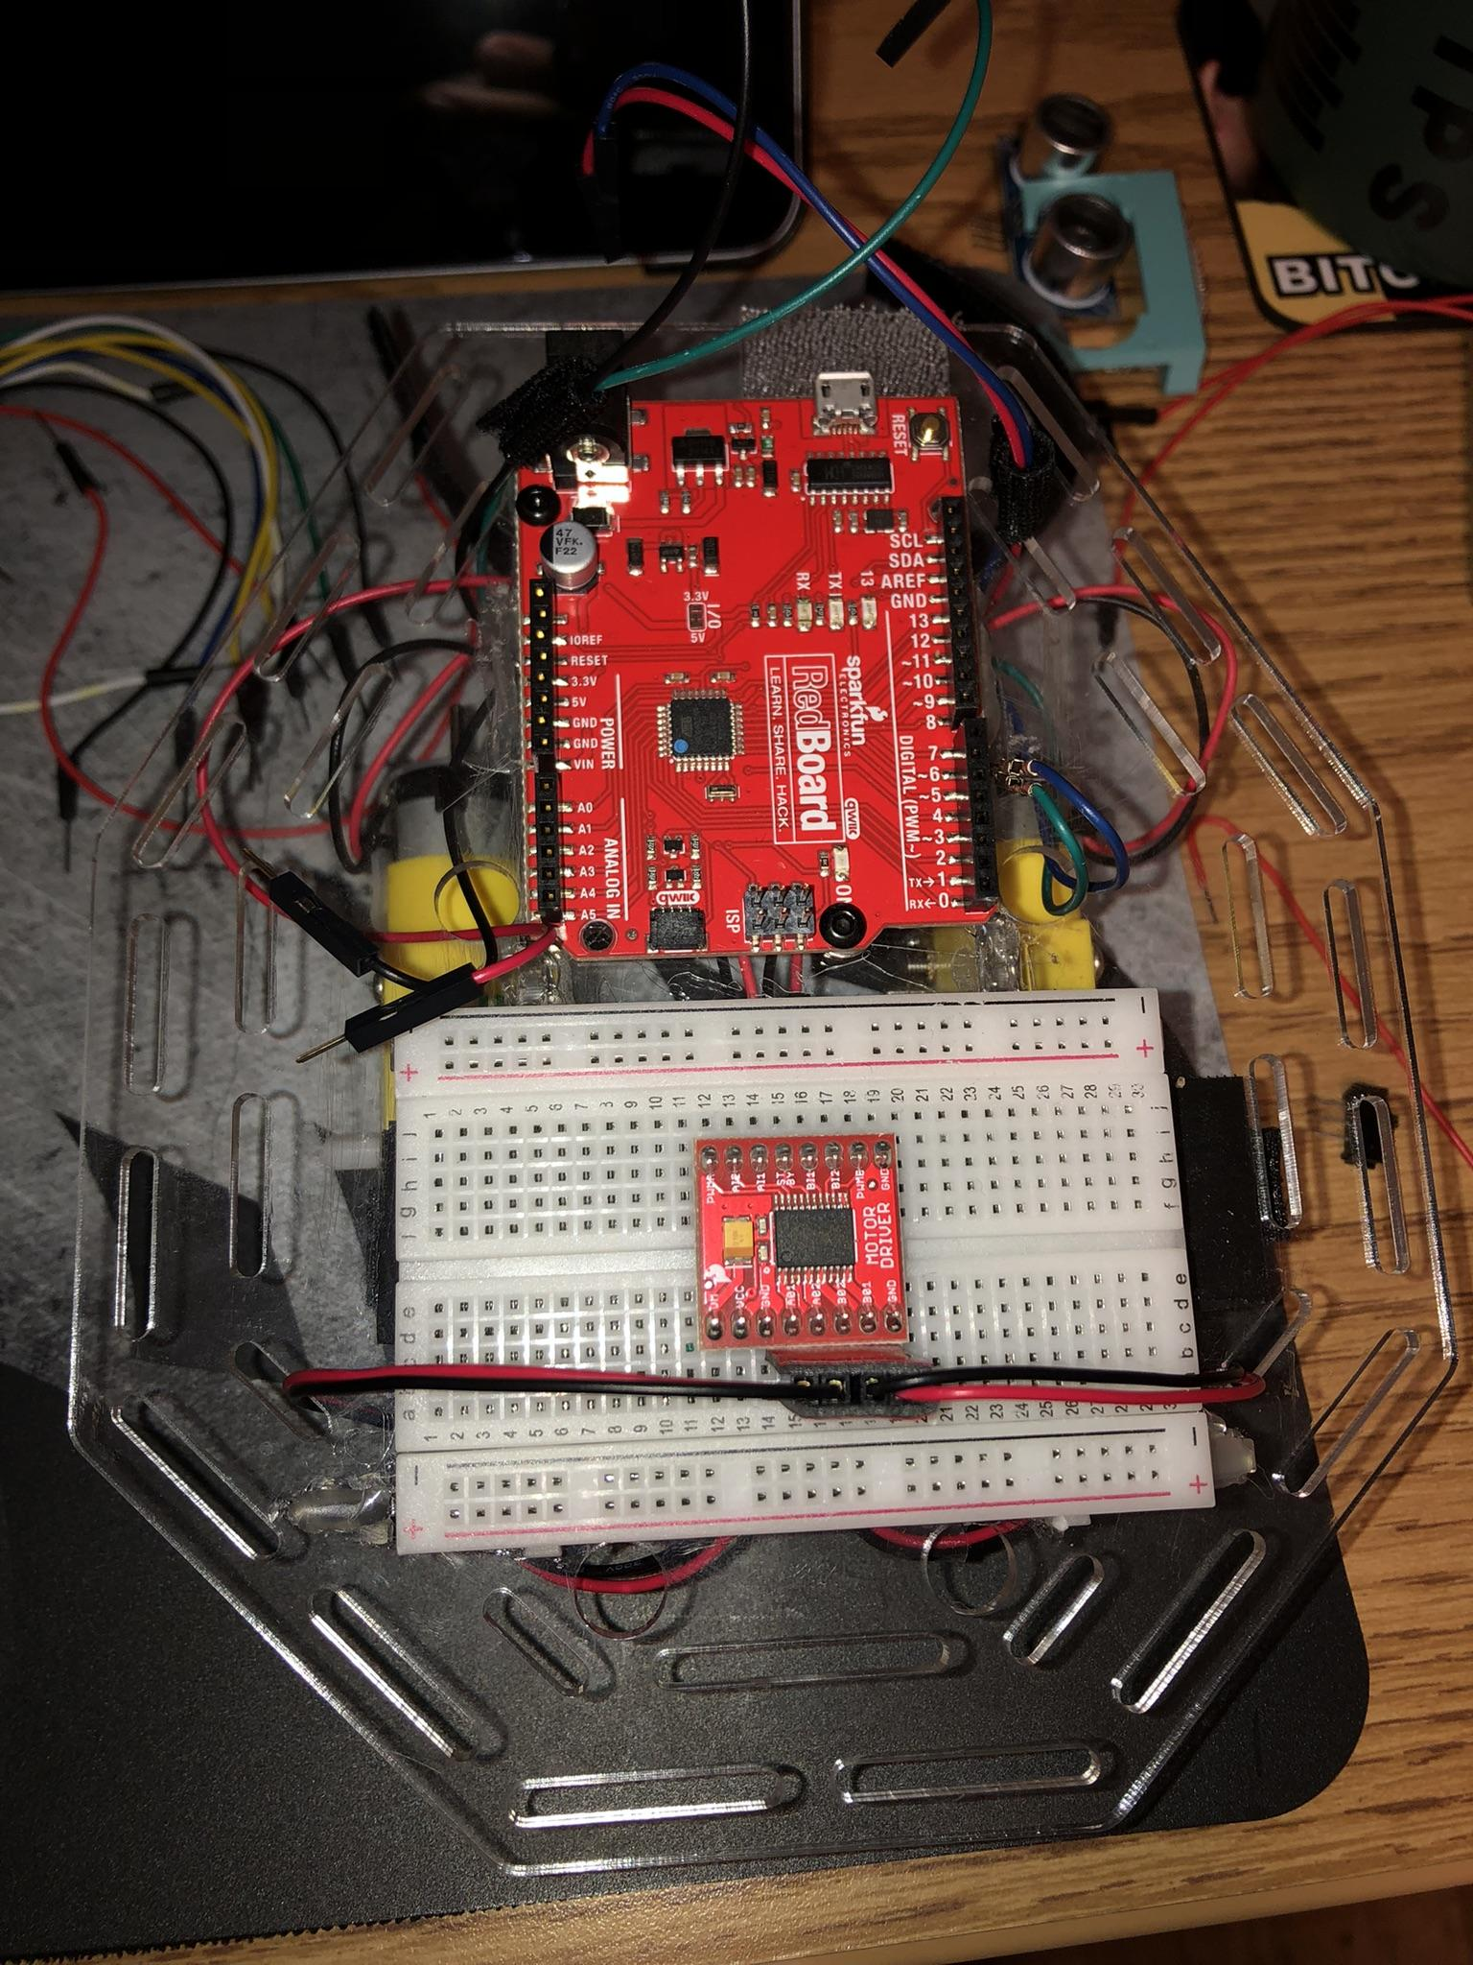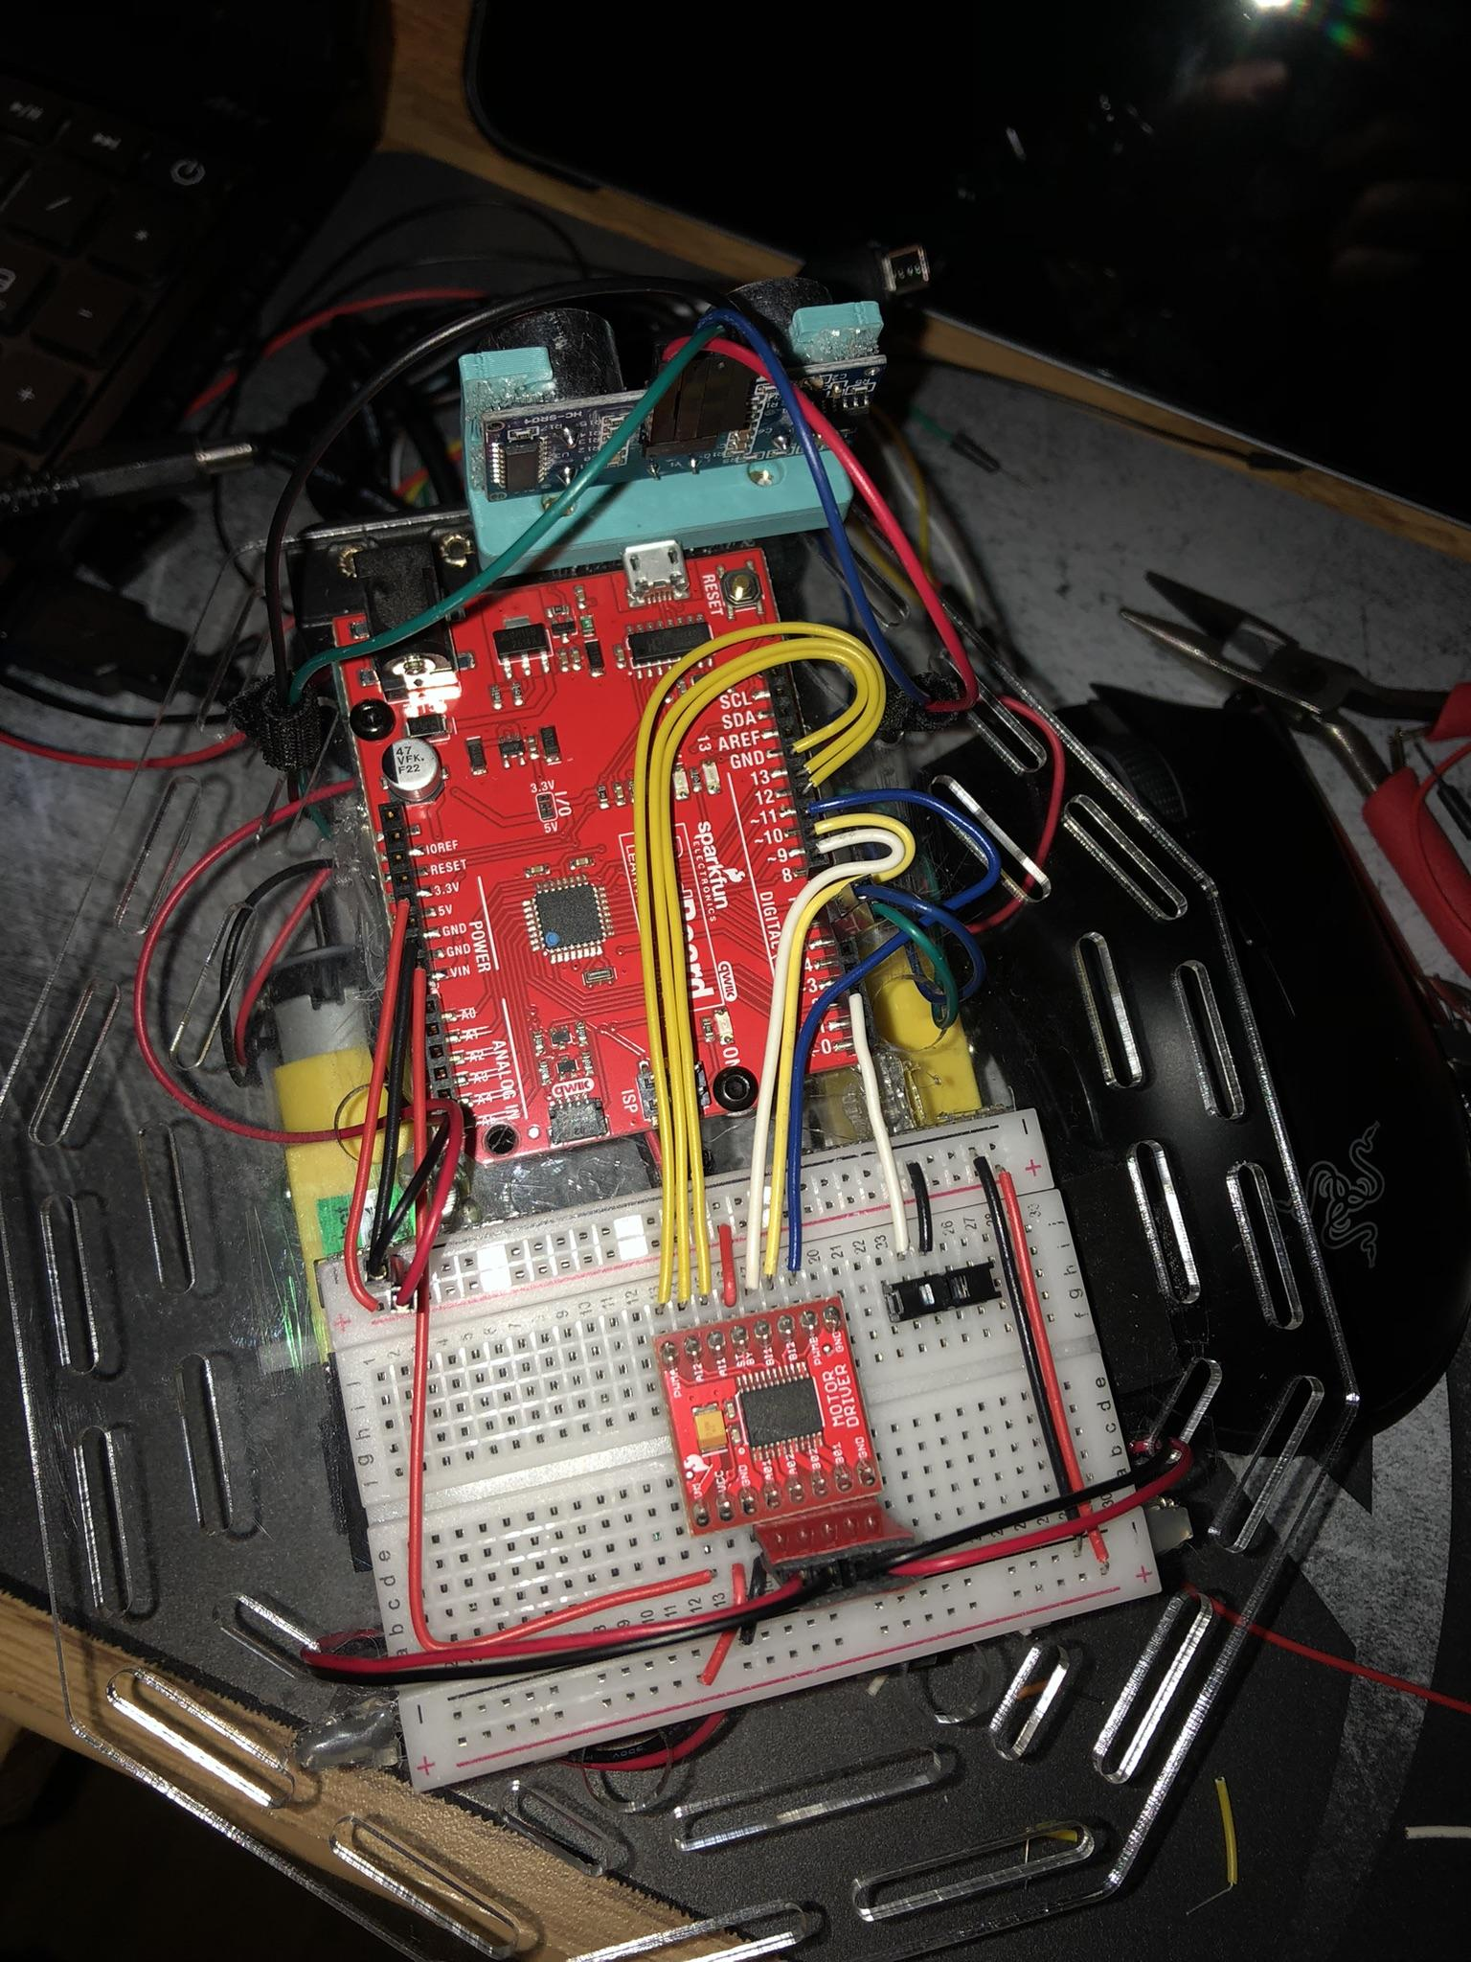
Unwired Robot Robot with New Wiring

What did I work on today?
This session was held shortly after the conclusion of the following. This meant that the robot was not functioning correctly when on battery power, but correctly on USB Power.
After taking photos of the robot wired using hookup wires, Owen Cutler took all of the temporary wiring off the robot in preparation to again rewire the robot. Referring to the wiring reference image from spark fun and the images of the wires form the previous session, the wire runs were planned. This was done by plotting where each wire had to go, and then measuring the length of each run along with any necessary bends. With the planning and measurements done, I began to cut hookup wire to the lengths measured. With the correct length wires, I then made any necessary bend before placing them on the robot. There was a different approach wiring this time around, with an attempt to keep wires running parallel to each other when possible. This resulted in a significantly easier layout to understand at a quick glance, and allowed for removal of wires without moving others.
After rewriting, Owen Cutler tested a few possible issues. The first test was simply ensuring that the robot still functioned correctly on USB power, with the new wiring. Second, the robot was tested (On battery power) with new motors to check that the motors attached to the robot were not causing the issues: they were not. Third, the robot was tested with only one motor on battery power. The robot was able to function correctly on battery power when only one motor was attached. This supported the previously proposed hypothesis that the robot had issues with the power received by the battery pack.
The information collected during this session was relayed to the rest of the team.

Record Group Meetings (if any):
ChatGPT4 was utilized to assist in the creation of a portion of the following bullet point summarization.
- Owen Cutler
- Minutes:
  - The robot was not functioning correctly on battery power but worked fine on USB power.
  - Removed all temporary wiring from the robot in preparation for rewiring.
  - Wiring planned by referring to a wiring reference image and images from the previous session.
  - Measurements taken for each wire run and necessary bends.
  - Hookup wires were cut to the measured lengths, bent where necessary, and placed on the robot following a new approach to keep wires parallel to one another.
  - This new wiring layout made the system easier to understand at a glance and allowed for easier wire removal without disturbing others.
  - After rewiring, the tested robot to ensure it still functioned correctly on USB power.
  - Tested with new motors on battery power to check if the motors were causing the issues; they were not.
  - Tested with only one motor on battery power. Robot functioned correctly.
- Action Items:
  - Task: Remove temporary wiring and prepare for rewiring.
    - Assigned to: Owen Cutler
    - Status: Completed
- Task: Plan wire runs and measurements for new wiring layout.
  - Assigned to: Owen Cutler
  - Status: Completed
- Task: Cut and bend hook up wires, place them according to the new layout.
  - Assigned to: Owen Cutler,
  - Status: Completed
- Task: Test robot functionality after rewiring (USB power).
  - Assigned to: Owen Cutler
  - Status: Completed
- Task: Test robot on battery power with new motors to check for issues.
  - Assigned to: Owen Cutler
  - Status: Completed
- Task: Test robot on battery power with one motor.
  - Assigned to: Owen Cutler
  - Status: Completed

What will I work on next time?

- Task: Troubleshoot hardware issue (robot only functions when plugged into a laptop).
  - Assigned to: Owen Cutler, Nolan Leonhardt
  - Status: In Progress
- Task: Investigate further hardware issues and determine root cause.
  - Assigned to: Owen Cutler, Nolan Leonhardt
  - Status: In Progress
- Task: Test robot before final tests in class.
  - Assigned to: Owen Cutler, Nolan Leonhardt
  - Status: Not Started

11/16/2024 | Starting Challenge Three | Owen Cutler, Nolan Leonhardt

The last meeting marked the completion of robot challenge two. Before the start of this meeting the Team Toyota Robot was able to drive in a straight line and turn to either the right or left when directed to on a predetermined path. The intention was to finish the entirety of robot challenge three in the course of this meeting. To achieve this, the robot must maintain its ability to drive in a straight line, detect when its path is blocked, and check for an open route to continue. If no route is available, the robot should stop moving. Much like all previous challenges, this would require extensive testing and subsequently fixing any discovered issues.

Planned tasks list:
- Implement obstacle detection and path-blocking logic.
- Conduct testing to verify functionality of all features.
- Fix any discovered issues or bugs from testing.
- Final review and testing of robot’s challenge three functionality.

Resources needed to complete the tasks
- Owen Cutler, Nolan Leonhardt
- Mary Morse Sunroom
- Team Toyota Robot
- Charged Laptop
- USB type A to USB type B cable
- Flat surface to test robot

Useful reference links: List any link related to today’s work

- SparkFun circuit 5B reference page
- Sensor Mount Demonstration
- Code before the meeting

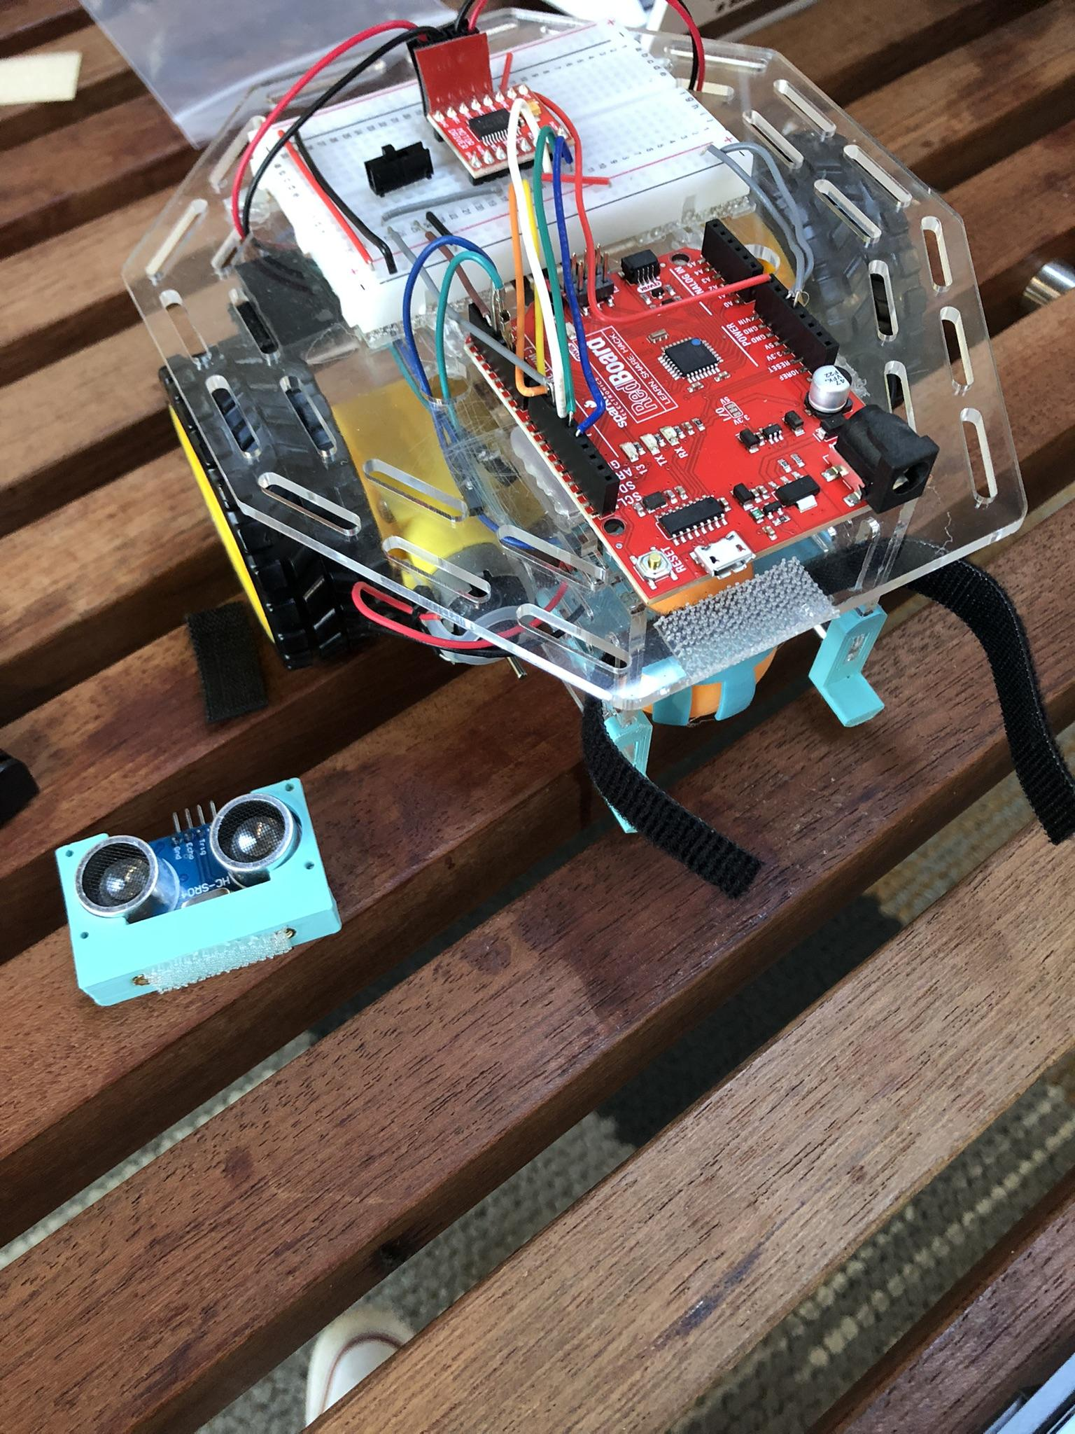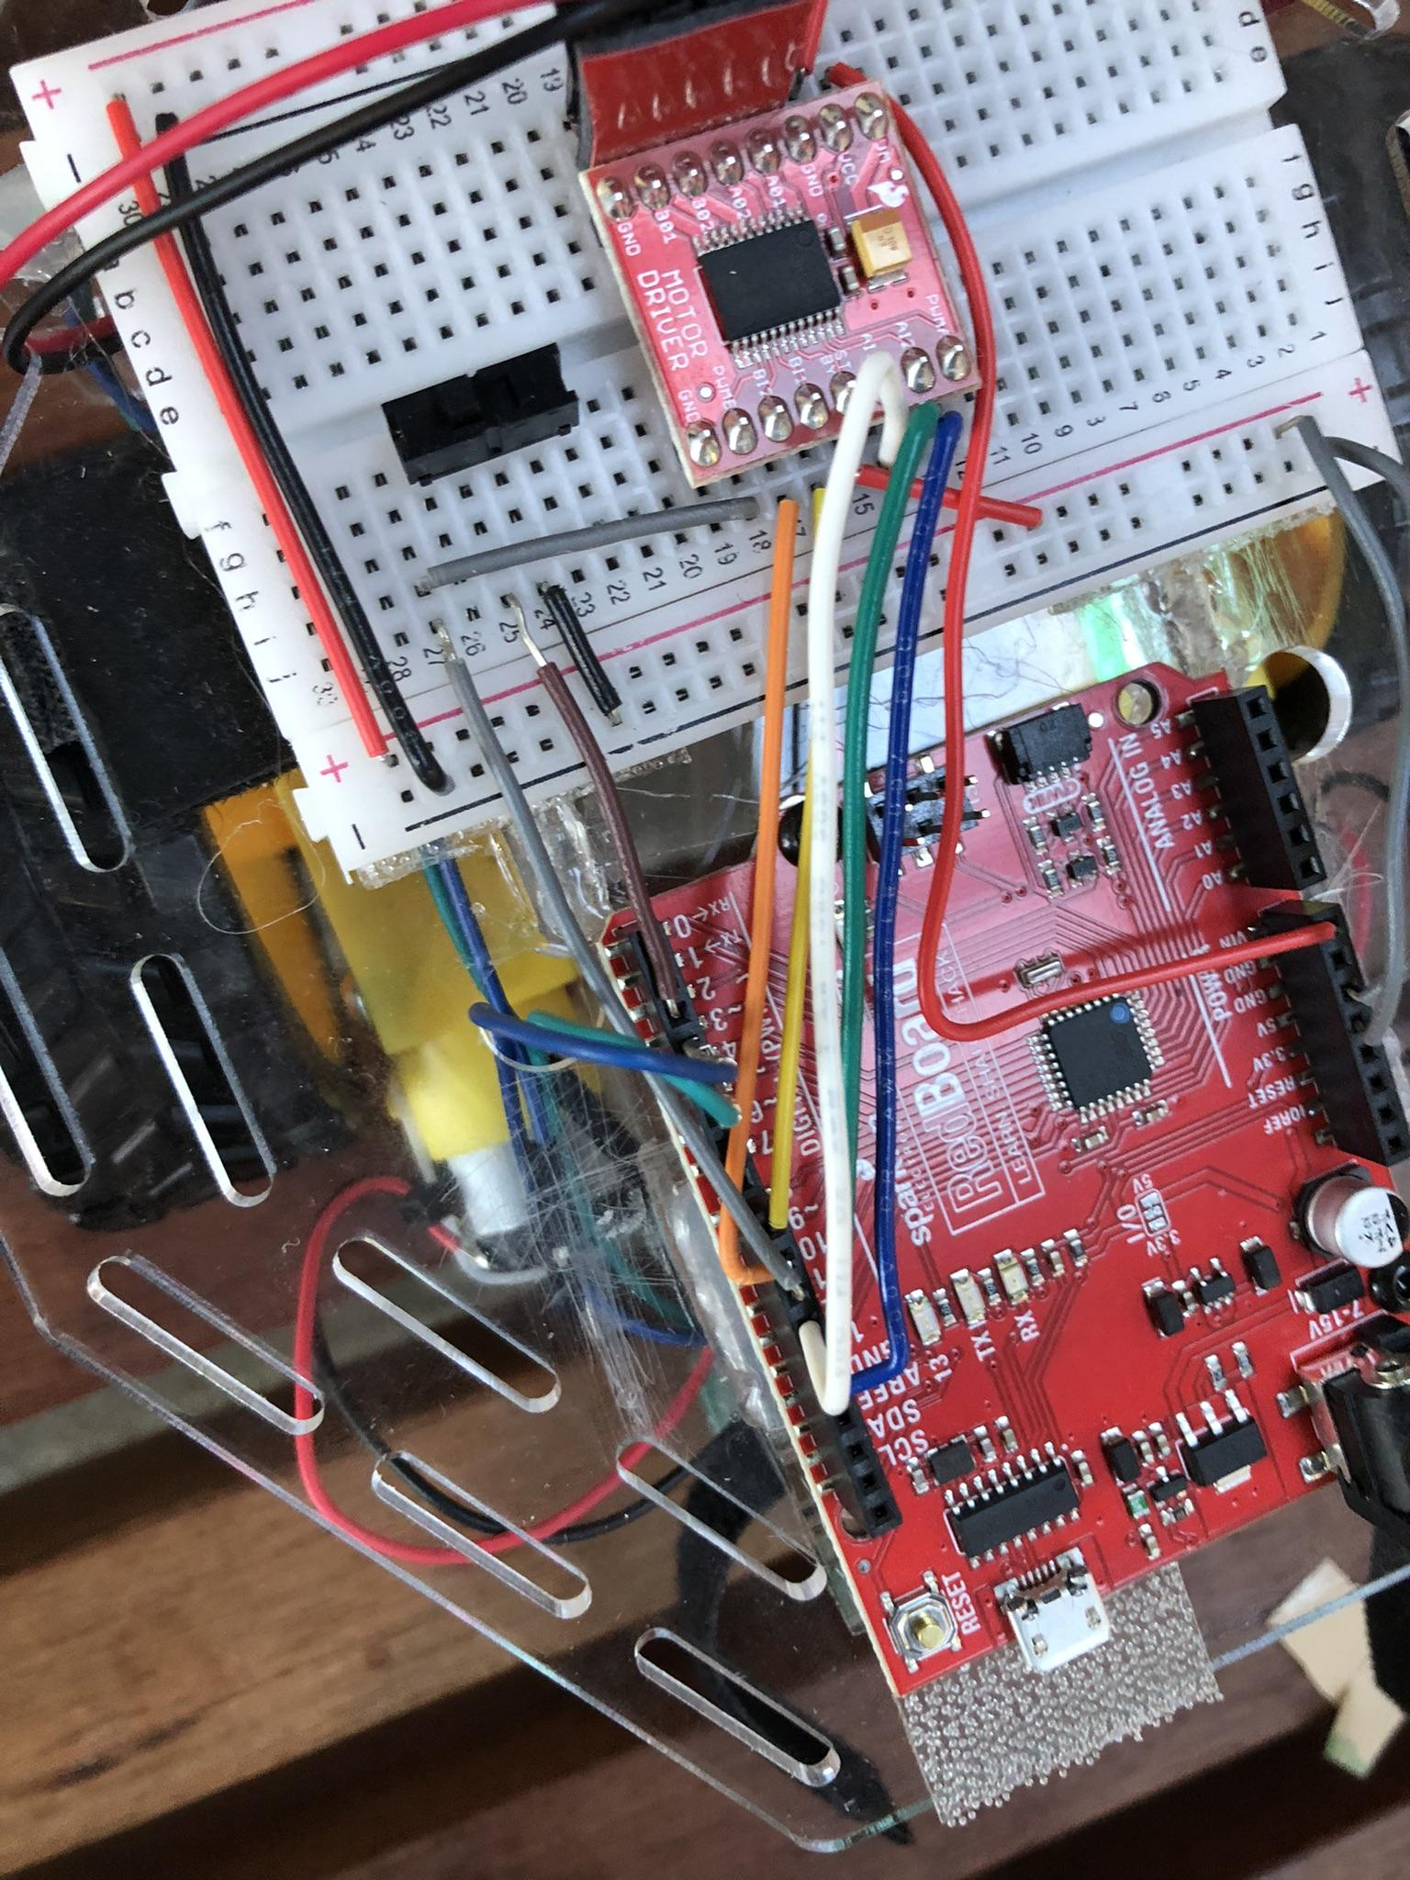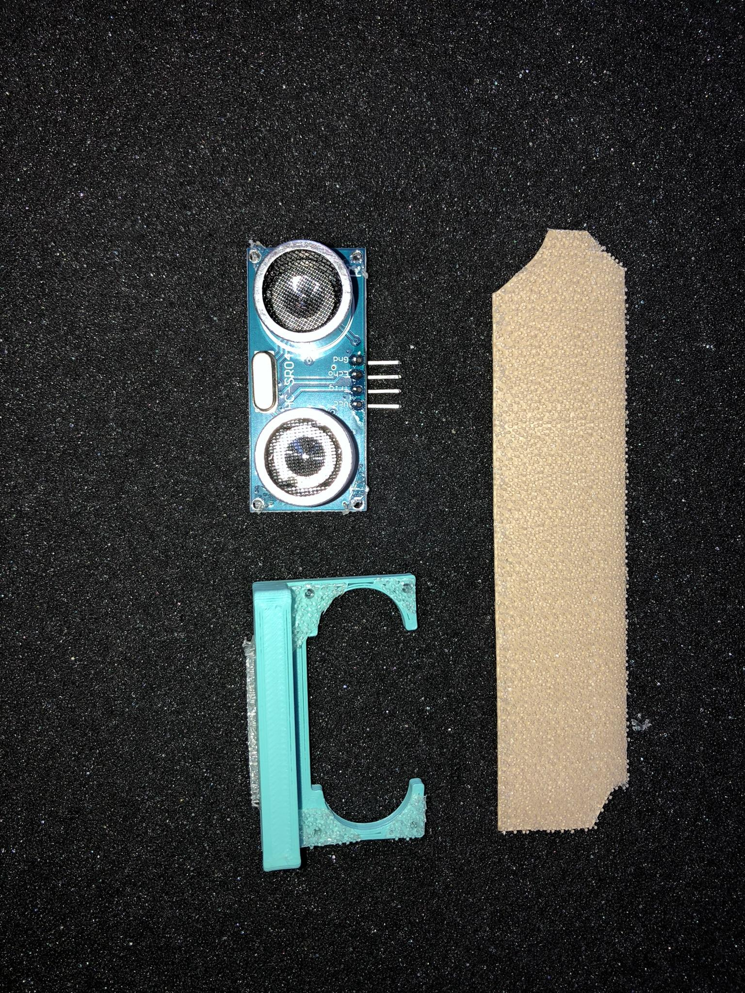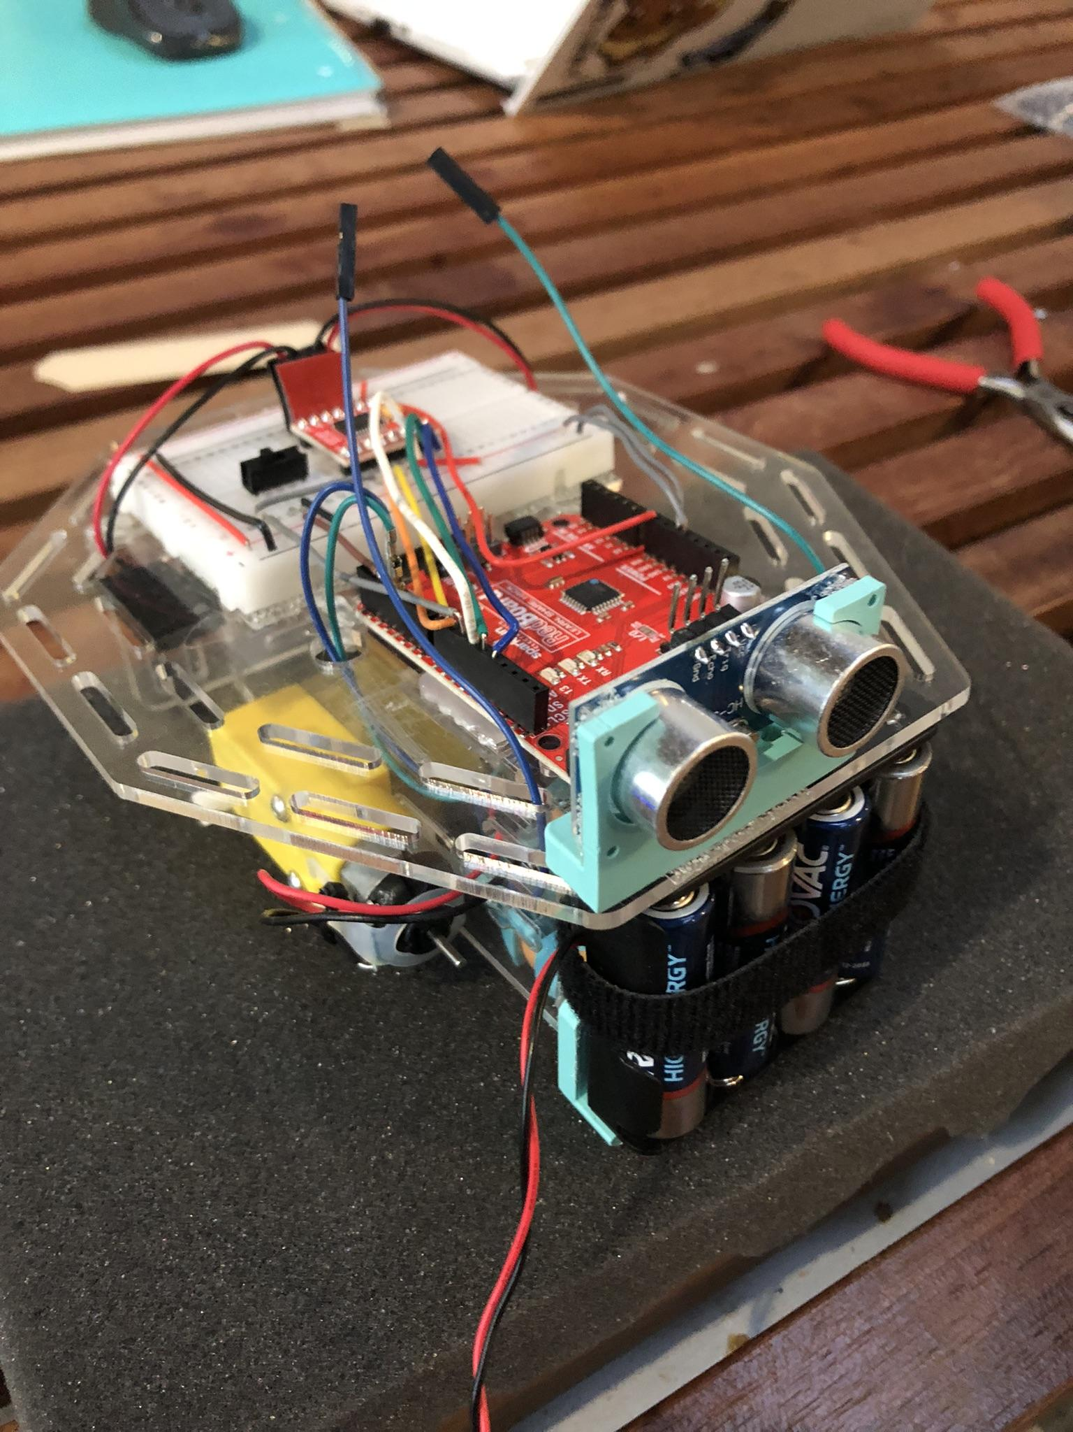
Robot Overview Close view of Sensor Mounting Supplies for Sensor Mounting Mounted Sensor

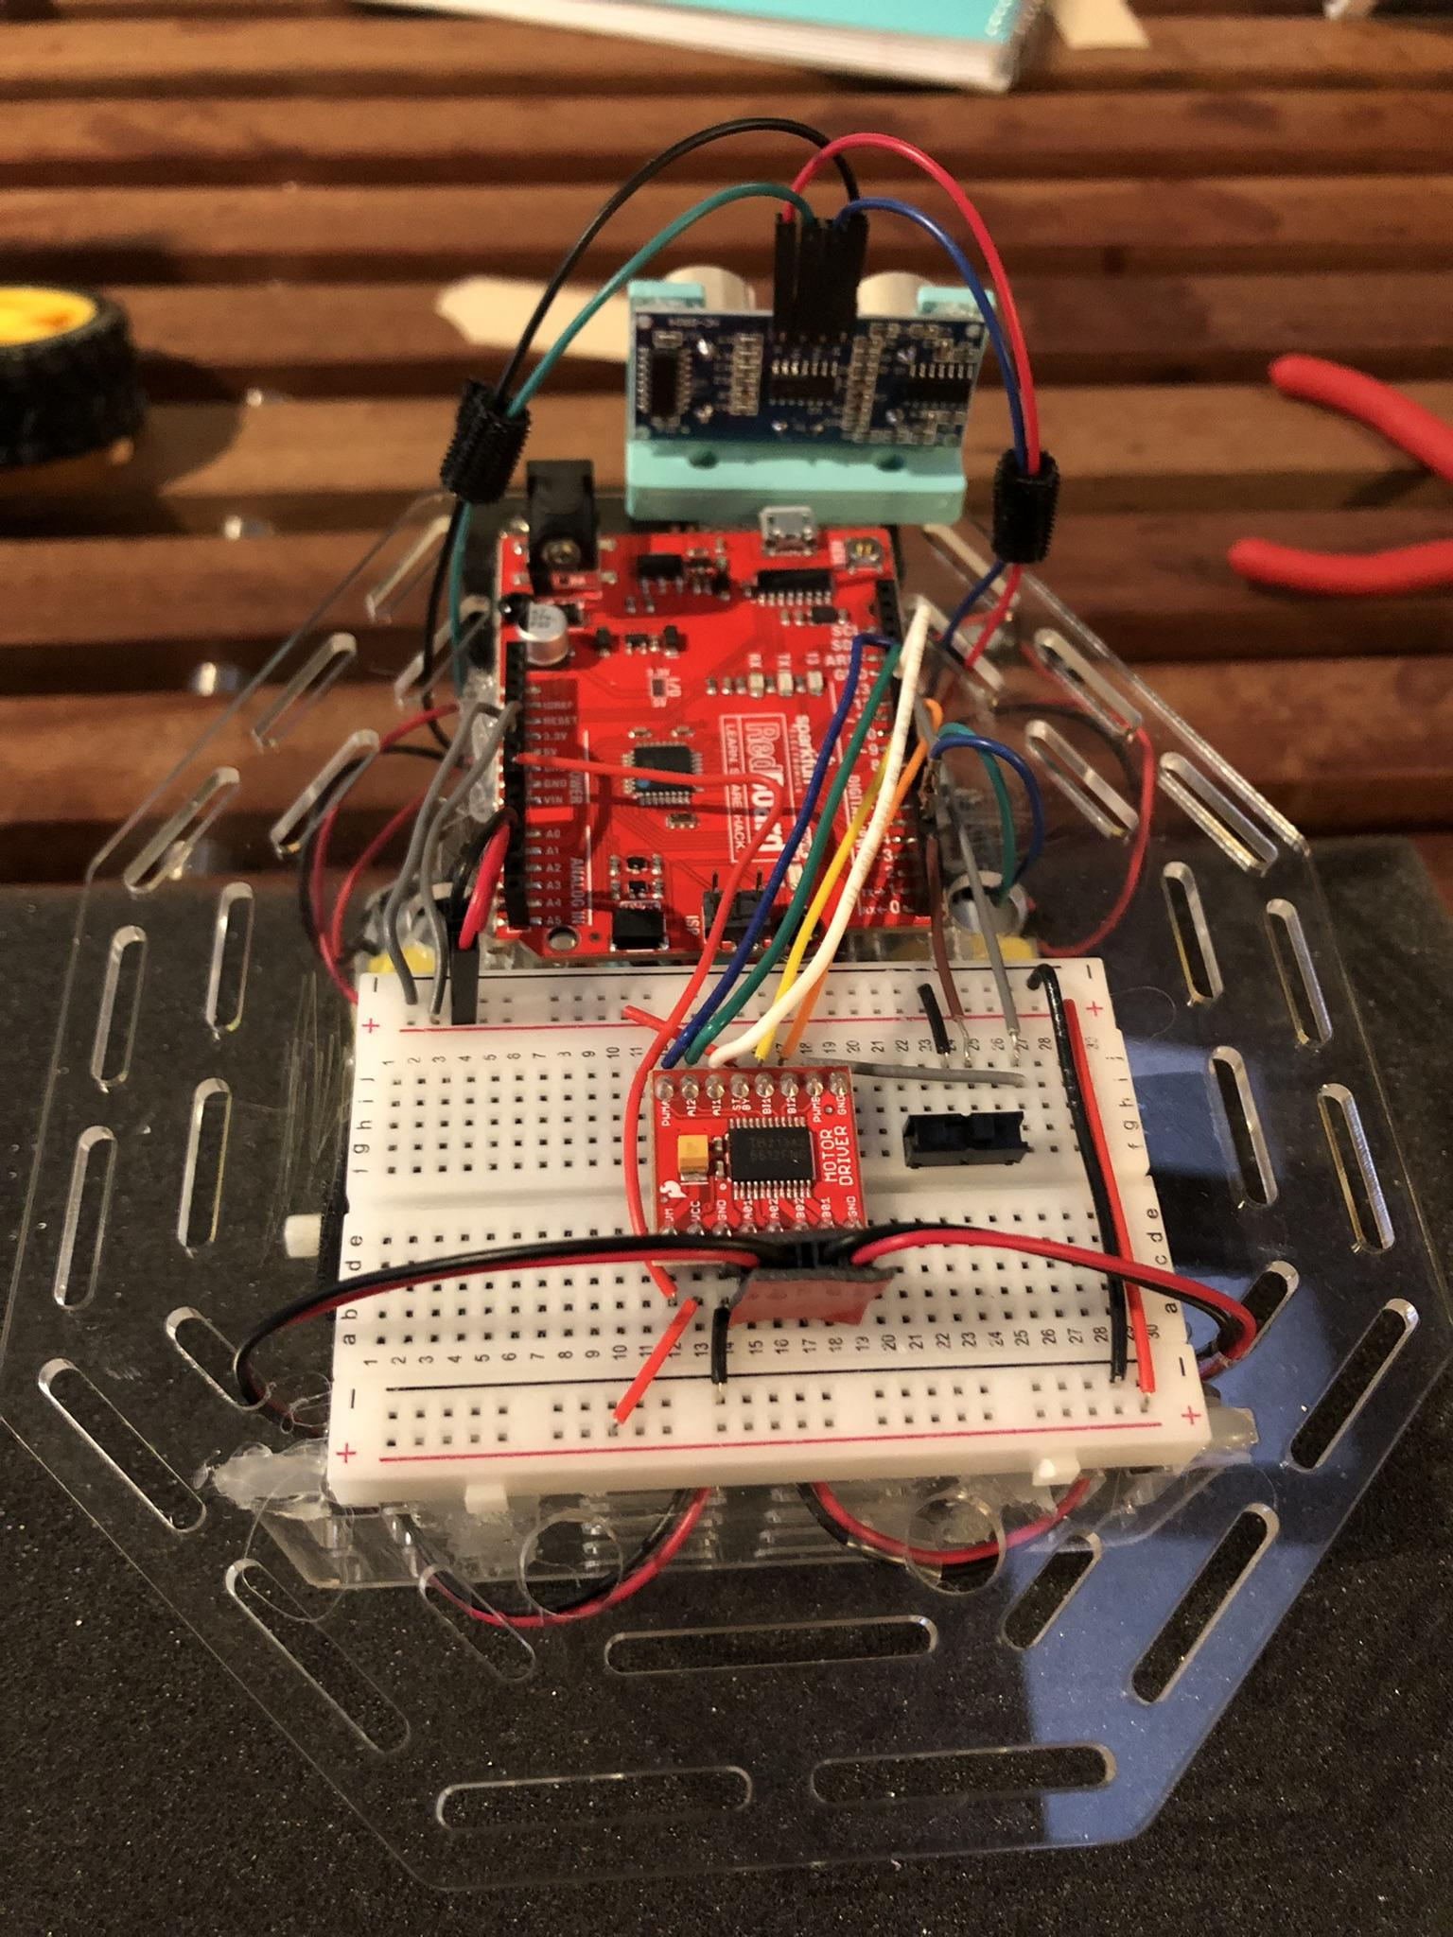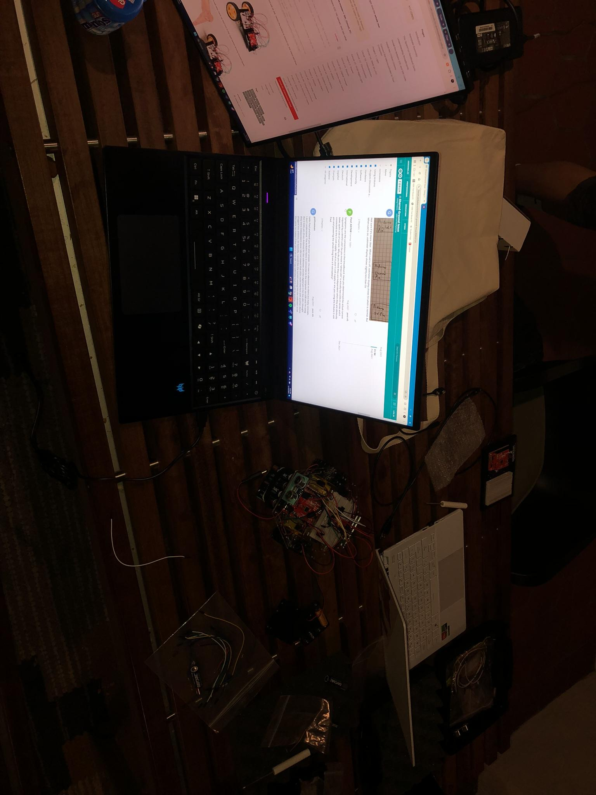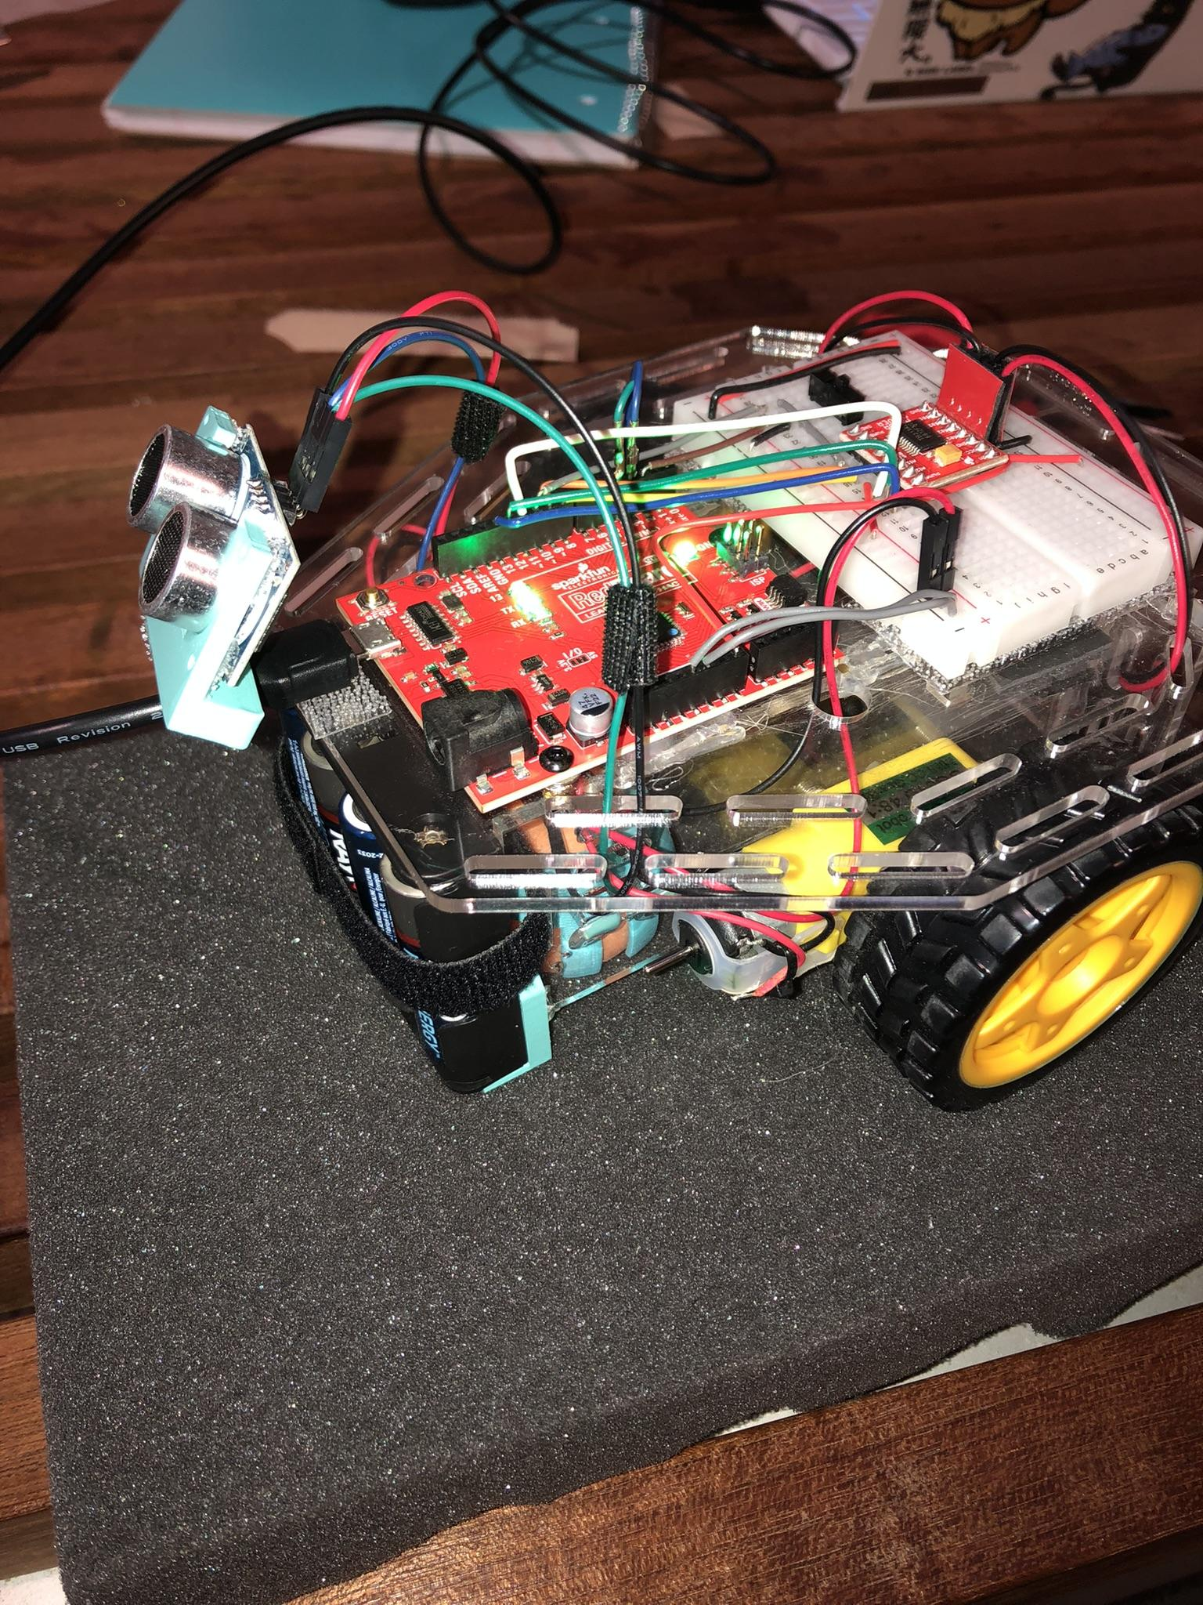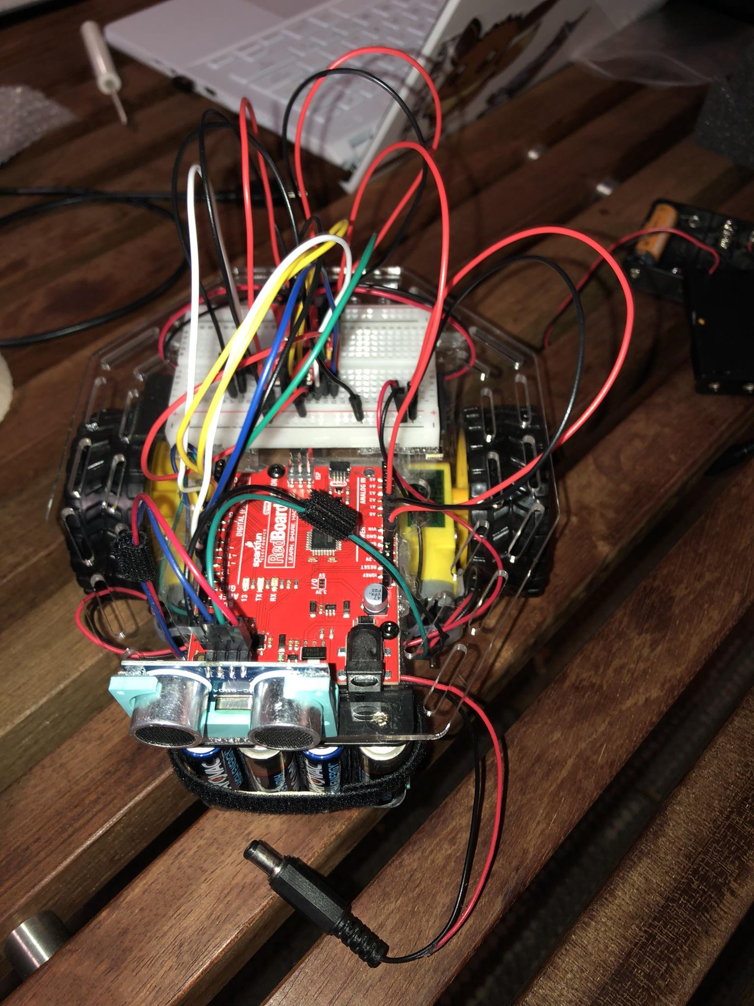
Mounted Sensor (Rear View) Work and Troubleshooting Sensor Removed for Port Access Rewired Robot

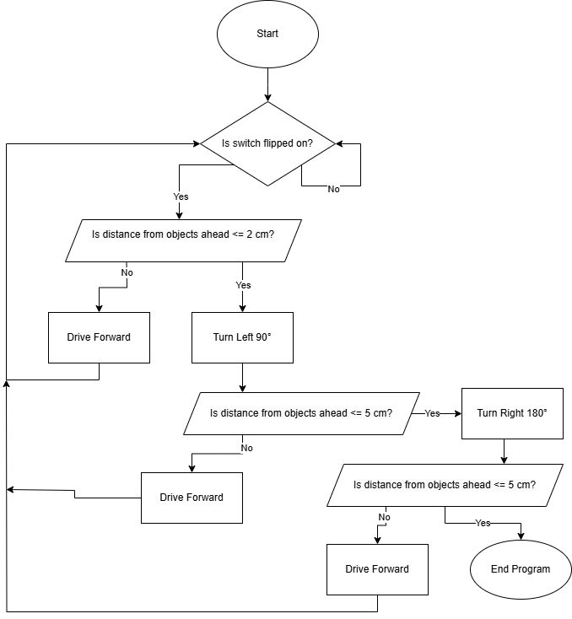
Program Flow Chart

What did I work on today?
The expectation before this meeting was that it would be a short session where the team would be able to complete the entirety of robot challenge three, to then do final testing the following Tuesday in class. The first of many roadblocks in this meeting was the unforeseen closure of the maker space for the day, in contrast to what the posted hours were. This meant the team's meeting was moved to the Mary Morse Residence Hall sunroom.
The first issue that the team had to solve this meeting was where to mount the sensor. Teams were provided with a solution in the form of a mounting area in front of the breadboard and over the ping pong ball “wheel”. This however would not be acceptable if we intended to keep our robot driving in a push, rear wheel drive (RWD), configuration with the ping pong ball as the rear “wheel”. Through previous testing this layout proved to be significantly more effective at turns, thus we were keen to keep the RWD layout. Looking to the opposite side, our robot’s forward face, an equivalent top mounted solution would block access to both the battery barrel port and the USB Type B port. An inverted mount, attached to the bottom of the top plate, isn’t possible due to the location of the battery pack. The temporary solution we came to was mounting the sensor, and its 3d printed mount, using Dual Lock Reclosable Fastener tape in front of the RedBoard ports. This allows us to remove the sensor when access to aforementioned ports is necessary and provides a prime location for clear unobstructed readings from the ultrasonic sensor.
With our ultrasonic sensor mounted we began to create our initial program for the robot. To start, Nolan Leonhardt had to find a way to efficiently loop the robot driving forward until an object was detected ahead of the robot. Additionally, the robot has to check its left to see if its path is blocked. Given the path is clear, the robot should continue forward. However, if the path is blocked, the robot will rotate 180° checking its right. If the right side is clear, it will continue forward; If both sides are blocked, the program will end, indicating that the robot has reached the end of the maze. There was an extensive discussion amongst the team deciding how this code should be implemented. The solution was a combination of a few ideas that included both while loops and a series of nested if statements.
With our code drafted and our robot set, we ran our maiden test. Plugging our battery pack in, placing the robot on the floor, and flipping the switch: our robot began to spin in a periodic cadence to its right. Frustrated, we went back to our code making a few small changes - that in retrospect as this Notebook entry is edited would have changed absolutely nothing in our results - and then tested the robot while plugged into our Nolan Leonhardt’s laptop. The results this time were what we expected, with the robot correctly functioning; yet, when we took the robot and attempted to run it on battery power the same problem arose. At this point we had realized there was some kind of hardware issue rather than a problem with our code. This started our process of ruling out possible issues. First, we rewired the whole bot using new jumper wires, no change; Second, we checked the placement of each wire ensuring that they were in the same position as the provided spark fun reference image, again no change; Third, we attempted to upload the code using Owen Cutler’s laptop and a different USB Type B Cable, once again to no avail. Frustrated, we ended the session at 10:00 PM, more than 5 hours after we began, with a robot that was only capable of functioning when plugged in via USB Type B cable to a laptop.

Record Group Meetings (if any):
ChatGPT4 was utilized to assist in the creation of a portion of the following bullet point summarization.
- Owen Cutler, Nolan Leonhardt
- Minutes:
  - Maker space was unexpectedly closed, so the team relocated to the Mary Morse Residence Hall sunroom.
  - Team discussed where to mount the sensor.
  - The suggested mounting location for the sensor would require us to change the direction our robot moves.
  - Considered mounting on the robot's forward face; however this would block access to the battery barrel port and USB Type B port.
  - An inverted mount under the robot was not feasible due to the battery pack's placement.
  - Decided to use Dual Lock Reclosable Fastener tape to mount the sensor in front of the RedBoard ports. Allowed easy removal of the sensor when necessary and provided unobstructed readings from the ultrasonic sensor.
  - Began developing the initial program.
  - Nolan Leonhardt led the effort to create a loop where the robot would move forward until an object was detected.
  - The robot was programmed to check if its left side was blocked. If clear, the robot would continue moving forward; if blocked, it would rotate 180° to check the right side.
  - If the right side was clear, the robot would continue forward. If both sides were blocked, the program would end, indicating the robot had reached the maze’s end.
  - Debated the best way to implement this logic, deciding to use a combination of while loops and nested if statements.
  - Ran the first test with the battery pack plugged in and the robot powered on.
  - The robot began spinning periodically to the right, which was not the expected behavior.
  - Small adjustments are made to the code and tested the robot again while plugged into Nolan Leonhardt’s laptop.
  - The robot worked as expected when connected to the laptop.
  - When switched to battery power, the same issue of spinning to the right occurred.
  - Came to the conclusion that the issue was hardware-related, not software-related.
  - Tried new batteries. Issue not fixed.
  - Tried a new battery pack with new batteries. Issue not fixed.
  - Efforts to troubleshoot began by rewiring the robot with new jumper wires, but the issue persisted.
  - Wire placement checked against the SparkFun reference image to ensure correct connections; this also did not solve the issue.
  - Attempted to upload the code using Owen Cutler’s laptop and a different USB Type B cable; the problem persisted.
  - After more than 5 hours of testing, the team concluded that the robot only functioned correctly when plugged into a laptop via USB Type B cable.
  - The meeting ended late, with the issue unresolved.

- Action Items:
  - Task: Resolve sensor mounting issue.
    - Assigned to: Owen Cutler, Nolan Leonhardt
    - Status: Completed
- Task: Develop code for robot’s movement based on sensor readings.
  - Assigned to: Nolan Leonhardt
  - Status: Completed
- Task: Test initial code functionality with the robot.
  - Assigned to: Owen Cutler, Nolan Leonhardt
  - Status: Completed
- Task: Troubleshoot hardware issue (robot only functions when plugged into a laptop).
  - Assigned to: Owen Cutler, Nolan Leonhardt
  - Status: In Progress
- Task: Investigate further hardware issues and determine root cause.
  - Assigned to: Owen Cutler, Nolan Leonhardt
  - Status: In Progress

What will I work on next time?

- Task: Troubleshoot hardware issue (robot only functions when plugged into a laptop).
  - Assigned to: Owen Cutler, Nolan Leonhardt
  - Status: In Progress
- Task: Investigate further hardware issues and determine root cause.
  - Assigned to: Owen Cutler, Nolan Leonhardt
  - Status: In Progress
- Task: Test robot before final tests in class.
  - Assigned to: Owen Cutler, Nolan Leonhardt
  - Status: Not Started

11/12/2024 | Completing Challenge Two | Owen Cutler, Nolan Leonhardt

Following the previous meeting, Team Toyota’s completion of Robot Challenge One, and its subsequent submission, we are left with a robot that has the capability to move in a straight line and stop after a set time (correlating with a desired distance). In the course of this meeting the team hopes to complete Robot Challenge Two. Much like Challenge One, likely to a greater degree, this will require testing and fixing discovered issues. The robot will have to now have the ability to turn right and left in addition to moving forward in a straight line.

Planned tasks list:
- Utilize robots and code created to complete challenge one to complete challenge two.
- Make the robot turn right.
- Make the robot turn left.
- Write test code directing the robot through the set maze. (Without going over boundary tape)
- Test robot and route.
- Solve discovered issues to create final code for Challenge Two.

Resources needed to complete the tasks
- Owen Cutler, Nolan Leonhardt
- Team Toyota Robot
- Maker Space Classroom
- Charged Laptop
- USB type A to USB type B cable
- Challenge Two Maze

Useful reference links: List any link related to today’s work

- Code before this meeting
- Final code for challenge two
- SparkFun circuit 5B reference page

- Videos:
  - Maze Testing - Major Route Issues
  - Maze Testing - Improvements Made
  - Maze Testing - Veering When Moving Forward
  - Maze Testing - Nearly Correct Route
  - Maze Testing - Turning Mistakes
  - Final In Class Demo

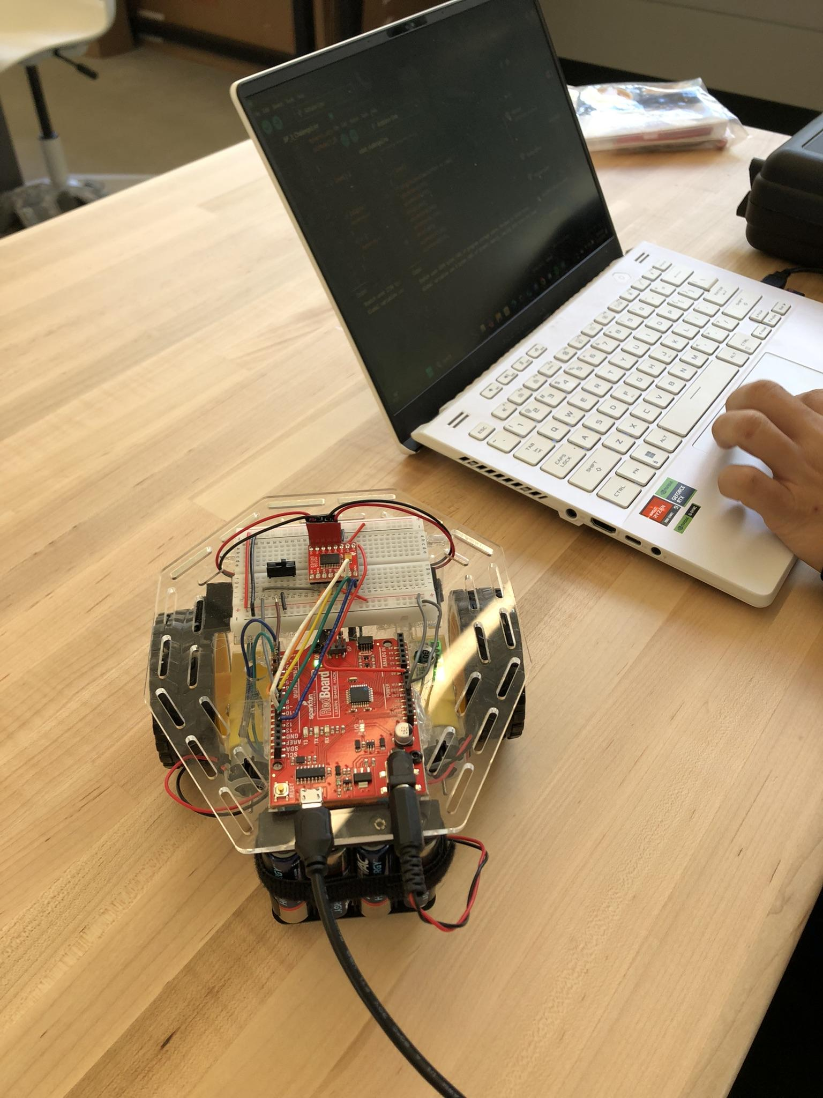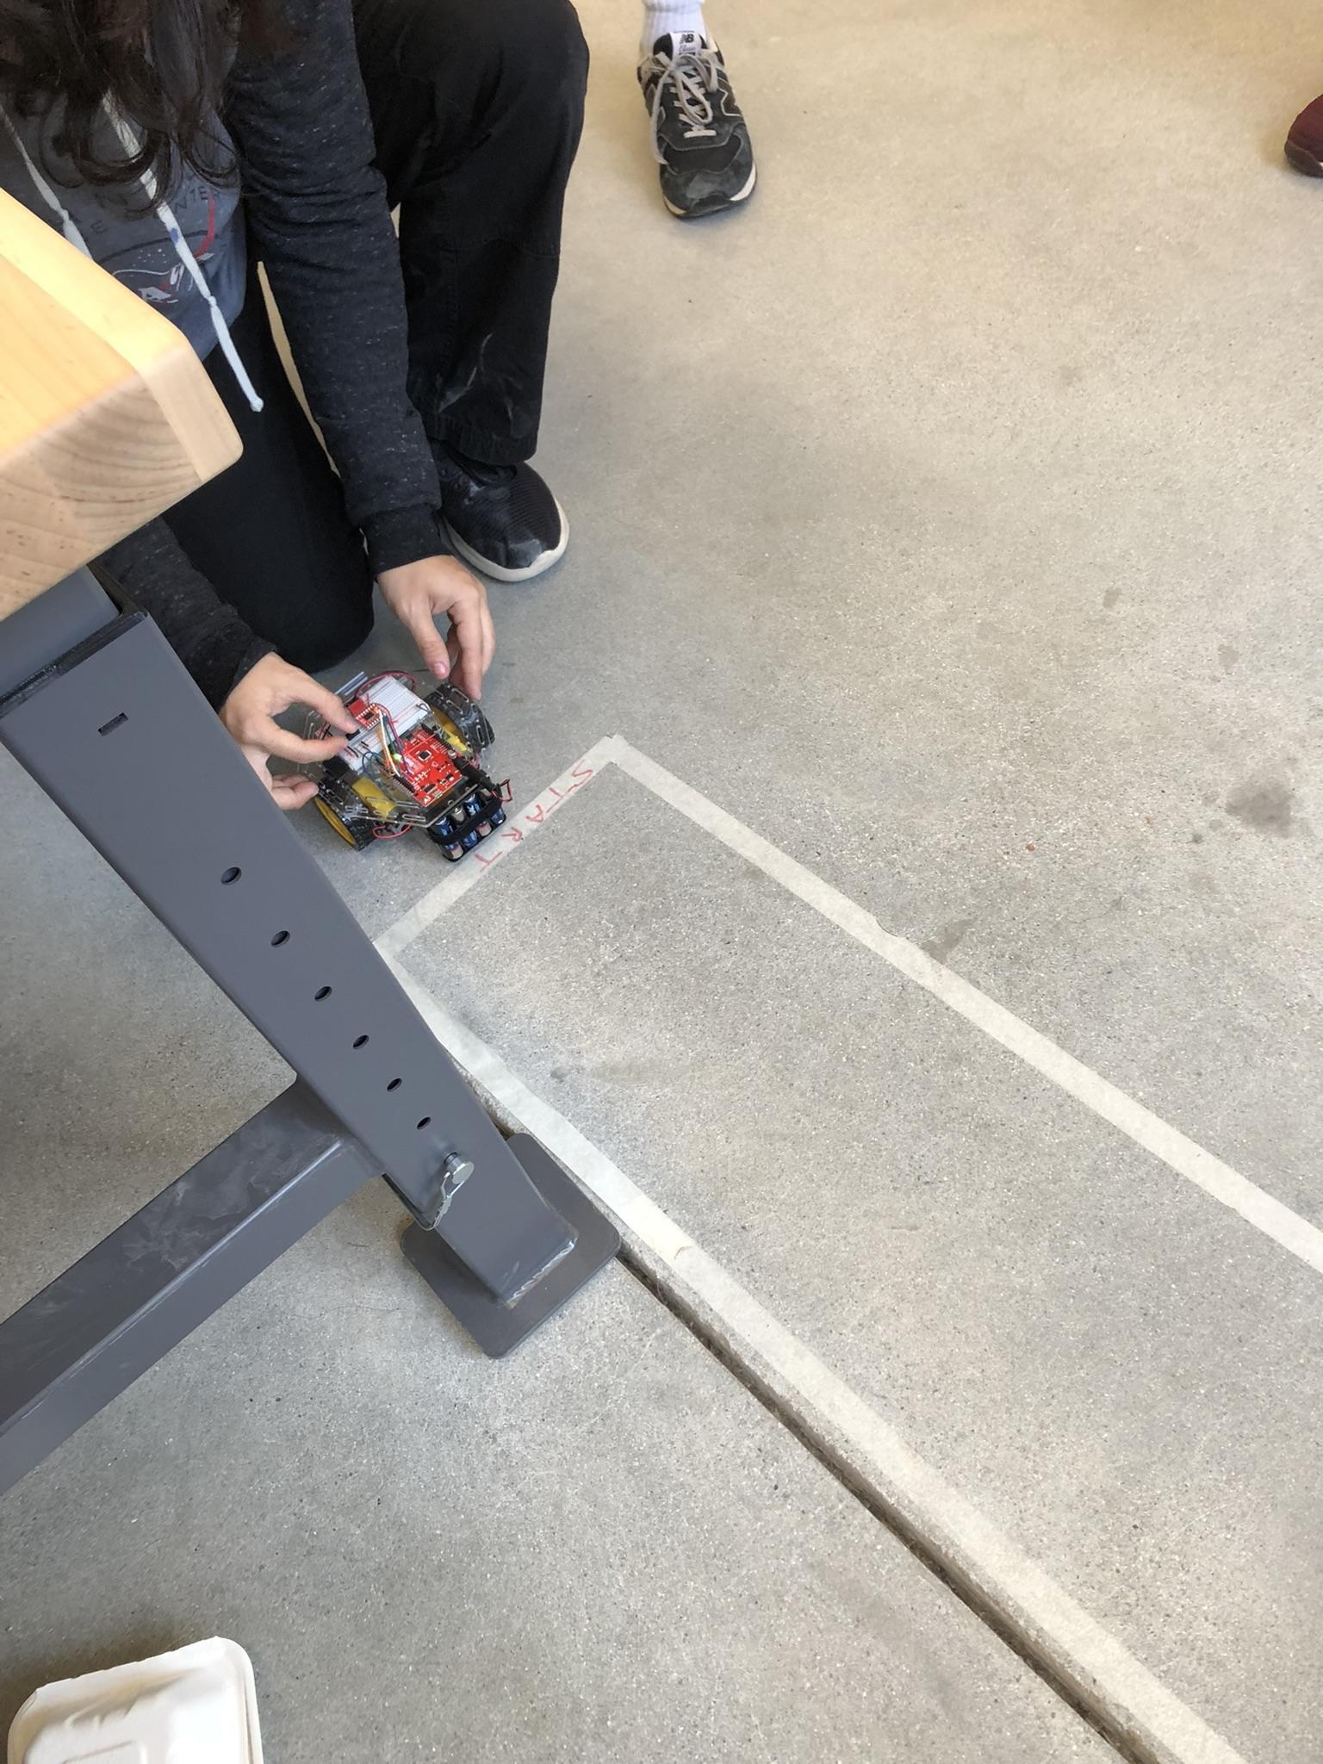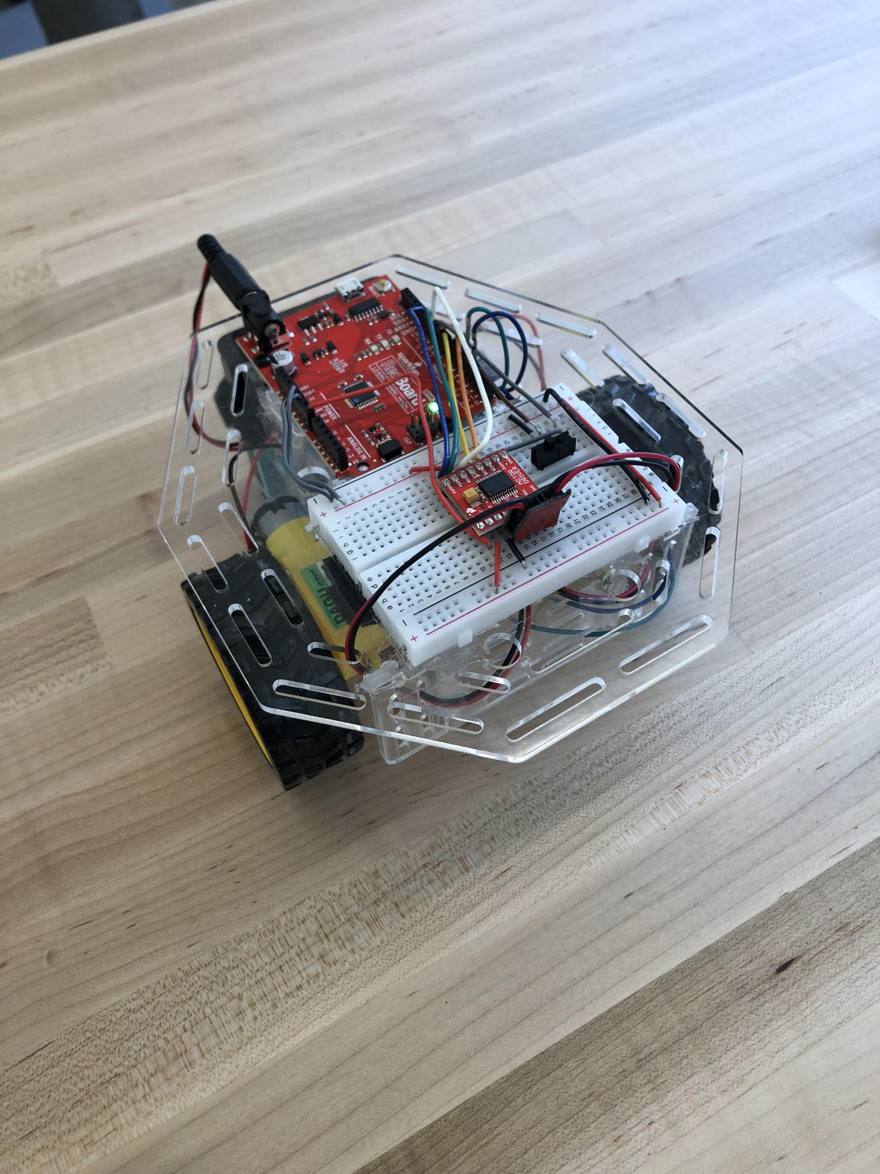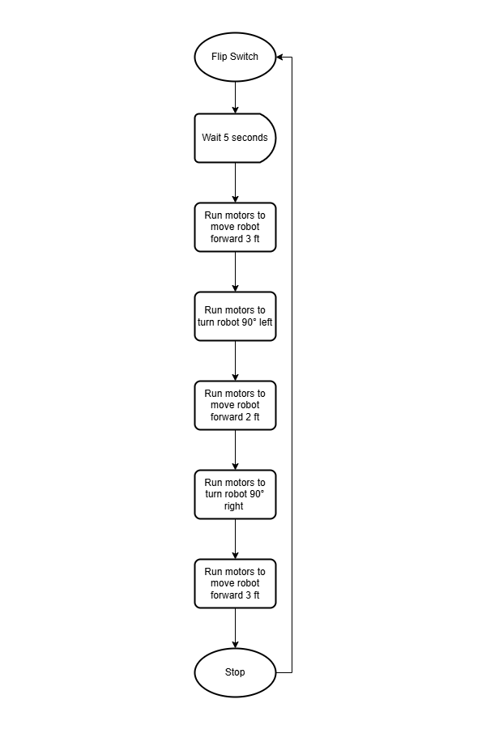
Robot at start of meeting. Testing. Robot at end of meeting. Flow Chart.

What did I work on today?
The meeting started with an, in retrospect foolish amount, of confidence.
Upon initial testing the robot seemed to still move in a straight line as it did during our Challenge One Demo. However, with further testing after implementing our turns for the maze the robot began to drift slightly to either the right or left when directed to move forward. First tests after observing this issue seemed to consistently show the robot drifting left. Thus, using our experience from Challenge One, we increased the speed of the left motor; this did not solve the issue.
The next thought was that there was an issue with the robot’s tyres maintaining consistent tracktion in the maze. Challenge Two’s maze is located on the floor of the maker space classroom. This meant that the robot was running on cold, dirty, concrete rather than cleaned wood like in Challenge One. The inconsistency in the direction of which the robot was drifting backed this hypothesis. Again Nolan Leonhardt attempted to change the difference between both motor’s speeds; yet, this resulted in no significant improvement, and any improvements were inconsistent.
After numerous testing attempts in the maze, Nolan Leonhard seemed to find a correct set of fixes. These included: cleaning the wheels before an attempt, lowering the robots overall speed, and making small adjustments to the degree at which the robot was turning.
In conclusion, we were able to have a successful demo run of the robot through the maze.
Record Group Meetings (if any):
- Owen Cutler, Nolan Leonhardt
- Minutes:
  - Initial test was run. Second test was run to verify consistency.
  - Initial tests showed that the robot still moved in a straight line as it did during Challenge One.
  - Created functions for the robot to turn right and left.
  - Note that the robot drifts to the left or right when moving forward.
  - Ran a handful of test attempts to navigate the maze.
  - Tests indicated that the robot drifted to the left.
  - Increased the speed of the left motor.
  - Drifting issue persisted.
  - Nolan Leonhardt hypothesizes that there is a lack of consistent tracktion between the wheel and ground.
  - A number of adjustments to motor speeds were made.
  - Improvements were present but inconsistent.
  - Ran more test attempts to navigate the maze.
  - Cleaned the wheels, lowering the robot’s speed, and making small adjustments to the turning angles.
  - Successful demo run of the robot through the maze.
- Action Items:
  - Task: Clean the robot's wheels before each testing session.
    - Assigned to: Nolan Leonhardt
    - Deadline: Ongoing for each testing attempt
    - Status: Completed before each test.
- Task: Lower the robot’s overall speed to reduce drifting.
  - Assigned to: Nolan Leonhardt
  - Deadline: Ongoing for each testing attempt
  - Status: Completed for each test
- Task: Identify and address motor imbalance causing veering issues.
  - Assigned to: Nolan Leonhardt, Owen Cutler
  - Status: Completed
- Task: Present and record in-class demo for Challenge Two submission.
  - Assigned to: Owen Cutler, Nolan Leonhardt
  - Status: Completed

What will I work on next time?
- Task: Write First Draft of Code for Challenge Two.
  - Assigned to: Nolan Leonhardt, Owen Cutler
  - Due Date: 11/18/2024
  - Status: Started
- Task: Make Necessary Changes to the Robot for Challenge Three
  - Assigned to: Owen Cutler
  - Due Date: 11/18/2024
  - Status: Started

11/05/2024 | Final Testing | Owen Cutler, Nolan Leonhardt

The goal of today’s meeting was to take our robot and the finished code for challenge one and run a few final tests. If any last minute issues are to arise, solve them before presenting the final in class demo. Once all final issues are resolved and the in class demo is complete, film a final video for submission.

Planned tasks list:
- Test the robot for any final issues.
- Fix any issues that arise.
- Complete final test for submission.
- Record Robot Completing the Final Test.

Resources needed to complete the tasks
- Owen Cutler, Nolan Leonhardt
- Make Space Classroom
- Robot
- Laptop with code.
- 4 Foot Long Test Tap Box.
- Camera to Record.

Useful reference links: List any link related to today’s work

- Final Test For Submission

What did I work on today?
We came into this meeting with our final tested code and the final tested robot with new wiring for Challenge One.
Our first test of the meeting was nearly exactly the result we desired and what was needed for our challenge one submission. We had a small issue with our robot turning slightly to the right. Upon further inspection in both the issue we were seeing and the robots code. Nolan Leonhardt changed the motor speed of the motor to an even slower speed that what had already been set. The left motor of our robot seemed to be significantly more powerful than our robot's left motor. This issue was noticed by Nolan Leonhardt when he was testing the code before this meeting however these final changes were needed to have the robot run in a nearly straight line.
Once this was finished we presented our in class demo of the robot for challenge one, and recorded the test for submission.

Record Group Meetings (if any):
ChatGPT4 was utilized to assist in the creation of a portion of the following bullet point summarization.
- Owen Cutler, Nolan Leonhardt
- Minutes:
  - Conducted the first test of the meeting, which nearly produced the desired result for Challenge One submission.
  - Noticed a small issue with the robot veering slightly to the right.
  - Upon further inspection, it was determined that the left motor was significantly more powerful than the right motor, causing the imbalance.
  - Nolan Leonhardt adjusted the motor speed, slowing the left motor to a more even speed, which helped correct the issue and allowed the robot to move in a nearly straight line.
  - The motor imbalance had been identified earlier by Nolan during testing, but these final adjustments were needed to achieve the desired performance.
  - After the adjustments, the team presented the in-class demo for Challenge One, recording the test for submission.

- Action Items:
  - Task: Test and finalize robot code for Challenge One.
    - Assigned to: Owen Cutler, Nolan Leonhardt
    - Status: Completed
- Task: Identify and address motor imbalance causing veering issues.
  - Assigned to: Nolan Leonhardt, Owen Cutler
  - Status: Completed
- Task: Adjust motor speeds to correct imbalance and achieve straight-line movement.
  - Assigned to: Nolan Leonhardt
  - Status: Completed
- Task: Present and record in-class demo for Challenge One submission.
  - Assigned to: Owen Cutler, Nolan Leonhardt
  - Status: Completed

What will I work on next time?
- Write First Draft of Code for Challenge Two.
  - Assigned to: Nolan Leonhardt, Owen Cutler
  - Due Date: 11/10/2024
  - Status: Started
- Make Necessary Changes to the Robot for Challenge Two
  - Assigned to: Owen Cutler, Nolan Leonhardt
  - Due Date: 10/10/2024
  - Status: Not Started

11/04/2024 | Coding the Robot | Nolan Leonhardt

Today’s main project goal will be to fully code the robot to fulfill the object of challenge 1 which is to drive in a straight line for four feet.

Planned tasks list:
- Write code for the robot
- Upload the code to the robot
- Test the code for the robot
- If it doesn’t work, troubleshoot and test again

Resources needed to complete the tasks
- Nolan (1 team member)
- Dorm common room (to test the robot)
- Robot, laptop, upload cable, sparkfun kit (incase I need to troubleshoot)
- A four foot long table

Useful reference links: List any link related to today’s work

- https://youtube.com/shorts/opbIKia_UIA
- https://youtube.com/shorts/uC8yP53VxCk

What did I work on today?
I coded the robot to follow the challenges labeled out. I first started by looking at my SF2 code which is similar to the code needed for the challenge and copied over the parts that I needed. I then decided to test my code on the floor to see if it ran. It did end up running but it drifted heavily to the right. I figured that this was due to the left motor being stronger than the right motor so I decided to up the speed of the right motor while lowering the speed of the left motor until it drove in a straight line.
Record Group Meetings (if any):
- Attendees: Nolan Leonhardt
- Minutes:
  - write initial code
  - test the initial code
  - rework code until it works the intended way.
What will I work on next time?
- Next time I will work to code the robot for challenge 2
- I will also reflect on this challenge and design ways to improve the design of the robot.

10/27/2024 | Rewiring Session One | Owen Cutler

The goal of today’s meeting is to take the tested wiring and reimplement it in a more easily manageable and clearly understandable way. Hookup wires should have clear paths that can be interpreted at a glance without extended explanation. Any runs of jumper wires should be organized in a thoughtful way. There should be no effect on the function of the robot following these changes.

Planned tasks list:
- Rewire the robot in a well managed and easily interpreted way.

Resources needed to complete the tasks
- Owen Cutler
- Dorm Room
- Robot
- Hook-Up Wire
- Jumper Wire
- Wire Cutter
- Wire Stripper
- Ruler

Useful reference links: List any link related to today’s work

- Sparkfun Wiring Reference Image

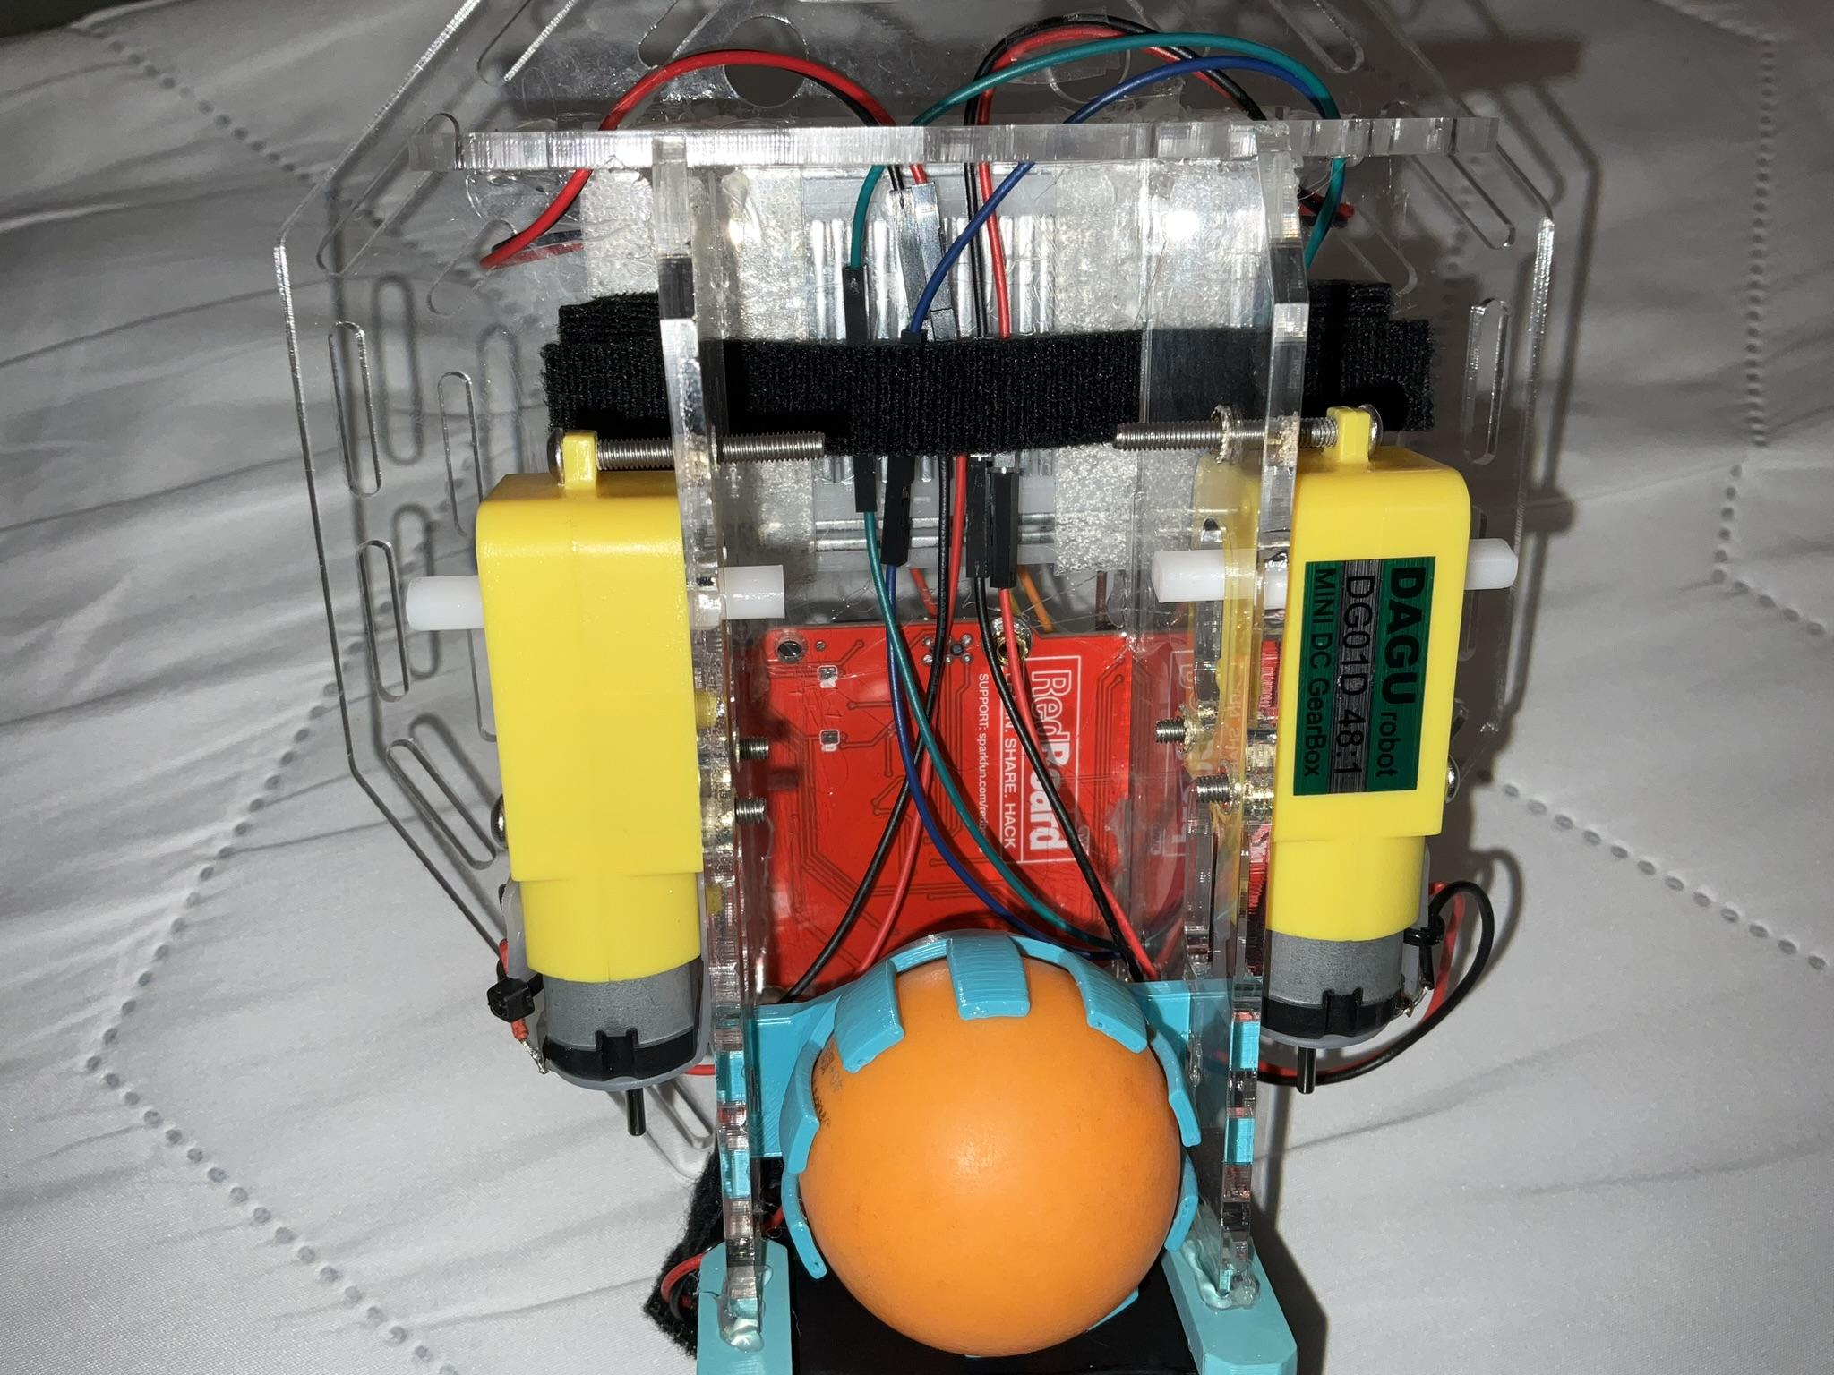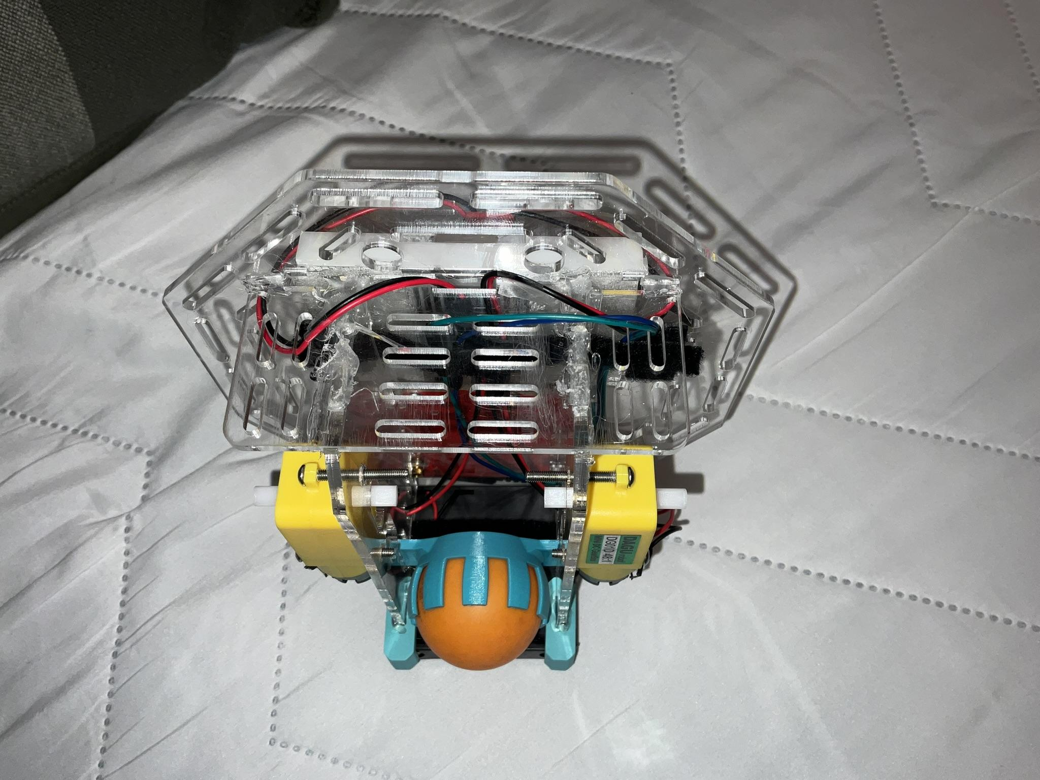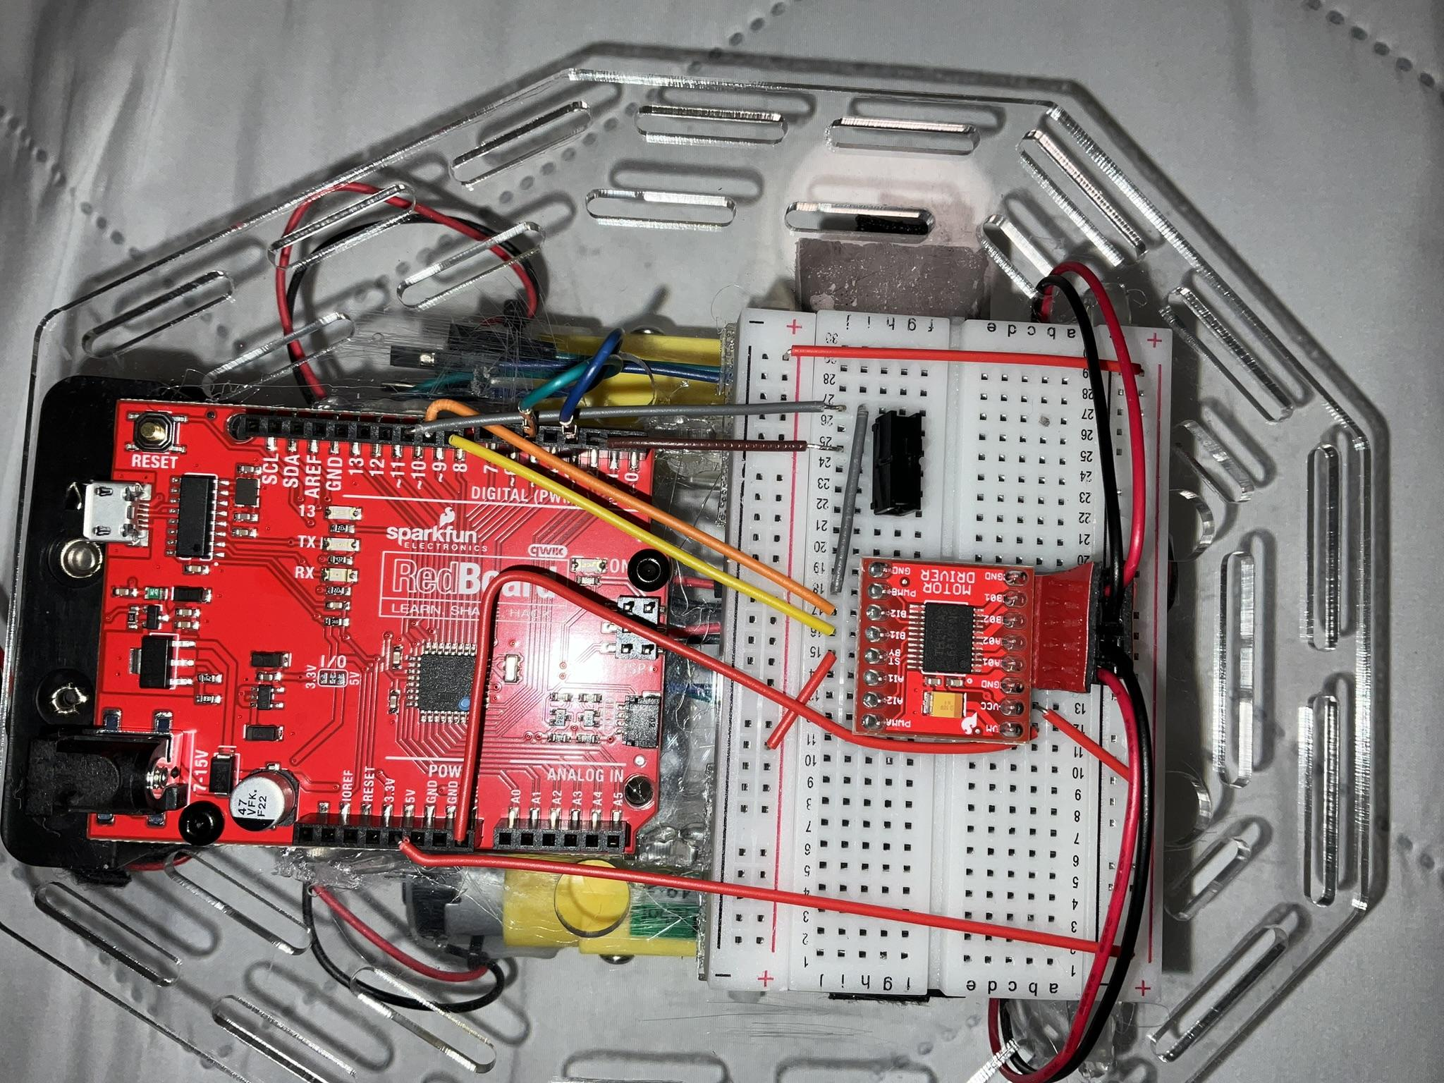
Wiring Harness (Bottom View) Motor and Sensor Wires Existing Bottom Area. Top Down View of Wiring.
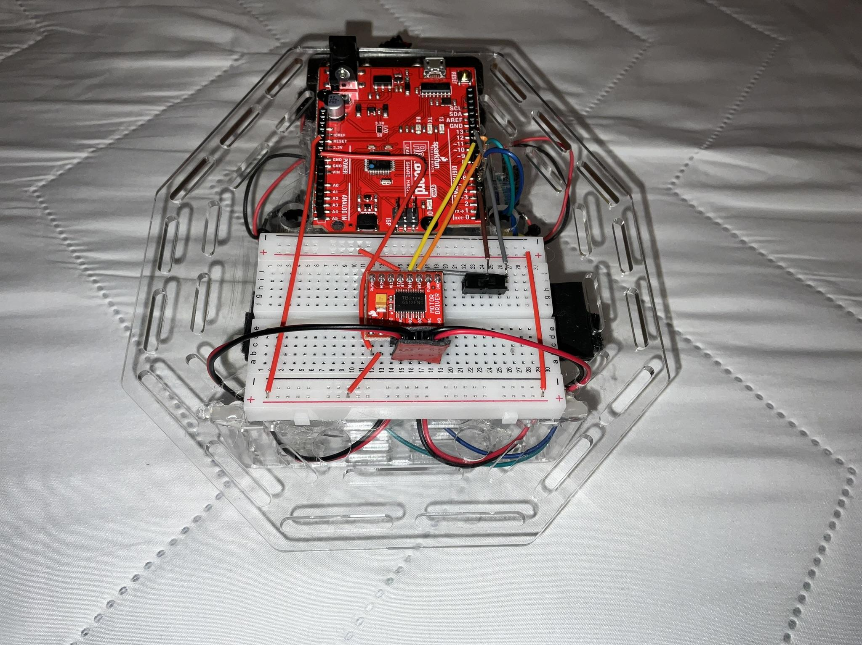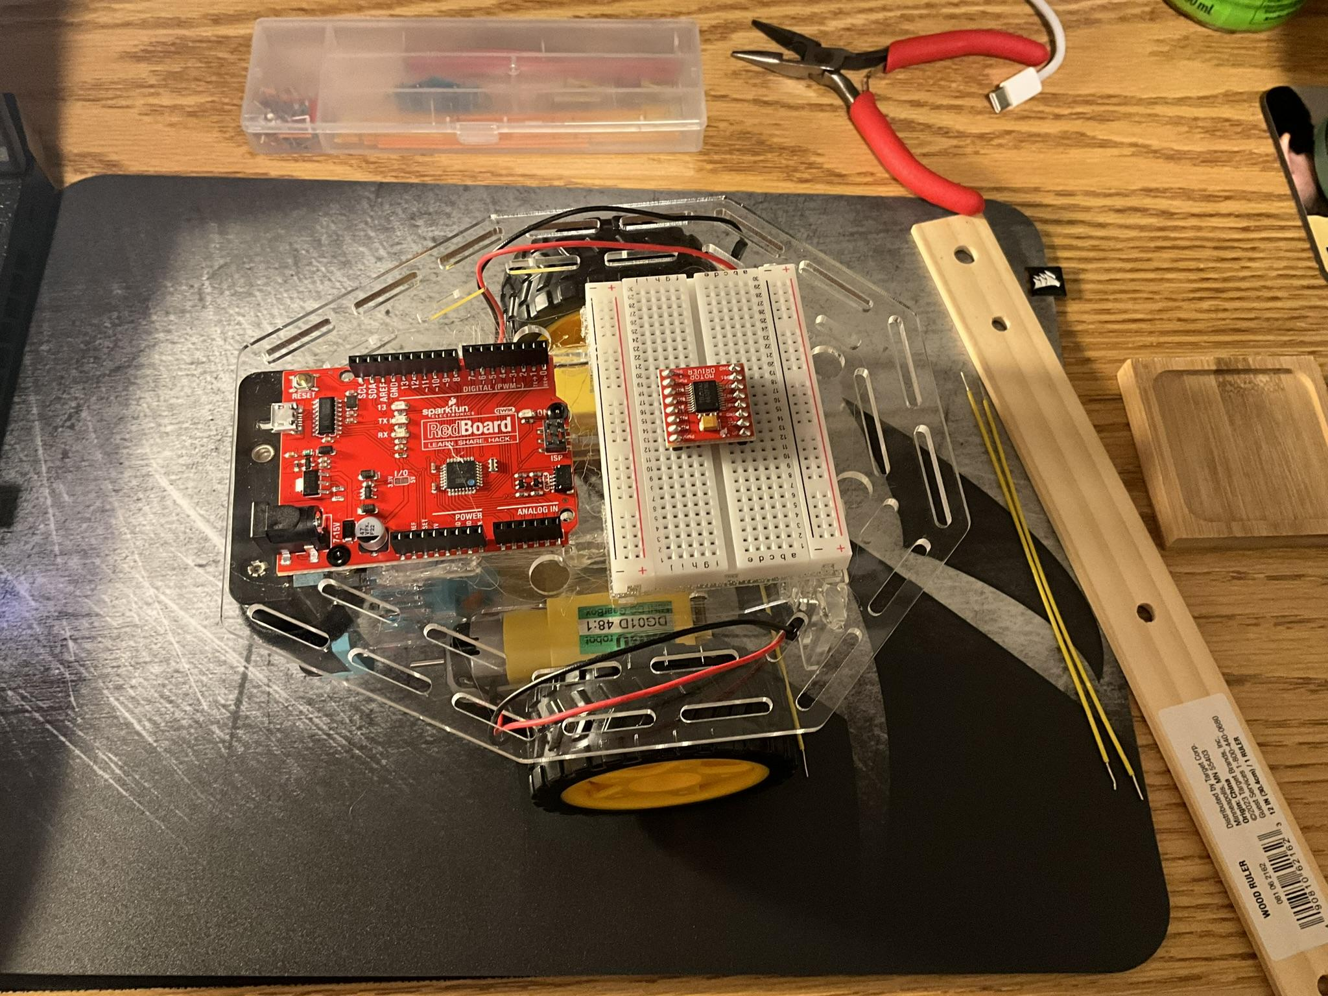
Front Top View of Wiring Before Work.

What did I work on today?
To begin, I removed the existing wires from the robot. This left me with only the frame, breadboard, RedBoard, motors, wheels, and battery pack attached together.
Next, referring to the wiring image we used to initially test our robot, I planned out the wire runs I needed to complete. I did this by plotting where each wire had to go, and then measuring the length of each run along with any necessary bends. With my planning and measurements done, I began to cut hookup wire to the lengths I measured. With the correct length wires, I then made any necessary bend before placing them on the robot.
An important stage of this process was finding how to manage both motor’s wires. The best route I found was into the interior of the robot’s frame and then out the front and up to the breadboard. However, in order to do this I had to find a way to fit the jumper wires through a hole in the frame that was slightly too small for both wires and their plastic connectors. My solution for this was momentarily taking off the plastic connectors which allowed me to slide the wire through this hole, then re-attaching the plastic connectors. Additionally I added a velcro wire harness to the bottom of the top frame plate. This was an additional way our robots wires were neatly managed.
Another task I completed in this meeting was starting the wiring for our eventual need of the distance sensor. These are the blue and teal jumper wires that are currently plugged into the RedBoard but just sit under the velcro harness.

Record Group Meetings (if any):
ChatGPT4 was utilized to assist in the creation of a portion of the following bullet point summarization.
- Owen Cutler
- Minutes:
  - Took photos of the robot, with a focus on the wiring, before removing wires. (Left the frame, breadboard, RedBoard, motors, wheels, and battery pack attached.)
  - Removed all wiring.
  - Utilized images taken of the robot before removing wires and the image used for testing.
  - Focused on managing the motor wires; routed them into the robot’s frame and out the front, up to the breadboard.
  - Addressed the issue of the narrow hole by temporarily removing plastic connectors, passing the wire through the hole, and then reattaching the connectors.
  - Attached an additional hookup wire to each of the motor wires to have enough length to reach the breadboard.
  - Planned wire runs by measuring lengths and necessary bends.
  - Cut hookup wire to the measured lengths, prepped wires with necessary bends, and placed them.
  - Added a velcro wire harness to the bottom of the top frame plate for additional wire management.
  - Started wiring for the distance sensor, with blue and teal jumper wires plugged into the RedBoard, sitting under the velcro harness for now.
- Action Items:
  - Task: Remove existing wires and prepare for new wiring.
    - Assigned to: Owen Cutler
    - Status: Completed
- Task: Plan and measure wire runs for motor and sensor wiring.
  - Assigned to: Owen Cutler
  - Status: Completed
- Task: Cut and prepare hookup wire to correct lengths.
  - Assigned to: Owen Cutler
  - Status: Completed
- Task: Manage motor wire routing and frame integration.
  - Assigned to: Owen Cutler
  - Status: Completed
- Task: Install velcro wire harness for additional wire management.
  - Assigned to: Owen Cutler
  - Status: Completed
- Task: Begin wiring for the distance sensor.
  - Assigned to: Owen Cutler
  - Status: Completed

What will I work on next time?
- Task: Finish and Test Robot’s code resulting in the final program.
  - Assigned to: Nolan Leonhardt
  - Due Date: 11/5/2024
  - Status: Started
- Task: Test and Film the Final Robot for Challenge One.
  - Assigned to: Owen Cutler, Nolan Leonhardt
  - Due Date: 10/5/2024
  - Status: Not Started

10/26/2024 | Maiden Work Session | Owen Cutler, Nolan Leonhardt

Today’s main project goal will be to finish the mechanical structure of the robot. This is so we can start testing the robot and have ample time to troubleshoot any electrical or technical issues if we run into them later on. Our secondary goal is to test the robot to make sure that everything works. This way we know that the motors, motor controller, breadboard, and red board all work before we try running the robot.

Planned tasks list:
- Assemble Acrylic Robot Frame.
- Ensure Acrylic Frame Assembly is Structurally Sound.
- Install Beadboard on Robot Frame.
- Install RedBoard on Robot Frame.
- Install Both Motors on Robot Frame.
- Ensure Battery Pack Attachment is Effective.
- Test Both Motors for any Hardware Issues.

Resources needed to complete the tasks
- Both team members present. (Owen Cutler & Nolan Leonhardt)
- Northeastern University Oakland Campus - Maker Space.
- Acrylic Robot Frame Pieces.
- Hot Glue & Hot Glue Gun.
- Breadboard.
- RedBoard.
- 2x Motors.
- Printed Table Tennis Ball Mount.
- Printed Battery Pack Mounting Feet.
- Plastic Wheels.
- Battery Pack.
- 4x AA Batteries.
- Velcro.
- Motor Driver.
- Jumper Wires.
- USB A to USB C Cable.
- Laptop.
- Table Tennis Balls.

Useful reference links: List any link related to today’s work

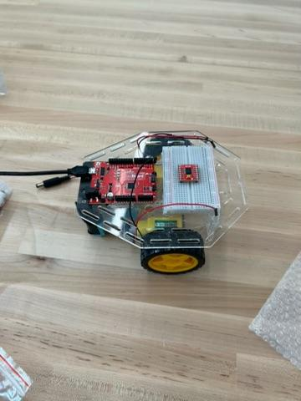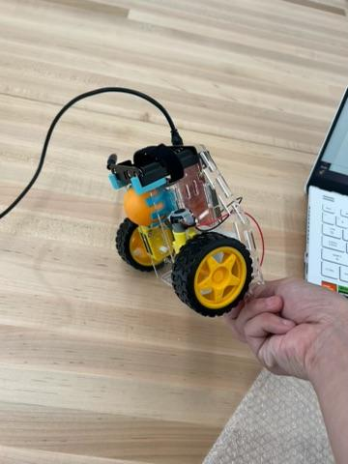
Top View. Robot Following Assembly Side View.

- Motor Test Video.
- Sparkfun Wiring Reference Image.

What did I work on today?
After Collecting all of our needed materials and setting up in the maker space, we began our work.
Firstly, we pieced together the robot frame according to the provided images and instructions. Once certain our work was correct, we glued the frame together. After a slight hiccup where the was an excess of glue behind where the battery back was intended to sit, we removed a small amount of material by via sanding. With the excess glue gone, the frame was fully assembled.
Second, the meeting attendees removed Nolan’s breadboard and RedBoard from the plastic base plate they were attached to. Another small issue occurred at this point; a few pieces of the bread board stuck to the adhesive pad upon separation. This meant re-attaching said pieces back to the breadboard before continuing. Once this was solved, we placed the velcro style (removeable) tape to both the top plate of the robot and the bottom of the breadboard, then attached the breadboard to the frame. The Redboard was also attached to the frame, this time using provided screws.
With both the breadboard and RedBoard attached to the acrylic frame, Nolan screwed both motors onto the frame. Following this process, the battery pack was filled with batteries and placed into its intended position, secured by a hook and loop fastener strap.
Third, having everything assembled the motors, breadboard, and motor driver were wired together using the, above linked, Sparkfun Wiring Reference Image for guidance. Owen read out the intended wire runs with Nolan then running the provided runs on the physical build. Once everything was assembled the motors were individually tested as seen in the above linked Motor Test Video.
With this we concluded our work for the day and unwired what had been done during this meeting, in order to then run hookup wire for the finished project.
Owen took the (now unwired) robot back to his dorm to be wired.

Record Group Meetings (if any):
ChatGPT4 was utilized to assist in the creation of a portion of the following bullet point summarization.

- Attendees: Owen Cutler, Nolan Leonhardt
- Minutes:
  - Collected materials and set up in the maker space.
  - Assembled the robot frame according to images and instructions.
  - Glued the frame together; resolved excess glue issue with sanding.
  - Removed Nolan’s breadboard and RedBoard from the plastic base plate.
  - Addressed minor issue of breadboard pieces sticking to adhesive pad.
  - Attached Velcro tape to the robot's top plate and the bottom of the breadboard.
  - Secured the breadboard and RedBoard to the frame; RedBoard attached with screws.
  - Installed motors onto the frame and secured the battery pack with a strap.
  - Wired motors, breadboard, and motor driver using Sparkfun Wiring Reference.
  - Conducted individual motor tests as per the Motor Test Video.
  - Concluded work for the day; unwired components for hookup wire installation.
  - Owen took the unwired robot back to his dorm for further wiring.
- Action Items:
  - Task: Assemble the robot frame.
  - - Assigned to: Team Members
  - - Status: Completed
  - Task: Attach all Components to Frame.
  - - Assigned to: Team Members
  - - Status: Completed
  - Task: Complete Initial Test Wiring.
  - - Assigned to: Team Members
  - - Status: Completed
  - Task: Conduct Individual Motor Tests.
  - - Assigned to: Team Members
  - - Status: Completed
What will I work on next time?
- Reimplement tested wire runs using hookup wires.
  - Assigned to: Owen Cutler
  - Due Date: 10/28/2024
  - Status: Not Started

Tab 2
Challenge One was fairly simple in concept. Much of the work our team had to complete was simply the initial construction of the robot. Taking a handful of laser cut acrylic pieces and attaching them together using hot glue, we assembled the frame of our robot. Then we attached an Arduino Uno, a Breadboard, a pair of small brushless motors, and a battery pack to the newly assembled frame.
With our robot (mostly) assembled the next step was wiring the robot. I took full responsibility for this task through the duration of this project. I would preemptively plan out my wiring run using TinkerCAD and by measuring each run on the robot. Then cutting and bending wires in a methodical and organized fashion I would place the wires on the robot. This was so important as it allowed for much easier troubleshooting and future modification than haphazard placement.
Having a FULLY assembled robot, the team was able to run forward nearly the exact length of the four foot track. This success was a huge step on the path of the rest of this project.

